JUNIOR SCHOOL ASSESSMENT
GRADE 8
PRETECHNICAL STUDIES
TERM 2

OPENER

Learner’s Name: ______________________________________________________________
Assessment No: __________________________ Grade: _________________________

Date: ______________________________________________________________________

FOR EXAMINERS USE ONLY.
Score Range | Performance Level | Tick
80-100 | Exceeding Expectation
60-79 | Meeting Expectations
40-59 | Approaching Expectations
Below 40 | Below Expectations

OUT OF |  | 60 MARKS
Learners
Score.
Learners

%

Instructions to Learners.
Answer all the Questions in the spaces provided after each question.
QUESTIONS.
1. The table below shows different ways three fire fighters were using to put off a fire that

broke at a school. Fill the gap with the types of methods they used |  |  | (4mks)
Fire fighter | Way that was used | Identify the method
Fire fighter 1 | Removed piece of burning wood
Fire fighter 2 | Covered burning area with a blanket.
Fire fighter 3 | Used carbon dioxide fire extinguisher
Fire fighter 4 | Poured cold water to the burning area.

2. Name the keying input device used when operating a television (1mks)

_____________________________________________________________________________

3. The practice of making informed decision decisions about earning, spending and saving your

money is know as ________________________________________________ | (2mks)
4.
a.) What is computer hardware? | (2mks)

_____________________________________________________________________________

_____________________________________________________________________________

b.) Use the picture below to name all the hardware parts labelled (8mks)

pg. 1

Part A ______________________________

Part B ______________________________
Part C ______________________________

Part E ______________________________


Part F ______________________________
Part G ______________________________

Part D _____________________________
c.) Classify all the hardware parts as indicated above in the table below.
Input devices(3mks) | Processing device | (1mk) | Output device (4mks)
1.__________________ | 1._______________________________ |  | 1._________________
2.__________________ | ________________________________ |  | 2._________________
3.__________________ |  |  | 3._________________
 |  |  | 4._________________
d.) Name the keying input device used when operating a television. (1mk)

_____________________________________________________________________________
5. ________________________________the process involving how an individual or an
organisation plans, controls and monitors usage of money for defined purposes. (2mks)
6. a.) Grade 8 learners in your school have planned to start a business at home in group. State
four methods they will use to generate business ideas. (4mks)
_____________________________________________________________________________

_____________________________________________________________________________
_____________________________________________________________________________
_____________________________________________________________________________

b.) Which four things will the learners consider to determine if their business can succeed. (4mks)
_____________________________________________________________________________
_____________________________________________________________________________

_____________________________________________________________________________
_____________________________________________________________________________

pg. 2

7. Identify the following safety items and indicate where or when they are used. |  |  |  | (6mks)
 | Safety item | Identity | Where used

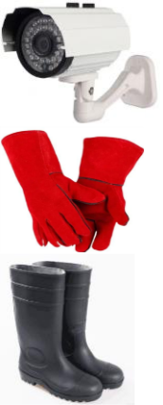
State four online threats at a work environment. (4mks)
__________________________________________________________________________
__________________________________________________________________________
__________________________________________________________________________
__________________________________________________________________________
8. Identify the following artistic drawings. (4mks)


_______________ | _______________ | _______________ | _____________________
9. Identify the following types of lines. |  |  | (3mks)
a.) | ___________________________

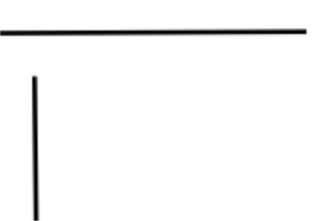

b.)

____________________________

c.) 

_____________________________

10. a.) Identify three forms of communication in business. (3mks)

_________________________________ ____________________________________
_________________________________
a.) Learners in Huduma junior school were discussing about various examples of oral
communication used today. Suggest any four examples they presented (4mks)
_______________________________________ ___________________________________
_______________________________________ ___________________________________

pg. 3

11. State three ways of keeping your body safe when using the computer. (3mks)
__________________________________________________________________________
__________________________________________________________________________
__________________________________________________________________________

12. Identify the characteristics of computers illustrated below. |  | (4mks)
 | Description | characteristic
a.) | a computer can perform millions of tasks without getting tired
b.) | It starts a task from beginning to end
 | without requiring human assistance.
c.) | Computers are reliable because they give consistent output
 | results for similar
 | tasks.
d.) | computers perform tasks without any errors if the correct data
 | is entered

13. State three injuries that can be caused by fire at work place. (3mks)
__________________________________________________________________________

__________________________________________________________________________
__________________________________________________________________________

pg. 4

