**JUNIOR SCHOOL EDUCATION ASSESSMENT**

 **2ND TERM 2024**

**GRADE 8**

PRETECHNICAL STUDIES

END OF MAY ASSESSMENT

NAME: _______________________________________________________

SCHOOL: _____________________________________________________

ASSESSMENT NUMBER ____________________ DATE___________________

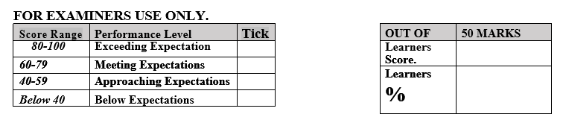

**LEARNER’S INSTRUCTIONS**

1. Write your name, School, Assessment Number and the exam date in the spaces provided above.
2. Answer all the questions in this paper.
3. Any rough work must be done in this paper.
4. All your answers must be written in the spaces provided in the question paper.
5. Writing and giving relevant examples is highly recommended.
6. It’s highly recommended to draw illustrations when explaining a concept.
7. Learners should check the question paper to ascertain that all the pages are printed as indicated and that no questions are missing.
8. Your answers must be clearly written (Legible) and well organized.
9. Use blue or black pens when writing answers and a pencil when drawing.
10. Learners must answer the questions in English.

### Name three components of Pre-technical Studies. (3 mks)

### ……………………………………………………….

### ……………………………………………………….

### ……………………………………………………….

1. Name the following storage devices. (5 mks)

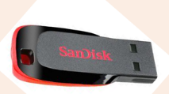

1. State five factors to consider when selecting a removable storage device for use. (5 mks)
2. ………………………………………………………………………………………….
3. ………………………………………………………………………………………….
4. ………………………………………………………………………………………….
5. ………………………………………………………………………………………….
6. ………………………………………………………………………………………….
7. Identify the scanners name below. (4 mks)



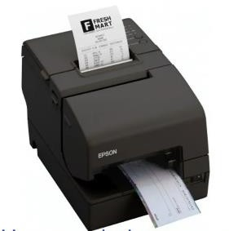

1. Define the following business term.(2 mks)

Communication ……………………………………………………………………………………………………………………………………………………………………………………………………

### State three advantages and three disadvantages of oral communication channels.(6 mks)

|  |  |  |
| --- | --- | --- |
|  | Advantages | Disadvantages. |
| 1 |  |  |
| 2 |  |  |
| 3 |  |  |

1. State three examples of written communication channels. (3 mks)
   1. ……………………………………………………………….
   2. ……………………………………………………………….
   3. ………………………………………………………………..

## State four Factors considered when selecting channels of communication.(4 mks)

1. ……………………………………………………………………..
2. ……………………………………………………………………..
3. …………………………………………………………………….
4. …………………………………………………………………….
5. Identify three common examples of visual programming applications. (3 mks)
6. …………………………………………………………
7. …………………………………………………………
8. …………………………………………………………
9. NAME the following picture to its hardware category. (8 mks)



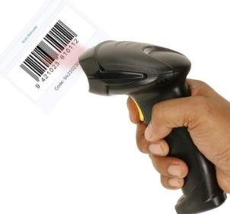



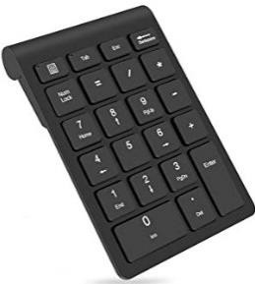

1. Give the name of the following safety wears. (4 mks)

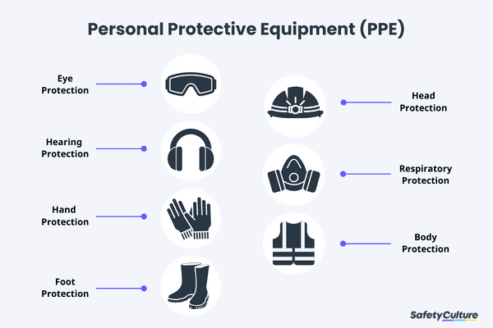

### State two causes of fire in a work environment. (2 mks)

1. ………………………………………………………………………………..
2. ………………………………………………………………………………..

### Name three injuries that can be caused by fire at work places. (3 mks)

1. ……..………………………………………………………………….…..
2. ………………………………………………………………………..…..
3. ……………………………………………………………………………..

### Outline two prevention methods of fire outbreaks in a work environment. (2 mks)

* 1. ……………………………………………………………………….
  2. ……………………………………………………………………….

1. List down two materials made of leather **(2mks)**

__________________ _________________

1. Give three types of marking tools. **(2mks)**

____________________________________________________________________________________________________________

1. Identify any three safety measures to observe when swimming **(3mks)**

____________________________________________________________________________________________________________________________________________________________________________________

1. Draw and name any four tools found in the first aid kit. **(8mks)**
2. Name four hazards to personal safety (3mks)

________________________________________________________________________________________________________________________________________________

1.  Name the tools below **(2 mks)**



1. List any two professions that require training on safety. **(2mks)**

________________________________________________________________________