KENYA JUNIOR SCHOOLS ASSESSMENT
FORMATIVE ASSESSMENT TEST
GRADE 8
RUBRICS
1-29-BE
30-49-AE
50-79-ME
80-100-EE

TICK

PRETECHNICAL EDUCATION
NAME: ……………………………………………………………………………………………
SCHOOL: ……………………………………………………………………………………….
ASSESSMENT NUMBER…………………………………….DATE: ……………………….
- What is safety?( 2 mks)
……………………………………………………………………………………………………………………………………
- State three examples of safety measures. (3 mks)
- …………………………………………………………………
- …………………………………………………………………
- …………………………………………………………………
- What is personal safety? (2 mks)
……………………………………………………………………………………………………………………………………
- What is a hazard?(2 mks)
…………………………………………………………………………………………………………………………………...
- Name three examples of Hazards to personal safety.( 3 mks)
- ……………………………………………..
- ……………………………………………..
- …………………………………………….

- Name two ways used to handle tools and equipment safely while performing tasks in the locality?( 3 mks)
- ………………………………………………………………………
- …………………………………………………………..…………..
- ………………………………………………………………………

- State two Safety Rules and Regulations at Work.( 2 mks)
- …………………………………………………………..
- …………………………………………………………..
- Mention two Careers related to Personal Safety.( 2mks)
- ………………………………………………………………….
- …………………………………………………………………

- What is the Role of safety in day-to-day life?( 2mks)
- ……………………………………………………………………
- ……………………………………………………………………

- Name two common types of injuries that occurs in the locality? (2 mks)
  - ………………………………………
  - ………………………………………

- State two Causes of injuries in the locality?( 2 mks)
- ………………………………………………………………………
- ………………………………………………………………………

- What is the Reason for first Aid?( 2mks)
  - ……………………………………………………………………
  - ……………………………………………………………………

- State three Items Contained in A First Aid Kit.( 3 mks)
- …………………………………………………….
- …………………………………………………….
- …………………………………………………….

- Name the following items

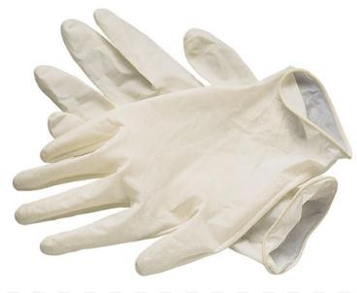
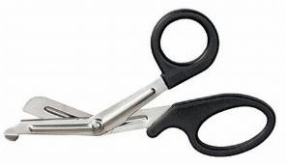
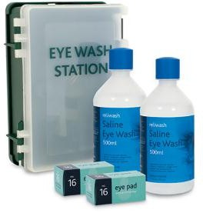

- Describe the Procedure of Administering First Aid for Cuts. ( 6 mks)
- ………………………………………………………………..
- ………………………………………………………………..
- ……………………………………………………………..….
- …………………………………………………………..……
- ………………………………………………………………..
- ………………………………………………………………..
- Describe the Procedure of Administering First Aid for Fracture. ( 6 mks)
- …………………………………………………………………………..
- …………………………………………………………………………...
- …………………………………………………………………………...
- …………………………………………………………………………...
- …………………………………………………………………………..
- ……………………………………………………………………….....

- Mention three careers Related to first Aid and Management of Injuries. ( 3 mks)
- ……………………………………………
- ……………………………………………
- ……………………………………………
- Mention five common materials found within the locality are( 5 mks)
- ……………………………………….
- ……………………………………….
- ………………………………………
- ……………………………………..
- ………………………………………

- Give two examples of Metals. (2 mks)
- ……………………………………
- ……………………………………

