KENYA JUNIOR SCHOOL ASSESSMENT
GRADE 7
MARKING SCHEME
MATHEMATICS.

- 9 and -9

a.
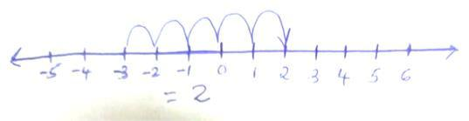

b.
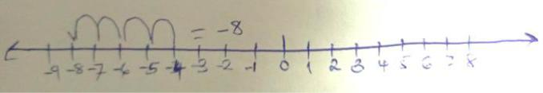

c.
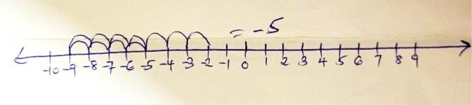

d.
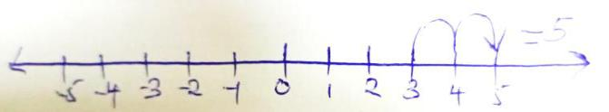

3.
0 is greater than -6
-3 is greater than -4

4.
a. ¹/4
b.

i. sh. 8000
- sh.4000.
- sh. 8000.
- sh. 6000

- 0.83.
- 0.5.

  - 7 steps.
  - 3.

(c)
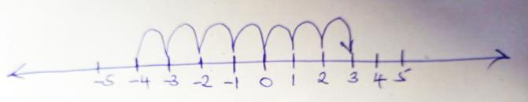

- 10cm.

  - Trapezium.

  - 60cm²

- 3a + 8b.

a- 70⁰ b- 70⁰ c- 50⁰ d- 120⁰

12.

(a)
- 120km.
- 50km.

- 10.30am

- 50km/hr
- 280 km.

