No. | COMPETENCE BASED CURRICULUM  ENDTERM EXAMINATION  MATHEMATICS GRADE 8 MARKING SCHEME
 | WORKING | AWARD | EXPLANATION
1. | a) -2>-3  b) -3<4  C) 5>-5 | B1  B1  B1
 |  | 03
2. | 24=2X2X2X3=2³X3  15=3X5  16=2X2X2X2=2⁴  LCM=2⁴X3X5  =16X3X5  =240 | M1  A1
 |  | 02
3. | a) 7, 2  b) 2,3 | B1  B1
 |  | 02
4. | a) $\frac{3}{4}×100$  =75%  b)$\frac{1}{4}×100$  =25% | M1  A1  M1  A1
 |  | 04
5. | 60=2²x3x5  80=2⁴x5  120=2³x3x5  GCD=2²x5  =4x5  =20 | M1  A1
 |  | 02
6. | 13,467,589  Digit 7=7000  Seven thousand | B1
 |  | 01
7. | Fifty five million five thousand and five  55,000,000  5000  5  55,005,005 | B1  B1 | All positions correct  6-6 positions correct  Less than6 positions
 |  | 02
8. | $a. 1\frac{3}{4}$= $\frac{7}{4}$  $b. 2\frac{6}{7}$= $\frac{20}{7}$ | M1  A1  M1  A1 | Must show multiplication and addition to score method
 |  | 04
9. | 27,707,807  Twenty seven million seven hundred and seven thousand eight hundred and seven | B1  A1
 |  | 02
10. | a)ones  b)hundredths | B1  B1
 |  | 02
11. | 256=2X2X2X2X2X2X2X2=2⁸ | 04
12. | a)  -10 -9 -8 -7 -6  Ans =+7  b)  -3 -2 -1 0 1  Ans =+1  c)  1 2 3 4 5 6 7 8 9  Ans =+9 | B1  B1  B1
 |  | 03

- What is the place value of total value of digit 6 underlined below.. (3mks) 47,397,263,402

Ten thousands t.v= p.v x N 10000 x 6
=60,000

- Round off the following numbers to the nearest number indicated in the brackets. (3mks) a) 473,678(100)

473700

b) 379(10)

380
c) 38,679(10,000)

40,000
- Write the following in symbols. (2mks)
  - Five billion, five million, five thousand and five.

5,005,005,005

llowing in words 80,000,045, 000
on, forty five thousand

lowing numbers as a product of their prime factors.

  - Write the fo (2mks)

Eighty billi

- Express the fol
a) 900 (2mks)
= 22 x32x52

b) 300 (2mks)
22 x 3x 52

- 196 (2mks

2
2 98 2x2x7x7
7 49 22x7
7 7
7 1
- 64 (2mks)

2 32 2x2x2x2x2

2 16 =25
2 8
4
2 2 2
- Use the number line to perform the following.
a) (+5) – (-2) (2mks)

b) (+2) + (+3) (2mks)

c) -7- (-8) (2mks)

- The G.C.D of two numbers is 12 and their L.C.M is 240. If one of the numbers is 60. Find the other number. (3mks)

N = GC.D x L.C.M 12 x 240 48
60

- If x=-2, 7=-6 and Z=4. Find the values of
- 4xy (3mks)
z

6=48=12
4

4x – 2x-
4

- 4z+2y-x (3mks)

4x4+(2x-6)-(-2)
16+(-12) – (-2)
16-12+2=6

- Three tanks are capable of holding 36, 84 and 90 Litres of milk. Determine the capacity of the greatest vessel which can be used to fill each one of them on exact number of times. (3mks)

3 | 36 | 84 | 90
2 | 12 | 28 | 30
 | 6 | 14 | 15 | 3x2=6litres

- Test whether the following numbers are divisible by 3. (4mks) a) 1257

1+2+5+7=15 divisible by 3

b) 7203

7+2+0+3=12 divisible by 2

- Three bells ring at intervals of 40 minutes, 45 minutes and 60 minutes. If they ring simultaneous at
6.30 a.m. at what time will they next ring together. (4mks)

2 | 40 | 45 | 60 23x32x5
2 | 20 | 45 | 30
2 | 10 | 45 | 15 | 360min
3 | 5 | 45 | 15 | 1hr=6cm
3 | 5 | 15 | 15
5 | 1 | 1 | 1 | 360=6hrs
 |  |  |  | 60 6hrs

1230HRS

- A bookstore had 30816 exercise books which were packed in cartons. Each carton contained 24 exercise books. The mass of an empty carton was 2kg and a full carton 12kg.
How many cartons were there (2mks)
I CARTON= 24bks 30816
30816/24=1284 carto

  - 1284 x 2568kg

  - What was the total mass of books alone? (2mks)
24bks=10kg 30816=?
30816 x 10=12840kg

2/3-two thirds
5/8-five eights
9/10-nine tenths
- Express 1.$\dot{5}$2$3 ̇$ as a fraction. (3mks)

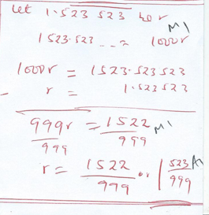

- The diagonal of a square measures 44cm.Calculate the perimeter of the square. 3mrks

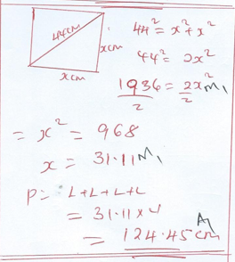

- Calculate; [3mks]
2.61 x 21.83 x 0.073
61.72 x 11.73

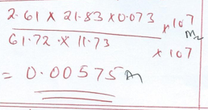

- Patrick spent 2/5 of his salary on food, 1/3 of the remainder on electricity and saved the rest.

(a). What fraction of his salary did he save? (2mrks).
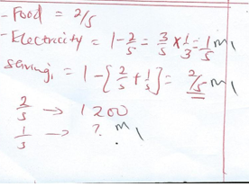

(b). If he spent Sh. 1,200 on food, how much did he spend on electricity? (2Mks)

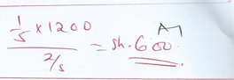

- If r=5, s=2, and t=3, find the value of; (3mks)

$\frac{r^{2}+s^{2}-t}{t^{3}}$

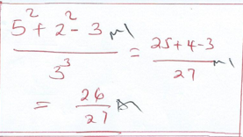

- A farmer has three containers of capacity 12L, 15L and 21L, calculate the capacity of:
- The smallest container which can be filled by each one of them an exact number of times (2 Mrks).

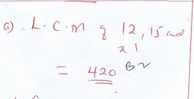

(b). The largest container which can fill each one of them an exact number of time.(2 Mks)

