JUNIOR SCHOOL EDUCATION ASSESSMENT
2ND TERM 2024
GRADE 8
MATHEMATICS
END OF MAY ASSESSMENT

NAME: _______________________________________________________
SCHOOL: _____________________________________________________
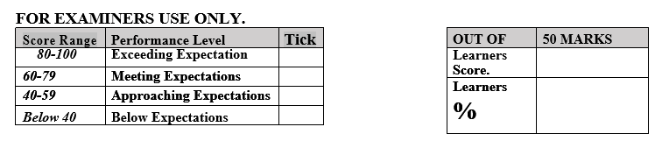
ASSESSMENT NUMBER ____________________ DATE___________________

LEARNER’S INSTRUCTIONS
- Write your name, School, Assessment Number and the exam date in the spaces provided above.
- Answer all the questions in this paper.
- Any rough work must be done in this paper.

- All your answers must be written in the spaces provided in the question paper.
- Writing and giving relevant examples is highly recommended.
- It’s highly recommended to draw illustrations when explaining a concept.
- Learners should check the question paper to ascertain that all the pages are printed as indicated and that no questions are missing.
- Your answers must be clearly written (Legible) and well organized.
- Use blue or black pens when writing answers and a pencil when drawing.

- Learners must answer the questions in English.

- Express the following numbers in words:-
- 74 379 652 137 (2 marks)

- 3 486 789 (2 marks)

- Round off the following numbers to the nearest numbers indicated in bracket (4 marks)
- 379(10)

- 89 365(100)

- 249 889(1000)

- 89 123 564(1 000 000)
- Three cisterns in a public lavatory are designed to flush at at intervals 0f 8, 13 , 15 seconds. After how many minutes will they flush together again? (3 marks)

- Evaluate 96 ÷ 6 + 7 x 15 – 14 x 5 ( 3 marks)

- A vegetable vendor had 1348 cabbages. He sold 750 on the first day and 240 on the second day. He added 462 to the remaining stock on the third day.
- How many cabbages did he have at the end? (2 marks)

- If he sold all the cabbages at an average price of sh. 12 each, how much money did he collect? (2marks)

- Express the following composite numbers as a product of prime factors (3 marks)
- 81

- 1386

- 2057

- The GCD of two numbers is 12 and the LCM is 240. If one of the numbers is 60, find the other number. (2 mks)

- Perform the following operations using number line ( 6 marks)

- +5 - (-2) =

- -10 – (-3) =

- (-2) – (+5)=

- Using divisibility test find out whether the following numbers are divisible by the number in bracket
- 104 844 (11) (2 marks)

- 84 735(9) (2 mks )

- 48 732(6) (2 mks)

- Work out without using a calculator

- 98 + 6734 + 348 (2 marks)

(3 marks)
- $\frac{648-243}{81}$

- What is the greatest mass that can be taken in exact number of times from 144g, 216g, 126g. (3marks)

- A man was born in 1966. His father was born in 1928 and the mother 3 years later. If the man’s daughter was born in 1992 and the son 5 years earlier, find the difference between the age of the man’s mother and that of the son. ( 3 marks)

- If x= -2, y= -6 and z= 4 find the value of
- 2y – 3x + z (2 marks)

- $\frac{3yz}{x}$ (2 marks)

