JUNIOR SCHOOL EDUCATION ASSESSMENT
2ND TERM 2024
GRADE 8
ISLAMIC RELIGIOUS EDUCATION
END OF MAY ASSESSMENT

NAME: _______________________________________________________
SCHOOL: _____________________________________________________

ASSESSMENT NUMBER ____________________ DATE___________________
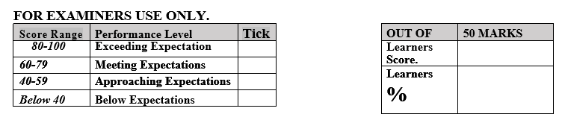

LEARNER’S INSTRUCTIONS

- Write your name, School, Assessment Number and the exam date in the spaces provided above.

- Answer all the questions in this paper.

- All your answers must be written in the spaces provided in the question paper.
- Writing and giving relevant examples is highly recommended.

- Learners should check the question paper to ascertain that all the pages are printed as indicated and that no questions are missing.
- Your answers must be clearly written (Legible) and well organized.
- Use blue or black pens when writing answers and a pencil when drawing.

- Learners must answer the questions in English.

- Define the term Quran. (2 mks)
………………………………………………………………………………………………………………………………………...

- Mention three Articles of Iman. (3 mks)
- ………………………………..……………..
- ……………………………………………….
- ……………………………………………….

- What is the meaning of Tawheed? (2 mks)
………………………………………………………………………………………………………………………………………………………………………………………………………………………………………

Mention two Categories of Tawheed. (2 mks)
    - ……………………………………………………………………
    - …………………………………………………………………….

Outline four Differences between Shahada and Tashahud. (8 mks)
 | Shahada | Tashhud
1
2
3
4

Define swalah. (2 mks)
………………………………………………………………………………………………………………………………………………

Mention three Essential condition of Swalah. (3 mks)

- ……………………………………………………………………
- ……………………………………………………………………
- ……………………………………………………………………

- Define the following. (4mks)
  - Twahara
……………………………………………………………………………………………………………………………………………..
  - Najaasat ………………………………………………………………………………………..
- Mention two types of Najaasat. (2 mks)
- ……………………………………………
- ……………………………………….…..

- State the three classes of water.(3 mks)
- …………………………………………………………….………
- …………………………………………………………………….
- …………………………………………………………………….
- Taking of ritual bath (Ghusl) is compulsory under the following circumstances: namely. (3mks)
    - …………………………………………………………………
    - …………………………………………………………………
    - …………………………………………………………………

- It is Sunnah to take bath in the following occasions: namely (3 mks)
- ………………………………………………….…………………..
- ………………………………………………………………………..
- ………………………………………………………………………..

State How to perform ritual bath (Ghusl)(5 mks)
- ……………………………………………………………………
- ……………………………………………………………….…..
- ……………………………………………………………………
- ……………………………………………………………………
- …………………………………………………………………….

Mention three Importance of taking Ghusl. (3 mks)
- ……………………………………………………………………
- ……………………………………………………………………
- ……………………………………………………………………
- What was the need for revelation of the Quran? State fine points. (5 mks)
- ………………………………………………………………….
- ………………………………………………………………….
- ………………………………………………………………….
- …………………………………………………………………..
- ………………………………………………………………….

- State three roles of Angel Jibril in the revelation of the Quran.(3 mks)
- .....................................................................................................
- ………………………………………………………………….
- …………………………………………………………………..
- Describe the two stages in which the Quran was revealed. (4 mks)
- ……………………………………………………………
- ………………………………………………………….….
- State four reasons for revelation of the Quran in portions. (4 mks)
- …………………………………………………………………..
- …………………………………………………………………….

