COMPETENCE BASED CURRICULUM
Kenya Junior Secondary Education Assessment
FORMATIVE ASSESSMENT
TIME
2 HRS
ENDTERM 1
INTEGRATED SCIENCE
G8
2024
SCHOOL: ……….……………………………………………………..……
NAME: ……………….…………………..………………………...………..
SIGNATURE: ………………ASSESSMENT NO…………………………..
RUBRICS (for official use)
MARK SCORE RANGE | Below 40 | 40-59 | 60-79 | 80-100
PERFORMANCE LEVEL | Below expectation | Approaching expectations | Meeting expectations | Exceeding expectations

OUT OF | 100%
LEARNERS SCORE
PERCENTAGE SCORE
PERFORMANCE LEVEL

FOR FACILITATOR’S USE ONLY

Answer all Questions

- State three components of integrated science. (3 mks)
- ____________________________________________________
- ____________________________________________________
- ____________________________________________________

- Sophie saw the following symbols chemical bottles. What are their meaning? (3 mks)
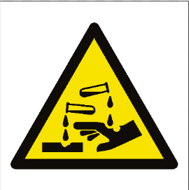
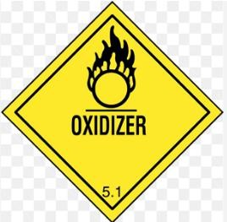
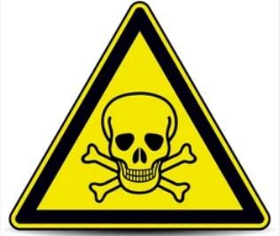
___________________ ___________________ _____________________
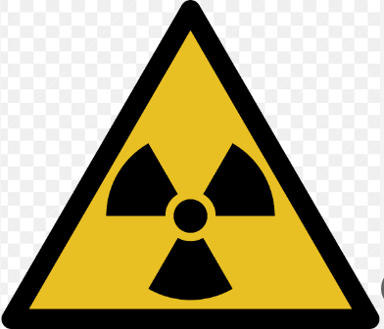
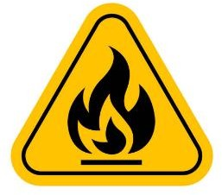

__________________ ______________________ ___________________

When working in the laboratory, you must observe the following safety rules: Namely? (2 mks)
- ______________________________________________________________
- ______________________________________________________________
- ______________________________________________________________
- ______________________________________________________________
- Name four scientific skill one attains through learning integrated science.(2 mks)
- ______________________________________________________________
- ______________________________________________________________
- ______________________________________________________________
- ______________________________________________________________

- Name three components of the atom. (3 mks)
- ______________________________________________________________
- ______________________________________________________________
- ______________________________________________________________
- Name the three states of matter.(3 mks)
- ____________________________________________________________
- ____________________________________________________________
- ____________________________________________________________
- write the symbol of the following elements.(3 mks)
- oxygen-___________________________
- magnesium-_______________________
- lead-_____________________________
- iron -_____________________________
- List four characteristics of gases.(2 mks)
- ____________________________________________________________
- ____________________________________________________________
- ____________________________________________________________
- ____________________________________________________________
- Observe the diagram below and identify the indicated processes of change of state.(2 mks)
W X
SOLID LIQUID GAS
Y Z

W= ______________________________________

X= _______________________________________

Y= _____________________________________

Z= _______________________________________

- Name three processes that require a decrease in temperature.(3 mks)
- ______________________________________________________________
- ______________________________________________________________
- ______________________________________________________________
- State the Functions of the different parts of the Microscope.(2 mks)

 | PART | USE/FUNCTION
1 | Eyepiece lens
2 | Body tube
3 | Stage
4 | Arm
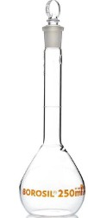
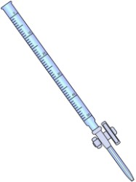
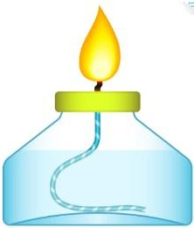
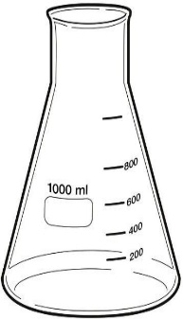
- Name the following instruments. (4 mks)

____________ ______________ ________________ __________________

- Name three laboratory apparatus used for measuring mass of substances.(3 mks)
- ____________________________________________________________
- ____________________________________________________________
- ____________________________________________________________

- Name the following parts of the light microscope.( 5 mks)
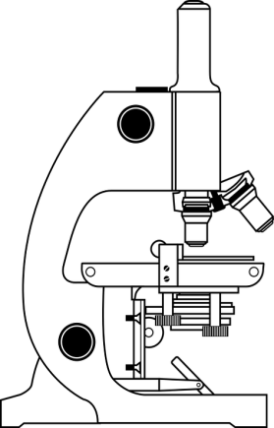

- Grade 8 students had their practical lesson in the laboratory.name two common accidents their Integrated Science teacher taught them. (2 mks)
- __________________________________________________________
- __________________________________________________________
- During an experiment in the school lab, Grade 8 learners Put 5g of powdered blue hydrated copper (II) sulphate in the test tube and set up the experiment as shown below.
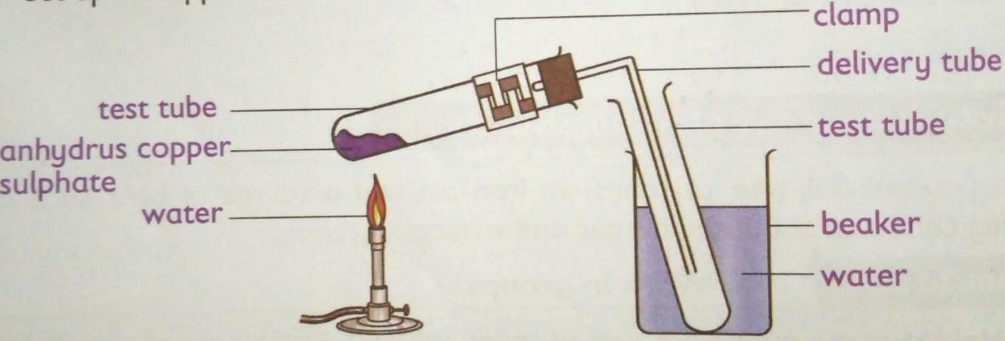

  - What is the colour of hydrated copper (ii) sulphate crystals before heating?
___________________________________________ (1 mark)

  - Upon heating the anhydrous copper (ii) sulphate crystals turned white. Why did the crystals change colour? (2 marks)
____________________________________________________________________________________________________________________________
  - This type of change is referred to as______________________(1 Mark)
- Name three protective wear for safety in the laboratory.( 3 mks)
- ____________________________________________________________
- ____________________________________________________________
- ____________________________________________________________
- Explain why most laboratory apparatus are made of glass. (2 marks )
- ________________________________________________________________
- ________________________________________________________________.
- The following diagram represents a non-luminous flame of the Bunsen burner.

(i) Name the parts labeled
A – ____________________________________________- ( 1 mark )
B – _____________________________________________ ( 1 mark )
C – _____________________________________________ ( 1 mark)

(ii) Which of the parts in (i) above is the hottest? ( 1 mark)
___________________________________________
(iii) Give two reasons why a non-luminous flame is preferred for heating. (2 mark)
      - ____________________________________________
      - ____________________________________________
- Name the other type of flame produced by a Bunsen burner. (1 mark )
_____________________________________________________________
- Under what conditions does the Bunsen burner produce the flame you have named in number 20 Above? (1 mark)
________________________________________________________________.
- After use, a non-luminous flame should be put off or adjusted to the other flame. Explain. (1 mark)
______________________________________________________________________________________________________________________________________
- Given below are pH values of different solutions P, Q and S. Study it and answer the questions that follow.
Solution pH
P 1
Q 7
S 14
a) Which two solutions would react together to give a solution with a pH of 7.0? (2mk)
__________________________________________________________________
- Nitrogen, oxygen and argon are obtained from the air using fractional distillation of air. Dust, carbon (IV) oxide and water vapour are removed from the air before fractional distillation is carried out.

(i)Name the compound used to absorb carbon (IV) oxide gas from the air (1mk)
_____________________________________________________________
(ii)Explain how water vapour is removed from the air (2mks)
_______________________________________________________________
(iii)At what temperature are the gases liquefied? (1mk)

________________________________________________________________

(iv)The boiling points of nitrogen, oxygen and argon are -196, -183 and -186 respectively. State the order in which the three are distilled off starting with the first to be distilled off. (1mk)
________________________________________________________________
- Study the diagram shown below to answer the questions that follow. The curve shows the heating curve of water in the laboratory.
A
B
C
D
E
108⁰C
100⁰C
Temp ⁰C
Time (Min)

(i) At what temperature does the water boil? (1 Mark)
______________________________________________________________________________________________________________________________________
(ii) Is the curve for a pure water or impure water?(1 Mark)
______________________________________________________________________________________________________________________________________
(iii) Give one effect of impurities on the boiling point of water (1 Mark)
___________________________________________________________________________________________________________________________________
- Write a word equation for the above reaction between calcium carbonate and dilute hydrochloric acid (1 Mark)
______________________________________________________________________________________________________________________________________

- Write the word equations for the reaction of sodium and chlorine(2 Marks)
__________________________________________________________________

- Write the word equations for the reactions between oxygen and each of the following.
i)Zinc metal.(1mrk)
______________________________________________________________________________________________________________________________________

ii)Calcium .(1mrk)
______________________________________________________________________________________________________________________________________

iii)Magnesium .(1mrk)
______________________________________________________________________________________________________________________________________

iv)Potassium .(1mrk)
______________________________________________________________________________________________________________________________________

v)Sodium .(1mrk)
______________________________________________________________________________________________________________________________________

- The apparatus below is commonly used in a chemistry laboratory to measure volumes.
(i)Give its name
(1 Mark)
______________________________________________________________________________________________________________________________________

(ii) Name any other three apparatus which can be used to measure volumes of liquids (3mks)
- _________________________________________
- _________________________________________
- __________________________________________

- The chromatogram of two inks and three dyes is drawn below.

Ink INK B RED BLUE YELLOW
A B DYE DYE DYE
(a) Name the colours of dyes present in ink A (2 Mark)
_____________________________________________________________________________________________________________________________________
(b) Suggest how separated dyes can be recovered (2 Mark)
_____________________________________________________________
(c) What properties of the dyes make this method of separation possible? (2 Mark)
- ______________________________________________________________
- ______________________________________________________________

- Name the method that can be used to separate the following
  - Ethanol and water mixture (1mk)
______________________________________________________________________________________________________________________________________
  - Kerosene and water mixture (1mk)
______________________________________________________________________________________________________________________________________
  - Common salt and iodine mixture (1mk)
______________________________________________________________________________________________________________________________________

- In temperate countries, salt is sprayed on roads to melt ice and clear roads but the long term effect on this practice is costly to motorist.
- Explain why salt help in melting the ice. (2mark)
______________________________________________________________________________________________________________________________________
- Explain why the long term effect is costly to motorist. (1mark)
______________________________________________________________________________________________________________________________________
- (a) The diagrams below are some common laboratory apparatus. Name each apparatus and state its use. (4marks)
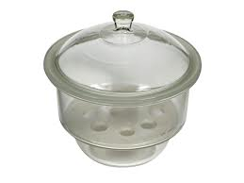

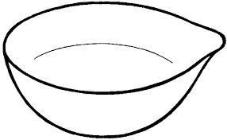

Name: _____________________________________Name: _________________________
Use:_____________________________________ Use:__________________________
- Give two reasons why air is a mixture but not a compound. (2 mark)
- ____________________________________________________________
- ____________________________________________________________

The end

