COMPETENCE BASED CURRICULUM
Kenya Junior Secondary Education Assessment
FORMATIVE ASSESSMENT
TIME
2 HRS
ENDTERM 1
INTEGRATED SCIENCE
G8
2024
SCHOOL: ……….……………………………………………………..……
NAME: ……………….…………………..………………………...………..
SIGNATURE: ………………ASSESSMENT NO…………………………..
RUBRICS (for official use)
MARK SCORE RANGE | Below 40 | 40-59 | 60-79 | 80-100
PERFORMANCE LEVEL | Below expectation | Approaching expectations | Meeting expectations | Exceeding expectations

OUT OF | 100%
LEARNERS SCORE
PERCENTAGE SCORE
PERFORMANCE LEVEL

FOR FACILITATOR’S USE ONLY

Answer all Questions

- State three components of integrated science. (3 mks)
- physics,
- chemistry,
- biology,
- earth science and
- astronomy
- health education
- nutrition

- Sophie saw the following symbols chemical bottles. What are their meaning? (3 mks)
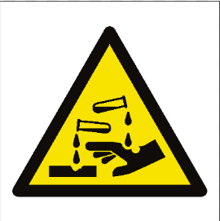
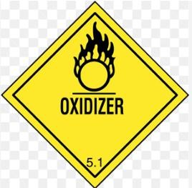
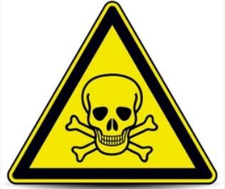
Poisonous oxidiser poisonous
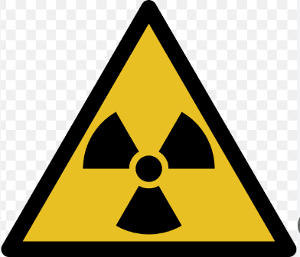
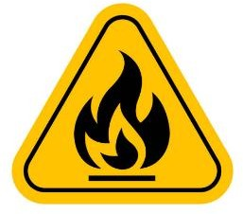

Carcinogenic Radioactive flammable

When working in the laboratory, you must observe the following safety rules: Namely? (2 mks)
- Work carefully as carelessness can cause accidents as well as inaccurate results.
- Wear gloves, laboratory aprons and safety glasses.
- Never eat or drink in the laboratory.
- Tie back loose hair, roll back and secure open sleeves and neckties and make sure you wear shoes that fully cover your feet.
- Do not carry out laboratory experiments at home or in the dormitories unless directed to do so by your class teacher.
- Carefully read chemical labels and understand the hazard symbol on them.
- Listen carefully to your teacher’s instructions on when and how to use safety equipment such as glasses, protective aprons, fire extinguishers and fire blankets.
- Make sure you know where the nearest fire alarm is in your school laboratory.
- Do not begin an experiment until the teacher instructs you to do so.
- Do not touch substances unless the teacher instructs you to do so. What looks harmless may be dangerous.
- Wash your hands with soap and running water after handling chemical substances. Some chemical substances are poisonous.
- Heat materials in suitable containers only, such as Pyrex glass container that can resist breakage.
- Always keep the open end of the test tube pointed away from the learners and yourself when heating chemicals because the fumes produced may be harmful.
- Pick up hot objects carefully using tongs or insulated materials.
- Make sure that you turn off the heat source when not in use to conserve energy.
- Always unplug electric cords by pulling out the plug and not the cord.
- Check that there are no flammable substances near the burner. Flammable substances will cause fire if exposed to a flame.
- After each experiment, tidy up your working area, clean all equipment and put them in their respective storage areas.
- Report any accidents, broken equipment and damaged facilities to your teacher. In this way, you will be taking responsibility for your safety and for those who use the laboratory after you.
- If a chemical gets into your eyes, wash it out with running water for about 12 minutes and then visit a health centre or hospital for further medical attention.
- If you inhale poisonous gases or vapour, move outside the laboratory for fresh air.Immediately seek medical assistance.
- Name four scientific skill one attains through learning integrated science.(2 mks)
- Manipulative skills and abilities.
- Observation skills.
- Classification skills.
- Measuring skills.
- Communication skills.
- Predicting skills.
- Conclusion skills.

- Name three components of the atom. (3 mks)
- Protons
- Neutrons
- Electrons
- Name the three states of matter.(3 mks)
- Solids
- Liquids
- gases
- write the symbol of the following elements.(3 mks)
- oxygen-O
- magnesium-Mg
- lead-Pb
- iron -Fe
- List four characteristics of gases. (2 mks)
- Expands when heated
- Cannot be compressed
- Have definite volume
- No definite shape
- No definite mass
- Contract when cooled
- Have weight
- Occupy space

- Observe the diagram below and identify the indicated processes of change of state.(2 mks)
W X

SOLID LIQUID GAS

Y Z

W= freezing

X= condensation

Y= melting

Z= evaporation

- Name three processes that require a decrease in temperature.(3 mks)
- Condensation
- Freezing
- deposition
- State the Functions of the different parts of the Microscope.(2 mks)

 | PART | USE/FUNCTION
1 | Eyepiece lens | - Used to observe specimen under the microscope.
2 | Body tube | - It holds the eyepiece lens and the objective lens in position  allowing light from the specimen to pass to the observer.
3 | Stage | - It is where the specimen is placed during examination or  viewing.
4 | Arm | - It supports the body tube and the lenses.  - It is also used to carry the microscope when moving it from one place to another.
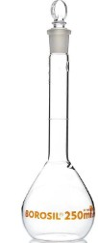
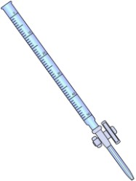
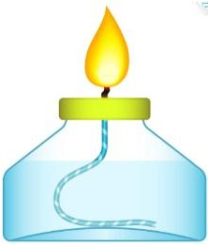
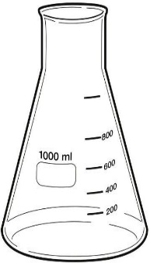
- Name the following instruments. (4 mks)

Conical flask spirit lamp burette flat bottomed flask

- Name three laboratory apparatus used for measuring mass of substances.(3 mks)
- Electric balance
- Double beam balance
- Triple beam balance
- Name the following parts of the light microscope.( 5 mks)
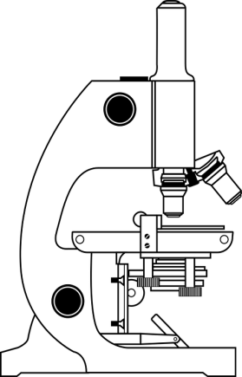
Eye-piece lens
Body tube
Base
Body tube
Stage

Mirror
Base

- Grade 8 students had their practical lesson in the laboratory.name two common accidents their Integrated Science teacher taught them. (2 mks)
- Burns, corrosion
- Falls and fractures
- Fires and explosions
- Cuts and scalds
- During an experiment in the school lab, Grade 8 learners Put 5g of powdered blue hydrated copper (II) sulphate in the test tube and set up the experiment as shown below.
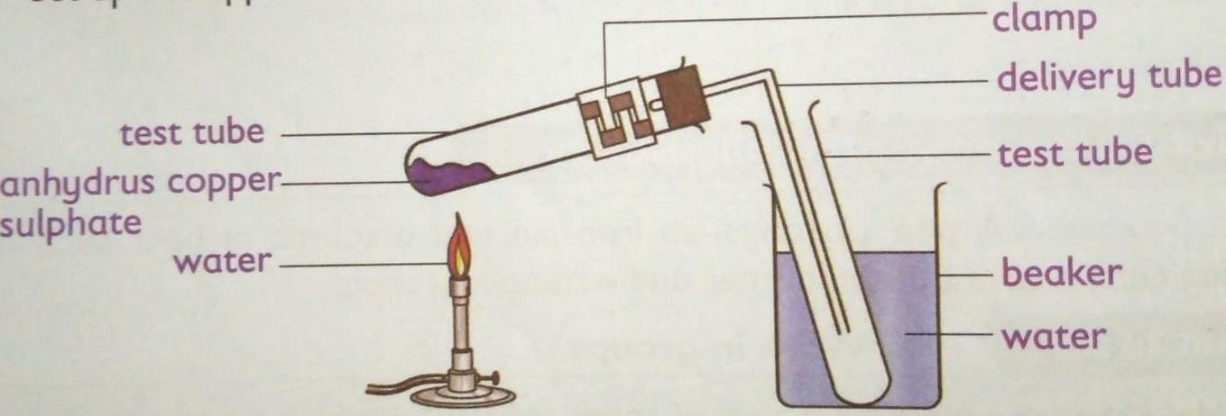

  - What is the colour of hydrated copper (ii) sulphate crystals before heating? Blue (1 mark)
  - Upon heating the anhydrous copper (ii) sulphate crystals turned white. Why did the crystals change colour? (2 marks)
It lost water which was making it hydrated. After losing water, it become white anhydrous copper (II) sulphate.

  - This type of change is referred to as temporary chemical changes or reversible chemical changes.

- Name three protective wear for safety in the laboratory.( 3 mks)
- Gloves
- Overall
- Safety goggles
- Facemask
- Headgear

- Explain why most laboratory apparatus are made of glass. (2 marks )
- Glass does not rust.
- Glass is transparent.
- Glass can withstand heating.
- The following diagram represents a non-luminous flame of the Bunsen burner.

(i) Name the parts labeled
A – Pale blue zone ( 1 mark )
B – Green blue zone ( 1 mark )
C – Almost colorless zone ( 1 mark)

(ii) Which of the parts in (i) above is the hottest? ( 1 mark)
The pale blue zone
(iii) Give two reasons why a non-luminous flame is preferred for heating. (2 mark)
      - It’s the hottest
      - It’s a clean flame
- Name the other type of flame produced by a Bunsen burner. (1 mark )
The luminous flame.

- Under what conditions does the Bunsen burner produce the flame you have named in 21. above? (1 mark)
When the air hole is closed.
- After use, a non-luminous flame should be put off or adjusted to the other flame. Explain. (1 mark)
Non-luminous flame is clear √ ½ such that its difficult to be seen. Thus its adjusted to the luminous flame which is visible due to its brightness √ ½ // saves on fuel

- Given below are pH values of different solutions P, Q and S. Study it and answer the questions that follow.
Solution pH
P 1
Q 7
S 14
a) Which two solutions would react together to give a solution with a pH of 7.0? (2mk)
P and S

- Nitrogen, oxygen and argon are obtained from the air using fractional distillation of air. Dust, carbon (IV) oxide and water vapour are removed from the air before fractional distillation is carried out.

(i)Name the compound used to absorb carbon (IV) oxide gas from the air (1mk)

Concentrated sodium hydroxide//KOH 1 mark
(ii)Explain how water vapour is removed from the air (2mks)
Cooled to -25ºc and turns to ice 1 mark
(iii)At what temperature are the gases liquefied? (1mk)

-200 ºc 1 mark

(iv)The boiling points of nitrogen, oxygen and argon are -196, -183 and -186 respectively. State the order in which the three are distilled off starting with the first to be distilled off. (1mk)
N₂, Ar, O₂ 1 mark
- Study the diagram shown below to answer the questions that follow. The curve shows the heating curve of water in the laboratory.
A
B
C
D
E
108⁰C
100⁰C
Temp ⁰C
Time (Min)

(i) At what temperature does the water boil? (1 Mark)
Between (100 and 108)0C. 1
(ii) Is the curve for a pure water or impure water?(1 Mark)
Impure water
(iii) Give one effect of impurities on the boiling point of water (1 Mark)
It raises the boiling point of the water. 1
- Write a word equation for the above reaction between calcium carbonate and dilute hydrochloric acid (1 Mark)
CaCO_{3 (s)} + H₂SO_{4 (aq)} CaSO_{4 (s)} + H₂O_{(l)} + CO_{2 (g)} 1 (or in words)

- Write the word equations for the reaction of sodium and chlorine(2 Marks)
Sodium+ Chlorine=Sodium Chloride

- Write the word equations for the reactions between oxygen and each of the following.
i)Zinc metal.(1mrk)
Zinc + oxygen=zinc oxide

ii)Calcium .(1mrk)
Calcium+ oxygen=calcium oxide

iii)Magnesium .(1mrk)
Magnesium+ oxygen= magnesium oxide

iv)Potassium .(1mrk)
Potassium+ oxygen= potassium oxide

v)Sodium .(1mrk)
Sodium+ oxygen=sodium oxide

- The apparatus below is commonly used in a chemistry laboratory to measure volumes.
(i)Give its name
(1 Mark)

Pipette

(ii) Name any other three apparatus which can be used to measure volumes of liquids (3mks)
- Volumetric flask
- Measuring cylinder
- Syringe
- Burette (any three)
- The chromatogram of two inks and three dyes is drawn below.

Ink INK B RED BLUE YELLOW
A B DYE DYE DYE
(a) Name the colours of dyes present in ink A (2 Mark)
. (a) Red and blue
(b) Suggest how separated dyes can be recovered (2 Mark)
By solvent extraction
(c) What properties of the dyes make this method of separation possible? (2 Mark)
- -Unequal solubilities
- Different absorption abilities

- Name the method that can be used to separate the following
  - Ethanol and water mixture (1mk)
Fractional distillation
  - Kerosene and water mixture (1mk)
Separating funnel
  - Common salt and iodine mixture (1mk)
Sublimation

- In temperate countries, salt is sprayed on roads to melt ice and clear roads but the long term effect on this practice is costly to motorist.
- Explain why salt help in melting the ice. (2mark)
It acts as an impurity in the ice hence lowering its melting point. 1
- Explain why the long term effect is costly to motorist. (1mark)
Salt accelerates the rate of rusting of the iron parts of the motor vehicles. 1
- (a) The diagrams below are some common laboratory apparatus. Name each apparatus and state its use. (4marks)
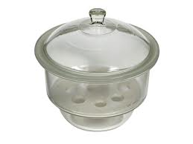

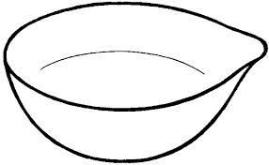

Name Desiccator Name Evaporating dish
Use Drying or keeping substances from moisture Use Evaporating liquids to obtain crystals

- Give two reasons why air is a mixture but not a compound. (2 mark)
- It can be separated by physical means
- The components are not chemically combined

