KENYA JUNIOR SCHOOLS ASSESSMENT
FORMATIVE ASSESSMENT TEST
GRADE 8
RUBRICS
1-29-BE
30-49-AE
50-79-ME
80-100-EE

TICK

INTEGRATED SCIENCE
NAME: ……………………………………………………………………………………………
SCHOOL: ……………………………………………………………………………………….
ASSESSMENT NUMBER…………………………………….DATE: ……………………….

- Name three components of the atom. (3 mks)
- …………………………………………………….………………………….
- ……………………………………………………..…………………………
- ………………………………………………………………………………..
- Name the three states of matter;(3 mks)
- …………………………………………………………………….
- …………………………………………………………………….
- …………………………………………………………………….

- Write the symbol of the following elements.(4 mks)

- Oxygen-…………………………..
- Magnesium-……………………..
- Lead-………………………………
- Iron -………………………………

- Write the word equation for the reaction between oxygen and hydrogen.(2 mks)
……………………………………………………………………………..

- Fill in the table below appropriately. Put sign for definite and for indefinite. (3 mks)

 | characteristics
 | SHA | VO | MA
SO
LI
GA

- List four characteristics of gases. (4 mks)
- …………………………………………………………………………….
- ……………………………………………………………………………
- ………………………………………………………………………...…..

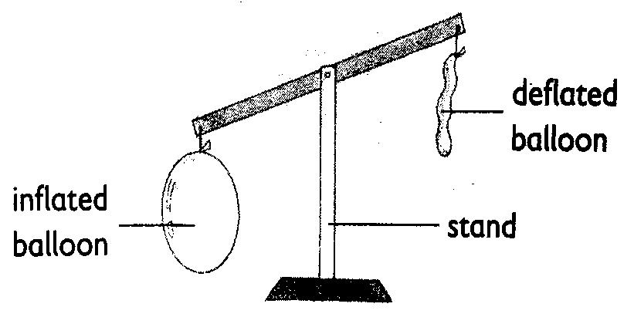
- In the diagram below, the pupils observed and concluded that gases….
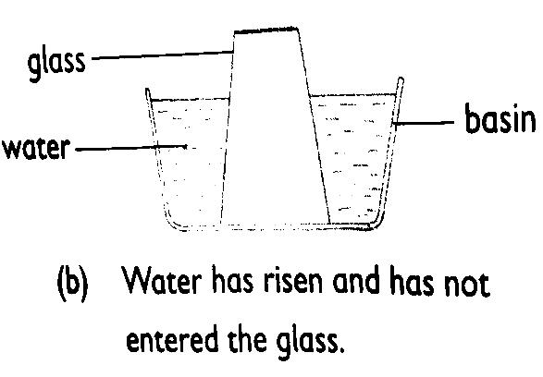

……………………………………….. …….……………………………………

- State two major factors that affects the state of matter?
- ………………………………………………….
- …………………………………………………

- Observe the diagram below and identify the indicated processes of change of state;
W X

SOLID LIQUID GAS

Y Z

W= …………………………………...…..

X= ………………………………………..

Y= ………………………………………..

Z= ………………………………………..

- Name three processes that require a decrease in temperature.(3 mks)
- ………………………………………………
- ………………………………………………
- ……………………………………………..

- Ole Kinyasa from Hope Junior School boiled water as shown in the diagram below and later noticed that there were some water droplets under the lid when he cooled the water.

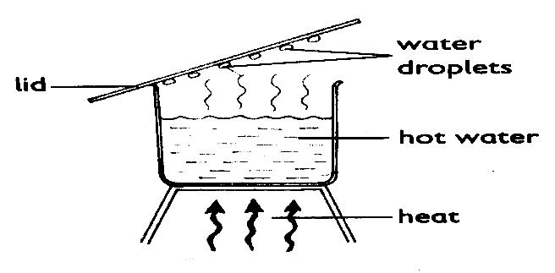

This demonstrates the process of …………………………….. (1 mk)

- When matter is heated it expands and when cooled, it contracts. The following diagrams show expansion and contraction of matter. Identify each category.

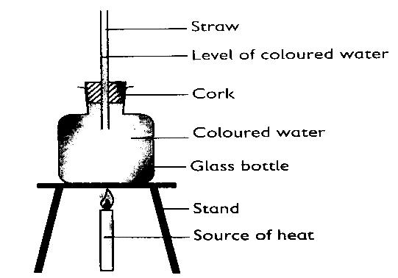
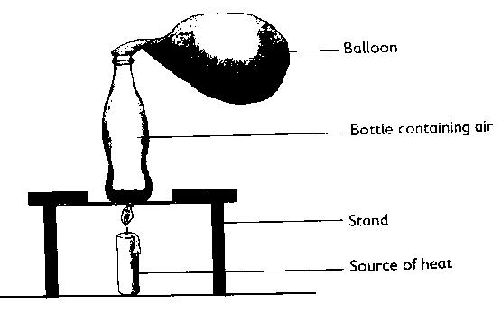

B
A

- The above experiments demonstrate?
A
……………………………………………………………………………………
B
…………………………………………………………………………………..

- Name three processes that requires an increase in temperature. (3 mks)
- …………………………………………………
- …………………………………………………
- ………………………………………………..

- Name three acid-base indicators apart from plant extracts. (3 mks)
- …………………………………………………….
- ……………………………………………………..
- ……………………………………………………..

- Mafuta conducted the experiment as demonstrated below.
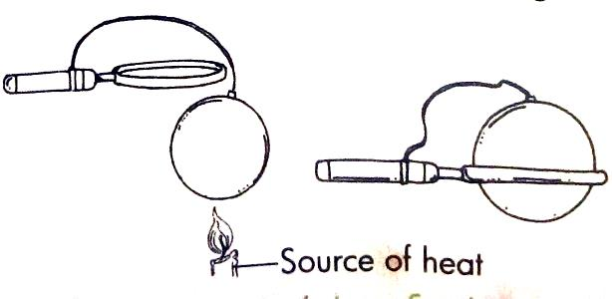

What was he trying to find out?

…………………………………………………………………..

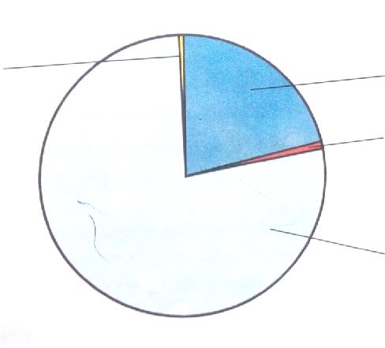
- The following pie chart represents various gases that constitute air. Indicate the gases and their percentages represented by the portions indicated on the pie chart.

- The following table represents basic quantities. Write their SI units and their symbols.(5 mks)
 | quantity | SI Unit | Symbol
1 | Length
2 | Mass
3 | Time
4 | Electric current
5 | Temperature
6 | Amount of substance
7 | Luminous intensity

- Name the following parts of the light microscope.( 3 mks)

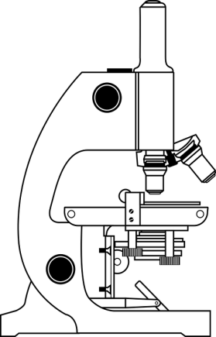

- What is the meaning of the following sign?( 3 mks)

- Calculate the area of the following object.( 3 mks)
15cm

10cm

12cm

- Mention two rules you must observe when in the laboratory. (2 mks)
- ……………………………………………………………………………
- ……………………………………………………………………………

- Name two heat instruments used in the lab for heating purposes.(2 mks)
- ……………………………………
- ……………………………………

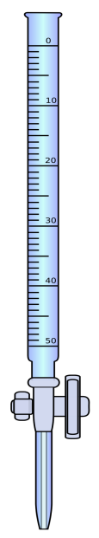
- Identify the following lab apparatus. (3 mks)
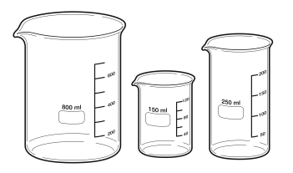

- The volume of 2355g of glass was found to be 50cm³.Calculate the density of mercury ( 2 mks)

