COMPETENCE BASED CURRICULUM
Kenya Junior Secondary Education Assessment
FORMATIVE ASSESSMENT
TIME
2 HRS
ENDTERM 1
CAS
G8
2024
SCHOOL: ……….……………………………………………………..……
NAME: ……………….…………………..………………………...………..
SIGNATURE: ………………ASSESSMENT NO…………………………..
RUBRICS (for official use)
MARK SCORE RANGE | Below 40 | 40-59 | 60-79 | 80-100
PERFORMANCE LEVEL | Below expectation | Approaching expectations | Meeting expectations | Exceeding expectations

OUT OF | 100%
LEARNERS SCORE
PERCENTAGE SCORE
PERFORMANCE LEVEL

FOR FACILITATOR’S USE ONL

Answer all Questions

questions

What is creative arts? (2 mks)
______________________________________________________________________________________________________________________________________________________
- Identify the materials needed in the game of handball.(2 mks)
- ____________________________________________________________________
- ____________________________________________________________________
- Give two types of passes in a game of handball. (2 mks)
- ____________________________________________________________________
- ____________________________________________________________________
- Define the following terms. (4 mks)
- Reception.
____________________________________________________________________________________________________________________________________________________
- Passing
____________________________________________________________________________________________________________________________________________________
- Pivoting
____________________________________________________________________________________________________________________________________________________
- Marking
____________________________________________________________________________________________________________________________________________________
- Which type of performance has been shown below?(1 mk)
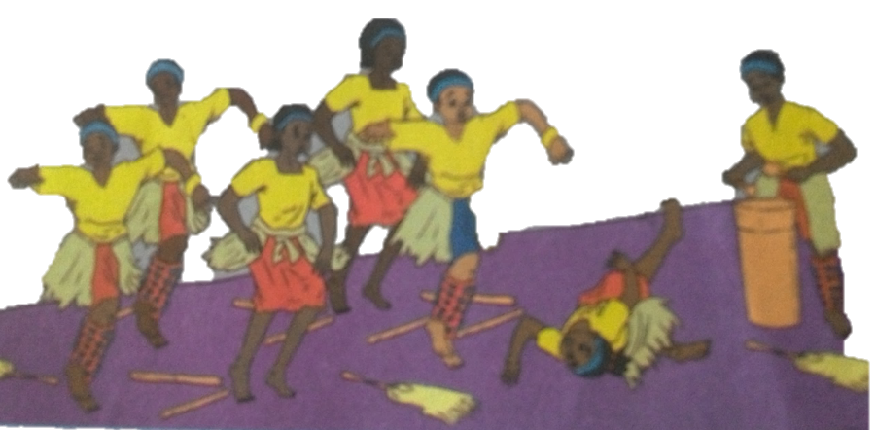

________________________

- One of the performer dripped and fell down. Say why the injuries happened above.(4 mks)
    - __________________________________________________________________
    - __________________________________________________________________
    - __________________________________________________________________
    - __________________________________________________________________
- State four ways to make sure that you are safe when dancing.(4 mks)
  - ________________________________________________________________________
  - ________________________________________________________________________
  - ________________________________________________________________________
  - ________________________________________________________________________
- Name some of the activities dancers need to do before a performance on stage.(3 mks)
  - ________________________________________________________________________
  - ________________________________________________________________________
  - ________________________________________________________________________
  - ________________________________________________________________________
- What are the functions of a soloist in a song performance?(8mks)
  - ___________________________________________________________________
  - ___________________________________________________________________
  - ___________________________________________________________________
  - ___________________________________________________________________
- Write the French rhythms for the following.(4 mks)

- Identify five roles of Creative arts and sports in the society.(5 mks)
- __________________________________________________________________________
- __________________________________________________________________________
- __________________________________________________________________________
- __________________________________________________________________________
- __________________________________________________________________________
- State four components of Creative Arts and Sports.(4 mks)
- ______________________________________________________________________
- ______________________________________________________________________
- ______________________________________________________________________
- ______________________________________________________________________
- State two Principles of Visual arts.(2 mks)
  - ______________________________________________________________
  - ______________________________________________________________
- What is a colour wheel?( 2 mks)
________________________________________________________________________________________________________________________________________________________________________________________________________________________
- Name three primary colours. (3 mks)
  - ________________________________________________________
  - ________________________________________________________
  - ________________________________________________________
- On the circles below, insert the colours you have identified as primary colors.( 3 mks)

- Identify the type of pass demonstrated below.(2 mks)

- Identify the type of marking illustrated below.( 2 mks)

________________________________ ________________________________________
- Which is the most common type of injury in a netball game?(4 mks)
- ________________________________________________________________
- _________________________________________________________________
- _________________________________________________________________
- _________________________________________________________________
- State and explain three elements of Music in Creative Arts.(6 mks)

__________________________________________________________________

__________________________________________________________________

________________________________________________________________

State three examples of themes in plays. (3 mks)
  - _______________________________________________________________
  - _______________________________________________________________
  - _______________________________________________________________
- State three Elements of Dance in Creative Arts.(3 mks)
- _________________________________________________________________
- _________________________________________________________________
- _________________________________________________________________
- The arts can be experienced through the following senses namely?(3 mks)
  - __________________________________________________________________
  - __________________________________________________________________
  - __________________________________________________________________

- What are 3d art forms?( 3 mks)
____________________________________________________________________________________________________________________________________________________________________________________________________________________________________________________________________________________
- Name three examples of 3D artworks (3 mks)
- ____________________________________________________________________
- ____________________________________________________________________
- ____________________________________________________________________

- Define ( 6 mks)
  - A still life drawing
____________________________________________________________________________________________________________________________________________________________________________________________________________________________________________________________________________________________________________
  - A composition

____________________________________________________________________________________________________________________________________________________________________________________________________________________________________________________________________________________________________________
  - Painting
____________________________________________________________________________________________________________________________________________________________________________________________________________________________________________________________________________________________________________

- List down three tools and materials used in painting.( 3 mks)

- __________________________________________________________________
- __________________________________________________________________
- __________________________________________________________________

- Draw a descant recorder.(8 mks)

