COMPETENCE BASED CURRICULUM
Kenya Junior Secondary Education Assessment
FORMATIVE ASSESSMENT
TIME
2 HRS
ENDTERM 1
CAS
G8
2024
SCHOOL: ……….……………………………………………………..……
NAME: ……………….…………………..………………………...………..
SIGNATURE: ………………ASSESSMENT NO…………………………..
RUBRICS (for official use)
MARK SCORE RANGE | Below 40 | 40-59 | 60-79 | 80-100
PERFORMANCE LEVEL | Below expectation | Approaching expectations | Meeting expectations | Exceeding expectations

OUT OF | 100%
LEARNERS SCORE
PERCENTAGE SCORE
PERFORMANCE LEVEL

FOR FACILITATOR’S USE ONL

Answer all Questions

MARKING SCHEME

What is creative arts? (2 mks)
Creative Arts is a description of various artistic activities that allow performers to use their imaginations, creativity, and express ideas through a variety of mediums to passage a message to the audience.
- Identify the materials needed in the game of handball.(2 mks)
- Balls
- Red Cards
- Whistle
- Yellow Cards
- Give two types of passes in a game of handball. (2 mks)
- Jump pass
- Side pass
- flick pass
- Define the following terms. (4 mks)
- Reception.
Is the act of receiving the ball with one or both hands.
- Passing
It is delivering the ball to a team mate during play in a handball game.
- Pivoting
It is the act of turning with one foot on the ground while the other foot makes repeated short steps.
- Marking
It is a defensive action that limits the chances of attacking players gaining possession of the ball.
- Which type of performance has been shown below?(1 mk)
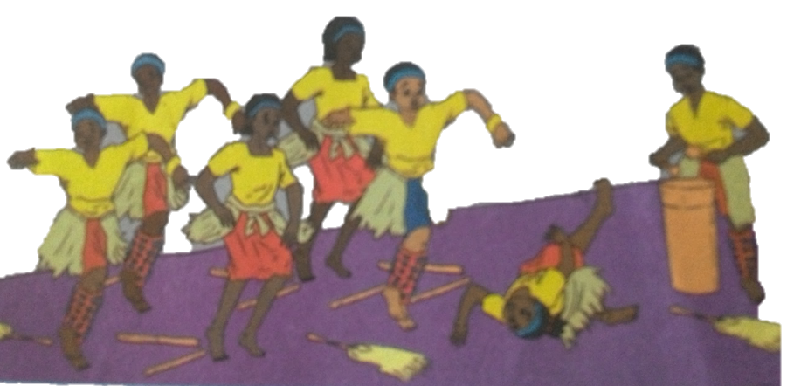

Dance

- Say why the injuries happened above.(4 mks)
    - Too high speed
    - Sticks on the floor
    - Slippery floor
    - Poor stage formation
    - Unconsciousness of the dancer
    - Uncoordinated body movements etc
- State four ways to make sure that you are safe when dancing.(4 mks)
  - Maintaining correct speed
  - Good stage formation
  - Avoiding too much use of props
  - Proper rehearsal before stage performance to avoid panic and falling unconscious
  - Checking stage to remove things that might cause falls
  - Ensuring the floor/stage is properly dry
  - Proper spacing of the dancers etc
- Name some of the activities dancers need to do before a performance on stage.(3 mks)
  - Rehearsal
  - Taking water to avoid panic
  - Exercise and relieving oneself
  - Making sure one is conversant with the stage etc
- What are the functions of a soloist in a song performance?(8mks)
  - Lead the song
  - Give clues
  - Change tone
  - Change formations
  - Starting the dance
  - Ending dance
  - Help capture the message and the mood of the dance
  - Pitching the dance songs
  - Cuing dance on the change of melodies, movements and dance
formations.

- Write the French rhythms for the following.(4 mks)

- Identify five roles of Creative arts and sports in the society.(5 mks)
- Creates a sense of identity-bring people together, creating shared experiences that help to foster a sense of community and collective identity.

- Creative arts and sports promote cohesion through teamwork.

Through creative arts and sports culture is preserved-it ensures that our history and traditions are not forgotten, and that future generations can appreciate and learn from them.

- Creative arts and sports provide provides us with entertainment through components such as music, dance, drama, narratives, films and movies, various sports i.e., soccer, basketball, netball, volley ball.
Economic roles of Creative arts and Sports.
- Creative arts and sports provide employment opportunities such as artists, musicians, referees, sports coaches, sports doctors, choreographers. Trainers, teachers etc.
- One can earn income through activities related to creative arts and sports hence eradicating poetry.
- Through creative arts and sports, a country can earn or generate tax revenue. (boosts revenue collection)
- Creative arts and sports attract investments which in turn increases job opportunities.
- Creative arts and sports stimulate growth of economy through sectors such as tourism. (Encourages tourism)
- State four components of Creative Arts and Sports.(4 mks)
- Visual arts -creative art forms appreciated through sense of sight such as;

- Play - a written work that tells a story through action and speech and is meant to be acted on a stage.

- Music - Music is a collection of coordinated sound or sounds. Making music is the process of putting sounds and tones in an order, often combining them to create a unified composition

- Dance – dance is the movement of the body in a rhythmic way, usually to music and within a given space, for the purpose of expressing an idea or emotion.

- State two Principles of Visual arts.(2 mks)
- Principle of dominance in Visual Arts.
Dominance is when a single element is so large and/or different compared to the rest of the design that it dominates.
It grabs your attention.
Famous examples include the London Eye that dominates the skyline of London or the Ashoka Lions that dominate the Indian Passport and other official documents.
- Principle of Proportion in Visual arts.
Proportion refers to the dimensions of a composition and relationships between height, width and depth. How proportion is used will affect how realistic or stylized. Proportion also describes how the sizes of different parts of a piece of art or design relate to each other.
Proportion in any art is the relative size of objects in relation to each other or corresponding to the other elements as a whole.

- What is a colour wheel?( 2 mks)
A colour wheel is an arrangement of colours on a circular diagram to show how they and are related to each other.
- Name three primary colours. (3 mks)
  - Yellow
  - Red
  - Blue
- On the circles below, insert the colours you have identified as primary colors.( 3 mks)

- Identify the type of pass demonstrated below.(2 mks)

Overhead pass
Chest pass

- Identify the type of marking illustrated below.( 2 mks)

Marking player with a ball marking player without a ball
- Which is the most common type of injury in a netball game?(4 mks)
- sprains,
- bruising,
- fractures and
- dislocation(1 mk)
- State and explain three elements of Music in Creative Arts.(6 mks)

Sound-any tone with characteristics such as controlled pitch and timbre

Rhythm- Rhythm is the pattern of sound, silence, and emphasis in a song

Melody- a melody is a combination of pitch and rhythm.

Harmony-harmony, in music, the sound of two or more notes heard simultaneously.

State three examples of themes in plays. (3 mks)
  - Justice
  - loyalty
  - Drugs,
  - Bullying,
  - Human rights
  - Corona
  - Education
  - Gender equality etc.

- State three Elements of Dance in Creative Arts.(3 mks)

Body - In dance, the body is the mobile figure or shape, felt by the dancer, seen by others. The body is sometimes relatively still and sometimes changing as the dancer moves in place or travels through the dance area. The body is the mobile instrument of the dancer and helps inform us of what is moving.
- Action – This is what a dancer does, for example travelling, turning, elevation, gesture, stillness, use of body parts, floor-work and the transference of weight

- Space – Space refers to the area through which the dancer's body moves.

- Time - It is an essential part of choreographing and performing dance. It helps us to stay together when we dance in unison, identify the beat and the rhythm of how we move and provide stimulus for choreography.
- The arts can be experienced through the following senses namely?(3 mks)

Sense of light
  - Hearing
  - Touch
  - Smell
  - Taste

- What are 3d art forms?( 3 mks)
These are artworks that have length, width and height. These artworks have volume. They can be turned around and viewed from more than one direction.
- Name three examples of 3D artworks (3 mks)
- Pottery.
- Sculpture.
- Basketry.
- Ornaments.

- Define ( 6 mks)
  - A still life drawing
Is a drawing of non-moving objects on a surface. Can be done from observation, memory or imagination.
  - A composition
Means arranging or placing different objects together.
  - Painting
Is a picture making technique that involves application of colour on a surface.

- List down three tools and materials used in painting.( 3 mks)

- Papers.
- Pencils.
- Ruler.
- Paint.
- Sponge.
- Paint brush
- Pair of compasses.
- Protractor.
- Palettes.

- Draw a descant recorder.(8 mks)

