KENYA JUNIOR SCHOOLS ASSESSMENT
FORMATIVE ASSESSMENT TEST
GRADE 8
RUBRICS
1-29-BE
30-49-AE
50-79-ME
80-100-EE

TICK

CREATIVE ARTS AND SPORTS
NAME: ………………………………………………………………………………………………
SCHOOL: …………………………………………………………………………………………….
ASSESSMENT NUMBER………………………………………….DATE: ……………………….

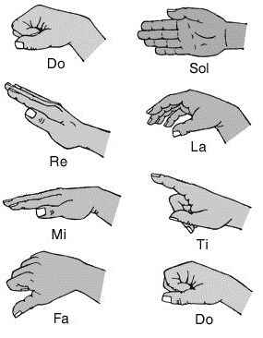
- Name the following sol-fa notes signs.

- Define the following terms
  - Pitch: ………………………….……………………………………………
  - Volume: …………………..………………………………………………..
  - Tempo: ……………………………………………………………………..
  - Dance formation: ………………………………………………………….
- What is body adornment?
…………………………………………………………………………………….

What is creative arts? (2 mks)
……………………………………………………………………………………………………………………………………………………………………………………………………
- What is sports? (2 mks)
…………………………………………………………………………………………………………………………………………………………………………………………………..
- Identify five roles of Creative arts and sports in the society.(5 mks)
- ……………………………………………………………………………………………
- ……………………………………………………………………………………………
- …………………………………………………………………………………………..
- …………………………………………………………………………………………..
- ………………………………………………………………………………………….
- State four components of Creative Arts and Sports.(4 mks)
- ……………………………………………….……
- …………………………………………………….
- …………………………………………………….
- …………………………………………………….
- State two Principles of Visual arts.(2 mks)
  - ……………………………………………………………………………….
  - ………………………………………………………………………………
- Outline four Basic Elements of a play. (4 mks)
- …………………………………………………………………………………………
- …………………….…………………………………………………………………..
- ………………………………………………………………………………………….
- ………………………………………………………………………………………….

- State and explain three elements of Music in Creative Arts.(6 mks)

………………………………………………………………………………………

………………………………………………………………………………………

………………………………………….………………………………………….

State three examples of themes in plays. (3 mks)
  - …………………………………………………….………
  - …………………………………………………….……….
  - ………………………………………………………………
- State three Elements of Dance in Creative Arts.(3 mks)
- ………………………………………………………………….
- ………………………………………………………………….
- …………………………………………………………………
- The arts can be experienced through the following senses namely?(3 mks)
  - …………………………………………….….
  - ………………………………………………..
  - ………………………………………………..

State three Factors to consider when making preparation and presentation of art research. (3 mks)
  - ………………………………………………………………………………
  - …………………………………………………………………………..…
  - ……………………………………………………………………………..

- What is the meaning of: (2mks)

  - An artiste:
…………………………………………………………………………………………

  - Audience
………………………………………………………………………………………..

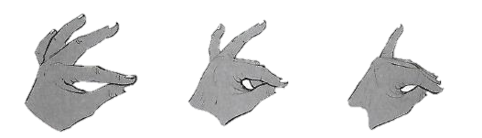
- Look at the hand signs below for notes B,A and G. Put the notes B A G under the correct hand sign.

- How can a song benefit a singer and listeners?
- ………………………………………………………………………………..
- ……………………………………………………………………………….
- Identify the three sections of a narrative (3mks)

- ………………………………………………………………………………….
- …………………………………………………………………………………
- …………………………………………………………………………………

- Write down two importance of studying performing arts to you? (2mks)
- …………………………………………………………………………………..
- …………………………………………………………………………………..

- What is the difference between performing arts and other arts? (2mks)
………………………………………………………………………………………………………………………………………………………………………………………………………………………………………………………………………………………………

- Write down three elements of performing arts. (3mks)
- ……………………………………………………………………
- ……………………………………………………………………
- …………………………………………………………………….
- Fill in the chart below;
- When performing a dance or a song adjudicators/judges check on;
- ………………………………………………………………………………
- ………………………………………………………………………………

- Name two categories of participants in a dance presentation:
- …………………………………………………
- …………………………………………………..

