KENYA JUNIOR SCHOOL EDUCATION ASSESSMENT
JUNIOR SCHOOL EDUCATION
ASSESSMENT TickSCORE%SCORE
LEVELRemarks: ___________________________________________________________
GRADE EIGHT (G8)
TERM 2 2024
MID TERM ASSESSMENT
AGRINUTRITION
Name: ____________________________________.
School: ___________________________________.
Assessment number: ___________________. Date: _______________________.

1. Martha, a grade 8 learner, prepared food using the equipment below.

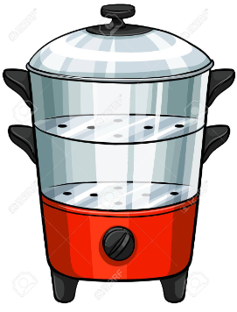

  - Which method of cooking did Martha use from the illustration above? (1mk)
…………………………………………………………………………………….

  - What are the three advantages of preparing food through the method shown above? (3mks)
- …………………………………….………………………………………….
- …………………………………………………………………………………
- …………………………………………………………………………….

- Grade 8 learners were discussing different ways of conserving water together with their importance. Give 4 reasons why water conservation is important. (4mks)
- ……………………………………………………………………………………….
- ……………………………………………………………………………………….
- ……………………………………………………………………………………….
- ……………………………………………………………………………………..

- During her visit to the tailor for the practical on fabric, Lucy made the seam below.



  - Identify the type of seam illustrated above. (1mk)
…………………………………………………………………………………

  - Beside the type of seam shown above, what are other three types of seams? (3mks)
- …………………………………………………………………………………..

- …………………………………………………………………………………..
- …………………………………………………………………………………..

- Water is harvested through various ways Give four ways that are under the surface runoff harvesting of water. (4mks)
- ……………………………………………………………………………………….
- ……………………………………………………………………………………….
- ……………………………………………………………………………………….
- ……………………………………………………………………………………….

- While at home, Mrs. Anjali asked her daughter to highlight some of the ingredients and substances needed during soap making. What are the four highlights if she gave correct answers? (4mks)
- ………………………………………………………………………………….
- ………………………………………………………………………………….
- …………………………………………………………………………………
- …………………………………………………………………………………

- During their visit to Kitale maize milling company, grade 8 learners were taught on some of the ways used in adding value to crop produce, highlight four of them. (4mks)
- …………………………………………………………………………………….
- …………………………………………………………………………………….
- ……………………………………………………………………………………..
- …………………………………………………………………………………….

7. While collecting water for use, Malindi School constructed the structure below.

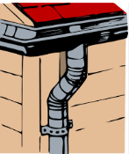

  - What is the term of the structure shown above? (1mk)
……………………………………………………………………………………..

  - What are the advantages of the structure shown above in water collection? (3mks)
- …………………………………………………………………………………
- …………………………………………………………………………………
- …………………………………………………………………………………

- Different tilth accommodates different size of seeds to enhance proper germination. Explain how the tilth affects the size of planting materials. (4mks)
………………………………………………………………………………………………………………………………………………………………………………………………………………………………………………………………………………………………………………………………………………………………………………………………………………………………………………………………………………………………………………………………………………………………

- During a laundry practical lesson, grade 8 learners were asked by their teacher to identify 4 ways that are used in special treatment of fabrics during laundry. Which answers did they give if they highlighted correct answers? (4mks)
- ……………………………………………………………………………………..
- …………………………………………………………………………………….
- …………………………………………………………………………………….
- …………………………………………………………………………………….

- In the preparation of animal products such as meat, different methods are used. Study the picture below.

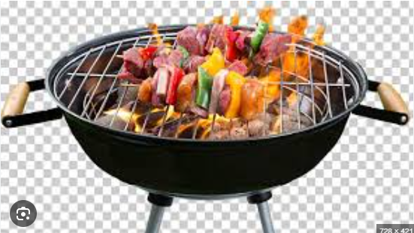

- Identify the method of cooking shown above (1mk)
………………………………………………………………………………….

b) What are the three disadvantages of the method of cooking shown above? (3mks)
- ………………………………………………………………………….
- ………………………………………………………………………….
- ………………………………………………………………………….
.

- During cleaning of articles, there are some precautions to be taken especially when cleaning loose colored articles. Highlight three precautions taken on loose colored clothes. (3mks)
- ……………………………………………………………………………………
- …………………………………………………………………………………….
- ……………………………………………………………………………………

- Rachael was encouraged by her teacher to plant some trees around the crops she had grown. Give one importance of trees around the grown crops. (1mk)
…………………………………………………………………………………….

- After harvesting crops from the farm, some procedures such as addition of value is done. Give two importance of adding value to harvested produce (2mks)
- ………………………………………………………………………………
- ………………………………………………………………………………

- One way of keeping healthy is eating foods that are nutritious such as vegetables. Give two ways of conserving vitamins and minerals in vegetables. (2mks)
- ……………………………………………………………………………..
- ……………………………………………………………………………..

- Different foods are cooked differently to facilitate easy eating and even digestion. Give any two methods of cooking. (2mks)
- ………………………………………………………………………………
- ……………………………………………………………………………..

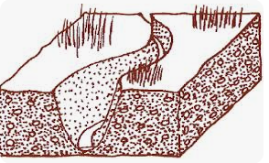
- Identify the following type of erosion.

………………………………………

- The picture below shows one of the methods of soil conservation Mr. Ken practices on his garden.

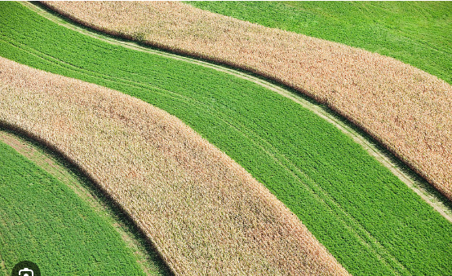

a). Identify the method of soil conservation. (1mk)

……………………………………………………………………………………..

b). Explain how the method conserves soil in an agricultural environment. (2mks)
………………………………………………………………………………………………………………………………………………………………………………………………………………………………………………………………………………..

c). Describe how the method mentioned in 1(a) above is carried out. (3mks)
……………………………………………………………………………………………………………………………………………………………………………………………………………………………………………………………………………………………………………………………………………………………………….…

d). Name three other soil conservation methods that can be practiced in the garden. (3mks)
- …………………………………………………………………………….
- …………………………………………………………………………….
- …………………………………………………………………………….

- State four importance of conserving soil in agricultural environment. (4mks)

- ………………………………………………………………………………………..
- …………………………………………………………………………………………
- …………………………………………………………………………………………
- …………………………………………………………………………………………
- The picture below shows a farm model constructed by Grade 8 learners. Study the farm model then answer the questions.

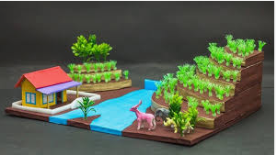

a). Identify some of the locally available materials used to construct the farm model. (3mks)
- …………………………………………………………..
- …………………………………………………………..
- …………………………………………………………..
b). From the farm model, identify one method of soil conservation. (1mk)

- ………………………………………………………………….

- Grade 8 learners went for a field excursion. They came across the method shown in the picture below of storing water.
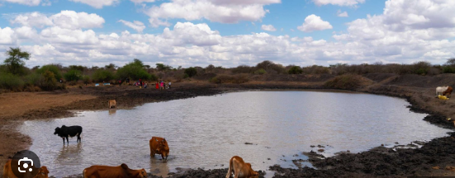

- Identify the method of storing water. (1mk)
………………………………………………………………………………..

- Name five tools that might have been used to construct the structure named in (5mks)
- …………………………………………………………………….
- …………………………………………………………………….
- …………………………………………………………………….
- ……………………………………………………………………
- ……………………………………………………………………

c. How is the structure in the picture above important to a farmer? (2mks)
- ………………………………………………………………………
- ………………………………………………………………………

- a. What is a farm layout? (2mks)

……………………………………………………………………………………………………………………………………………………………………………………………………………………………………………………………………………………………………………………………………………………

- Write two importance of Farm layout. (2mks)
- ……………………………………………………………………………….
- ……………………………………………………………………………….

- Identify four methods of harvesting and storing water for farming purposes (4mks)

- …………………………………………………………………………………
- ……………………………………………………………………………………
- ……………………………………………………………………………………
- …………………………………………………………………………………

a). State four factors to consider when setting up a water harvesting and storage unit at school. (4mks)
- ………………………………………………………………………
- ……………………………………………………………………
- ……………………………………………………………………
- …………………………………………………………………
b). State three types of water storage tanks. (3mks)
- ……………………………………………………………….
- ………………………………………………………..……..
- …………………………………………………………………

- Why do you sprinkle a layer of salt on all parts of the fish when processing it? (2mks)

…………………………………………………………………………………………………………………………………………………………………………………..
- Name three hygiene practices you should observe when processing fish. (3mks)
- ……………………………………………………………………………………
- ……………………………………………………………………………………
- ……………………………………………………………………………………

- List four importance of processing fish and dressing poultry carcass. (4mks)
- ……………………………………………………………………………………………………………………………………………………………………………………………………………………………………………………………………………………………………………………………………………………

- Why should cold water be used when cleaning fish? (1mk)
- ……………………………………………………………………………….
- ……………………………………………………………………………….
- ……………………………………………………………………………….

