JUNIOR SCHOOL EDUCATION ASSESSMENT
2ND TERM 2024
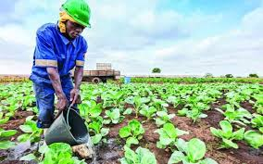
GRADE 8
AGRICULTURE AND NUTRITION
END OF MAY ASSESSMENT

NAME: _______________________________________________________
SCHOOL: _____________________________________________________

ASSESSMENT NUMBER ____________________ DATE___________________
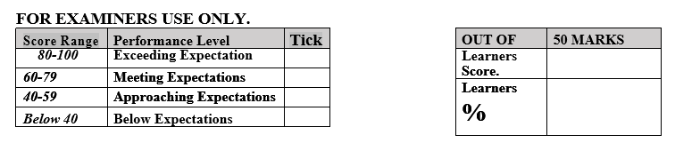

LEARNER’S INSTRUCTIONS

- Write your name, School, Assessment Number and the exam date in the spaces provided above.

- Answer all the questions in this paper.
- Any rough work must be done in this paper.

- All your answers must be written in the spaces provided in the question paper.
- Writing and giving relevant examples is highly recommended.
- It’s highly recommended to draw illustrations when explaining a concept.

- Learners should check the question paper to ascertain that all the pages are printed as indicated and that no questions are missing.
- Your answers must be clearly written (Legible) and well organized.
- Use blue or black pens when writing answers and a pencil when drawing.

- Learners must answer the questions in English.

Observe the following diseased plants carefully. Identify the following effects of vegetables crops attacked by pests and diseases.(6 mks)
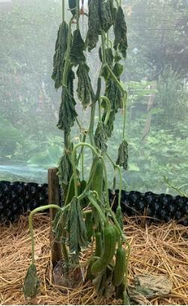
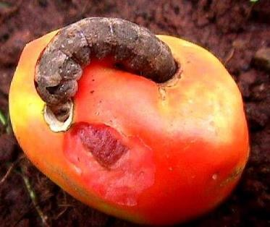
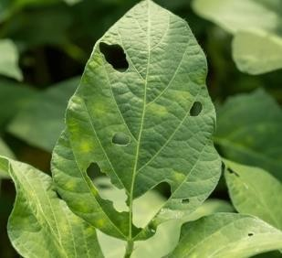

f

State five ways used to Control of pests and diseases on vegetables crops. (5 mks)

- ………………………………………………………………………………………..
- ……………………………………………………………………………………….

- Grace is a fish farmer from Lake Victoria. Identify three processes she carries out to prepare fresh fish for transportation, storage and consumption.(3 mks)
  - ……………………………………………..
  - …………………………………………….

- Abraham visited a fish processing site and took the following photographs. Identify the process or activity taking place in each picture.(4 mks)
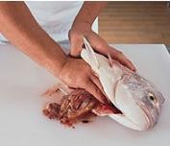

Name four practices carried out to dress a poultry carcass.(4 mks)

…………………………………………………………………………………..

…………………………………………………………………………………..

- State two Methods used in preserving milk. (2 mks)
- ……………………………………………
- …………………………………………….
- Mention three Methods used to preserve meat. (3 mks)
- ……………………………………………
- ……………………………………………

- What is the importance of preserving milk and meat? (2 mks)
- …………………………………………………………………………………………
- …………………………………………………………………………………….……

State five methods of soil conservation in agricultural environment. (5 mks)
- ………………………………………………………………………………….
- ……………………………………………………………………………….
- State two components of agriculture and nutrition. (2 mks)
- ……………………………………………………………………………….
- ……………………………………………………………………………….
- Mention five causes of Soil Pollution in Farming.(5 mks)

- ………………………………………………………………………………
- ………………………………………………………………………………

- Identify the following method of soil conservation in farming. (5 mks)
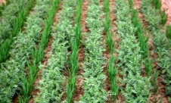
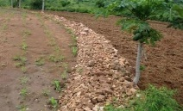
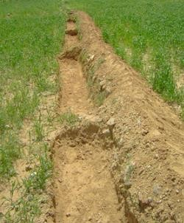

State two importance of Farm layout. (2 mks)
- ………………………………………………………………………………………………..
- ………………………………………………………………………………………………..

Mention four Local available material that can be used to make a farm model in school. (4 mks)
- ……………………………………………………….
- ………………………………………………………..
- State five methods of harvesting and storing water for farming purposes. (5 mks)
  - ………………………………………………………..
  - ………………………………………………………..

Outline five Factors to consider when setting up a water harvesting and storage unit at home or at school.(5 mks)
  - …………………………………………………………………………………………………
  - ………………………………………………………………………………………………….

State five Importance of harvesting and storing water.( 5mks)
- ……………………………………………………………………………………
- ……………………………………………………………………………….……

State four Maintenance practices of water harvesting and storage structures.(4 mks)
  - ……………………………………………………………………………………………
  - ………………………………………………………………………………..................

State three Uses of water harvested and stored on the farm.(3 mks)
- …………………………………………………………………..
- …………………………………………………………………..

In Kenya we have various types of water tanks made from various materials. Mention three types of water storage tanks.(3mks)
  - ……………………………………….
  - ……………………………………….

- Davis, a grade 8 learner wants to start an innovative gardens at home, state five ways in which the innovative gardens would benefit him. (5 mks)

- ………………………………………………………………………………………..
- …………………………………………………………………………………………

(3 Marks)
- Discuss three farming practices that pollute soil?

a)________________________________________________________

b)_________________________________________________________

c) _________________________________________________________
(2 Marks)
- Anita, a grade 8 student keeps some poultry at home as shown below.

State three routine practices she most likely uses.

  - ______________________________________

  - ______________________________________

  - ________________________________________

(6 Marks)
- Grade 7 learners were asked by their teacher to state and explain the practices carried out during minimum tillage. What answers do you think they gave?

i.________________________________________________________________________________________

____________________________________________________________________________________

ii._______________________________________________________________________________________

_____________________________________________________________________________________

iii._______________________________________________________________________________________

____________________________________________________________________________________

25. State the meaning of Agroforestry.

(1 Marks)

(2 Marks)

- State two ways by which innovative lights are used to scare birds.

  - _______________________________________________________

  - ________________________________________________________

(1 Marks)
27. Identify the type of seedbed mainly used to conserve moisture.

(2 Marks)
- During a classroom discussion grade 7 learners were requested to define the term agroforestry. What do you think they gave as an answer?

_________________________________________________________________________________________

___________________________________________________

(2 Marks)
- Name two common weeds.

  - …..................................................................

  - …..................................................................

(2 Marks)
- What are the two types of seedbeds that may be used to conserve soil moisture?

  - _______________________________________________________________

  - ________________________________________________________________

(2 Marks)
- List two examples of minimum tillage practices.

  - ____________________________________________

  - ____________________________________________

(1 Marks)
- Define the following term.

Conservation _______________________________________________________________

(5 Marks)
- Name five factors to consider when planning to plant crops.

__________________________________________________

____________________________________________________

______________________________________________________

______________________________________________________

______________________________________________________

(1 Marks)
34. Identify the domestic animal in the picture below.
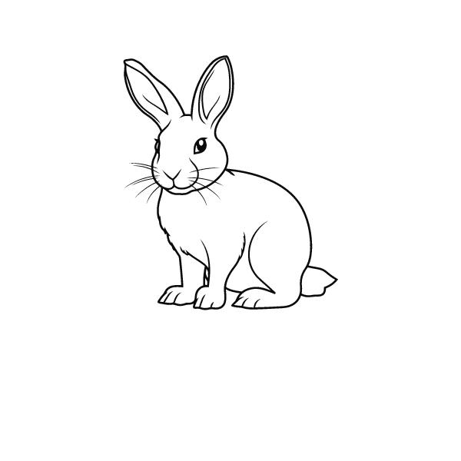

(2 Marks)
- State two activities that increase the rate of soil erosion.

  - ____________________________________________________

  - ____________________________________________________

(3 Marks)
- Apart from sunken bed, name three other structures that farmers use to retain water in the farm.

____________________________________________

___________________________________________

___________________________________________

37. A sickle as a farm tool is used for …......................................................................... (1 Marks)

(4 Marks)
- During a discussion, grade 7 learners were asked to discuss ways of conserving water. what answers dis they give?

i.____________________________________________________________

ii.____________________________________________________________

iii._____________________________________________________________

iv._____________________________________________________________

(2 Marks)
39. Name the types of soil erosion marked X and Y in the diagram below.
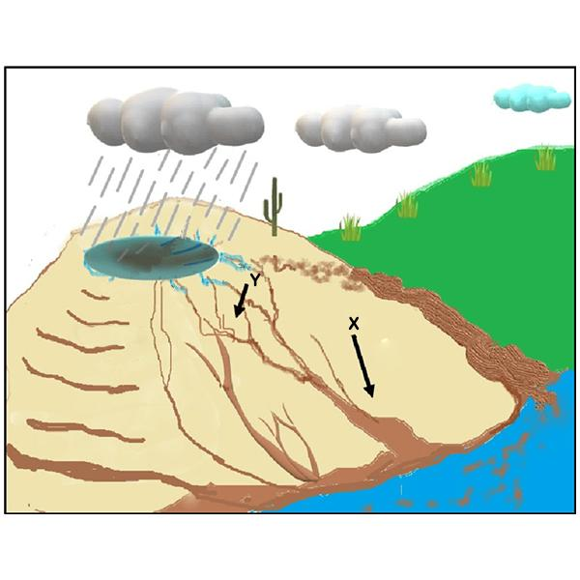

(2 Marks)
- Define the following term.

Water conservation __________________________________________________________
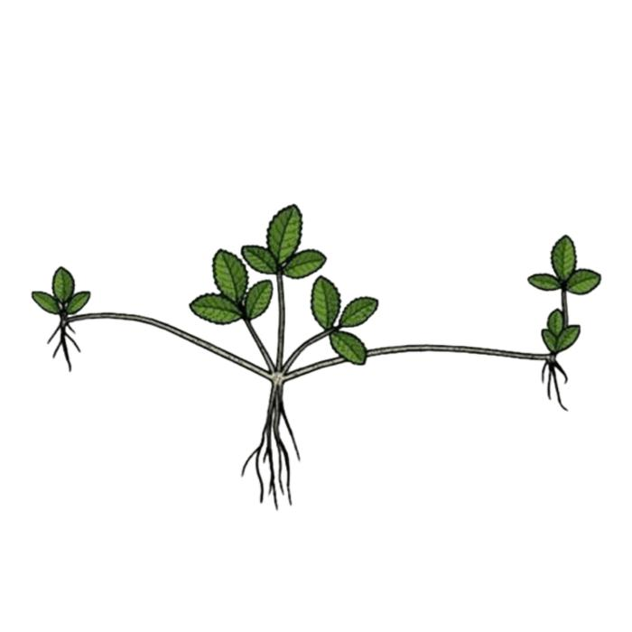
(2 Marks)
- The diagram below shows a creeping crop. Name two examples of such cro

(2 Marks)
- Identify two trees that are suitable for agroforestry.

_________________________________________________

__________________________________________________

