COMPETENCE BASED CURRICULUM
Kenya Junior Secondary Education Assessment
FORMATIVE ASSESSMENT
TIME
2 HRS
ENDTERM 1
AGRICULTURE AND NUTRITION
G8
2024
SCHOOL: ……….……………………………………………………..……
NAME: ……………….…………………..………………………...………..
SIGNATURE: ………………ASSESSMENT NO…………………………..
RUBRICS (for official use)
MARK SCORE RANGE | Below 40 | 40-59 | 60-79 | 80-100
PERFORMANCE LEVEL | Below expectation | Approaching expectations | Meeting expectations | Exceeding expectations

OUT OF | 100%
LEARNERS SCORE
PERCENTAGE SCORE
PERFORMANCE LEVEL

FOR FACILITATOR’S USE ONLY

Answer all Questions

- State two components of agriculture and nutrition. (2 mks)
- ________________________________________________________________
- ________________________________________________________________
- List four effects of soil pollution. (4mks)
- ______________________________________________________________________
- ______________________________________________________________________
- ______________________________________________________________________
- ______________________________________________________________________

Outline five Safe Soil pollution Control measures include the following methods. (5 mks)
  - ____________________________________________________________
  - ____________________________________________________________
  - ____________________________________________________________
  - ____________________________________________________________
  - ____________________________________________________________
- Surface run off is conserved or collected in structures such as:(3 mks)
- ___________________________________________________
- ___________________________________________________
- ___________________________________________________
- Identify the following method of soil conservation in farming. (5 mks)
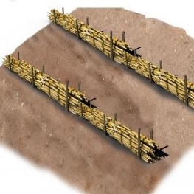
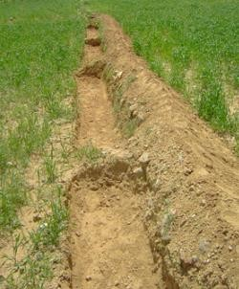
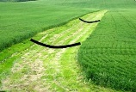
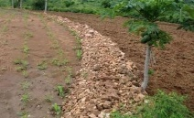
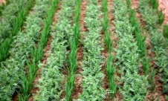

What is a Farm Layout? (2 mks)
____________________________________________________________________________________________________________________________________________

- Name four importance of conserving water in Farming.(4 mks)
- _________________________________________________________________
- _________________________________________________________________
- _________________________________________________________________
- _________________________________________________________________
- Match the following methods of planting ( 3mks)
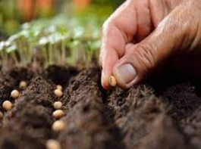
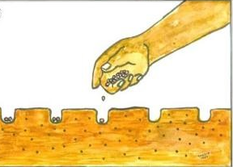
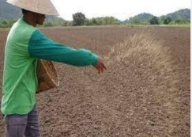
Drilling
Dibbling
Broadcasting
- What are Soil conservation measures? (2 mks)
_________________________________________________________________________________________________________________________________________________

Mention four importance for Soil conservation. (4 mks)
- ________________________________________________________________________
- ________________________________________________________________________
- ________________________________________________________________________
- ________________________________________________________________________

State two importance of Farm layout. (2 mks)
- ________________________________________________________________________
- ________________________________________________________________________

Mention four Local available material that can be used to make a farm model in school. (4 mks)
- ________________________________________________________________________
- ________________________________________________________________________
- ________________________________________________________________________
- ________________________________________________________________________.

State three Uses of water harvested and stored on the farm.(3 mks)
- ______________________________________________________________________
- ______________________________________________________________________
- ______________________________________________________________________

In Kenya we have various types of water tanks made from various materials. Mention three types of water storage tanks.(3mks)
  - ___________________________________________________________________
  - ___________________________________________________________________
  - ___________________________________________________________________
- What is a Kitchen garden?(2 mks)
________________________________________________________________________________________________________________________________________________________________________________________________________________________________________________________________________________________________
- State five roles of a kitchen garden in food and nutrition security.(5 mks)
- ______________________________________________________________________
- ______________________________________________________________________
- ______________________________________________________________________
- ______________________________________________________________________
- _____________________________________________________________________.

State four examples of innovative kitchen gardens. (4 mks)
- ___________________________________________________________________
- ___________________________________________________________________
- ___________________________________________________________________
- ___________________________________________________________________
- Grade 8 learners wanted to start an innovative gardens at home, state five ways in which the innovative gardens would benefit them. (5 mks)
- ____________________________________________________
- ____________________________________________________
- ____________________________________________________
- ____________________________________________________
- ____________________________________________________
- State five methods of harvesting and storing water for farming purposes. (5 mks)
  - ______________________________________________________________________
  - ______________________________________________________________________
  - ______________________________________________________________________
  - ______________________________________________________________________
  - ______________________________________________________________________

Outline five Factors to consider when setting up a water harvesting and storage unit at home or at school.. (5 mks)
  - ___________________________________________________________________________
  - ___________________________________________________________________________
  - ___________________________________________________________________________
  - ___________________________________________________________________________
  - ___________________________________________________________________________

State five Importance of harvesting and storing water. (5mks)
- __________________________________________________________________
- __________________________________________________________________
- __________________________________________________________________
- __________________________________________________________________
- __________________________________________________________________

State four Maintenance practices of water harvesting and storage structures. (4 mks)
  - ___________________________________________________________________________
  - ___________________________________________________________________________
  - ___________________________________________________________________________
  - ___________________________________________________________________________

- Draw a farm layout. (19 mks)

