COMPETENCE BASED CURRICULUM
Kenya Junior Secondary Education Assessment
FORMATIVE ASSESSMENT
TIME
2 HRS
ENDTERM 1
AGRICULTURE AND NUTRITION
G8
2024
SCHOOL: ……….……………………………………………………..……
NAME: ……………….…………………..………………………...………..
SIGNATURE: ………………ASSESSMENT NO…………………………..
RUBRICS (for official use)
MARK SCORE RANGE | Below 40 | 40-59 | 60-79 | 80-100
PERFORMANCE LEVEL | Below expectation | Approaching expectations | Meeting expectations | Exceeding expectations

OUT OF | 100%
LEARNERS SCORE
PERCENTAGE SCORE
PERFORMANCE LEVEL

FOR FACILITATOR’S USE ONLY

Answer all Questions

- State two components of agriculture and nutrition. (2 mks)
- Agriculture
- Home science/ nutrition

- List four effects of soil pollution. (4mks)
- It causes production of crops that are not safe for consumption or use by human beings. This poses health risks.
- Soil pollution also affects soil fertility and soil pH affecting agricultural production. This affects food security.

Outline five Safe Soil pollution Control measures include the following methods:(5 mks)
  - Reusing of plastic materials such as using bottles for drip irrigation.
  - Use of correct types and amount of artificial fertilizer and agrochemicals.
  - Safe disposal of used agricultural chemical containers.
  - Safe disposal of plastic wastes, containers and straws.
  - Recycling waste materials into other useful products.
  - Practicing organic farming which is the growing of crops and rearing livestock without using artificial fertilisers and agricultural chemical.
  - Planting trees and cover crops to reduce surface run-off than carry contaminants and distribute over the soil surface.
- Surface run off is conserved or collected in structures such as:(3 mks)

- Water retention ditches.
- Earth basins.
- Water retention pits.

- Identify the following method of soil conservation in farming. (5 mks)

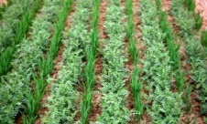

Grassed water ways
Strip cropping

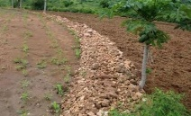

Stone lines

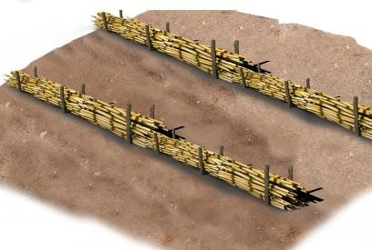
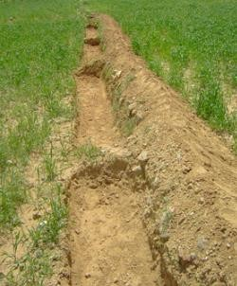

Soil bunds
Trash lines

What is a Farm Layout? (2 mks)

- A farm layout is a drawn plan that shows various farm enterprises and where they are placed in the farm.
- A farm layout is a plan of how various farm components (enterprises) are arranged and set up on the farm.

- Name four importance of conserving water in Farming.(4 mks)

- Surplus or excess water can be conserved and used during the times of water scarcity in the farm.
- Conserving water reduces the cost of farming. This is because money that would be used to buy water in the farm is saved.
- Conserving water ensures availability of water for human life and livestock.
- A lot of water is wasted during rainy season.
- Rain water which forms surface run-off after heavy downpour is prevented from damaging property.

- Match the following methods of planting ( 3mks)

Broadcasting

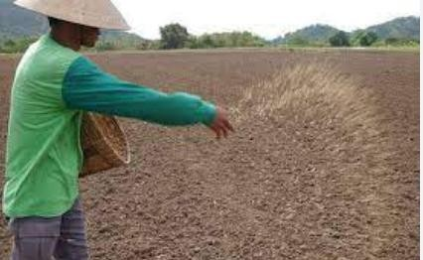
Dibbling
Drilling
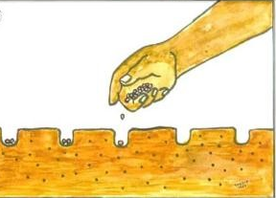

- Restricted cultivationWhat are Soil conservation measures? (2 mks)
Refers to a combination of practices done or taken to prevent the loss of soil through soil erosion.

Mention four importance for Soil conservation. (4 mks)
- To keep top soil in its place.
- To maintain fertility in the soil.
- To maintain soil productivity.
- Helps to increase agricultural production promotes food security.

State two importance of Farm layout. (2 mks)
- It helps in maximum utilization (use) of land.
- Farm enterprise are orderly arranged.

Mention four Local available material that can be used to make a farm model in school. (4 mks)
- Cartons.
- Cardboards.
- Soil.
- Papier mache.

State three Uses of water harvested and stored on the farm.(3 mks)

Watering /irrigating crops.

Watering animals.
- Domestic uses such as washing, cleaning items etc.

In Kenya we have various types of water tanks made from various materials. Mention three types of water storage tanks.(3mks)
  - Plastic.
  - Metallic.
  - Concrete.
- What is a Kitchen garden?(2 mks)
It is any convenient size of a plot, space or structure located in a home where a variety of crops are grown mainly for family consumption.

- State five roles of a kitchen garden in food and nutrition security.(5 mks)
- To produce safe, fresh food that is accessible to the family.
- It is a reliable source of green leafy vegetables, herbs, fruits, legumes and cereals for home consumption.
- Growing of both seasonal and off-season crops that ensures steady supply of nutritious food.
- Help family to meet their nutritional needs and promotes healthier lifestyles.
- Generates income from sale of surplus (excess) produce.
- Helps to save family income direct towards purchase of vegetables, fruits and others.
- Provide alternative when staple foods are not in stock.
- Helps to increase food production.
- Some form of kitchen gardening use recycled materials like plastics hence contributes to environmental conservation.

State four examples of innovative kitchen gardens. (4 mks)
- Container.
- Wick.
- Hanging pots.
- Tyre.
- Multi-storey gardens.
- Simple drip.
- Organic sack garden.

- Grade 8 learners wanted to start an innovative gardens at home, state five ways in which the innovative gardens would benefit them. (5 mks)

- Use locally available materials.
- Requires little amount of water.
- Easy to manage because less labour is required.
- Makes good use of little space.
- Some are portable-can be moved from one area to another.
- High productivity or yields.
- Aesthetic value around the compound.
- Ideal for urban areas and congested homesteads.
- State five methods of harvesting and storing water for farming purposes. (5 mks)
  - Use of rooftops.
  - Use of diversion channels. (directs water into water ponds and water tanks.)
  - Water ponds.
  - Shallow water pans.
  - Tanks.

Outline five Factors to consider when setting up a water harvesting and storage unit at home or at school.(5 mks)
  - Location.
  - Accessibility.
  - Type of crop to be irrigated using water.
  - Size of the farm.
  - Dimension of the storage unit.
  - The slope of the land.
  - The cost of the work.

State five Importance of harvesting and storing water.( 5mks)
- Harvesting and storing water helps to supplement other sources of water.
- It provides water during shortage and in dry seasons.
- Water is available through out.
- Reduces cost of farming.
- Excess water from the rain is utilized.
- Helps to prevent destruction of infrastructures such as buildings and roads by surface runoff.

State four Maintenance practices of water harvesting and storage structures.(4 mks)
  - Plant grass around the water pans and water ponds to control soil erosion and sedimentation and to stabilize the embankments.
  - Remove foreign material in water found in water pans, ponds and tanks.
  - Structures such as water pans and water pons should be fenced.
  - Water tanks should be cleaned and foreign materials such as gravel, twigs, leaves sieved out during water entry.
  - Clean the gutters to remove accumulated materials.

- FARM LAYOUT
