KENYA JUNIOR SCHOOLS ASSESSMENT
FORMATIVE ASSESSMENT TEST
GRADE 8
RUBRICS
1-29-BE
30-49-AE
50-79-ME
80-100-EE

TICK

AGRICULTURE AND NUTRITION
MARKING SCHEME

- Identify the following soil conservation practices

Contour Ploughing
Terracing

- Name the following agricultural practice for conserving water.
Mulching

Give three types of planting materials used for establishing agroforestry. (3 mks)
- Seeds.
- Cuttings.
- Seedlings.

Name two practices carried out when caring for established agroforestry trees. (2 mks)
- Mulching.
- Watering.
- Weeding.
- Protecting from animal damage.
- Removing diseases and pest infected parts.
- Pruning.
- Give three types of sites that can be used for planting crops.( 3mks)
- Ground sites.
- Containers sites.
- On walls.
- Along the fence.
- Along the driveways.

Give two categories of planting materials. (2mks)
  - Seeds.
  - Vegetative materials.

List three importance of agroforestry trees in conserving the environment? (3 mks)
- They control soil erosion.
- They provide food for livestock and human beings.
- Their leaves decompose to add nutrients to the soil.
- They provide shade for livestock and shelter for crops.
- They provide habitat to wild animals and birds.
- They act as windbreaks.
- They absorb carbon dioxide from the air and increase oxygen supply.

Give two characteristics of agroforestry trees. (2 mks)
- Ability to grow alongside other crops.
- Fast growing.
- Have multiple uses.
- Ability to fix Nitrogen into the soil.
- Ability to hold soil particles together to prevent soil erosion.

Give two factors to consider when choosing agroforestry trees. (2 mks)
- Select trees that protect various living organisms.
- Select trees which control soil erosion.
- Select trees which provide multiple products.
- Select trees which provide nutrients to the soil.

Name two types of vegetative planting materials.(2 mks)
  - Cuttings.
  - Suckers.
  - Vines.
  - Bulbils.
  - Splits.
  - Tubers.
  - Crowns.

- State effective methods and techniques for soil conservation.
- Grass water ways
- Stone lines
- Trash lines
- Bunds
- Crop rotation
- Contour Plowing:
- Terracing:
- Windbreaks:
- Strip Cropping:
- Conservation Tillage:
- Cover Crops:
- Mulching:
- Conservation Buffer Strips

Why is it important to add value to animal products?(2mks)
- To increase the shelf life.
- To reduce their bulkiness/make them lighter for easy transportation and storage.
- To get a variety of products.
- Identify the following agricultural technologies. (2mks)

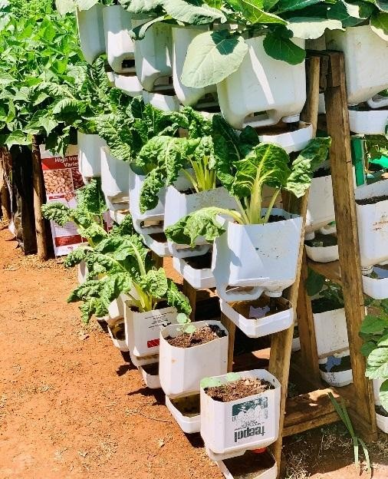

Wick irrigated garden
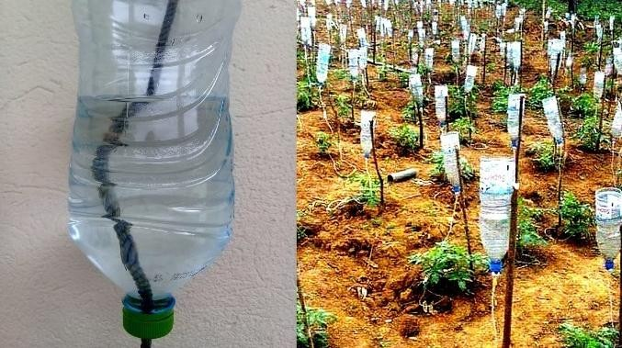
Innovated drip irrigation.

- Identify the primary threats to soil conservation
- Chemical contamination
- Slash and burn
- Land overuse,
- Overgrazing, etc.

- Why is soil conservation a important?
- Preserving Agricultural Productivity:
- Protecting Ecosystems and Biodiversity:
- Water Quality and Quantity:
- Climate Change Mitigation
- Mitigating Soil Erosion:

- Name five Benefits of Soil Conservation
- Sustaining Agricultural Productivity: Preventing Soil Erosion:
- Enhancing Water Quality: Mitigating Climate Change:
- Conserving Biodiversity and Ecosystems:
- Improves soil quality and productivity
- Optimizes water infiltration.
- Provides food and shelter
- State four techniques to apply in water harvesting for farming.
- Shallow Water Pans

Water Ponds

Water Tanks
- Sand Dams
- Grey Water Recycling
- Contour Trenching
- Fog Harvesting
- Gutter Installation
- Identify the following water harvesting techniques
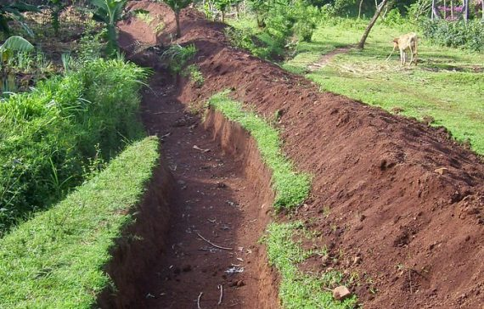

Contour Trenching Water Ponds

- Name the following pest

Rat cut worm

