KENYA JUNIOR SCHOOLS ASSESSMENT
FORMATIVE ASSESSMENT TEST
GRADE 8
RUBRICS
1-29-BE
30-49-AE
50-79-ME
80-100-EE

TICK

AGRICULTURE AND NUTRITION
NAME: ………………………………………………………………………………………………
SCHOOL: …………………………………………………………………………………………….
ASSESSMENT NUMBER………………………………………….DATE: ……………………….

- Identify the following soil conservation practices

- Name the following agricultural practice for conserving water.

Give three types of planting materials used for establishing agroforestry. (3 mks)
- ……………………………………..
- ……………………………………..
- ……………………………………..

Name two practices carried out when caring for established agroforestry trees. (2 mks)
- ………………………………………………………..
- ………………………………………………………..
- Give three types of sites that can be used for planting crops.( 3mks)
- …………………………………………………………………..
- ………………………………………………………………….
- ………………………………………………………………….

Give two categories of planting materials. (2mks)
  - ………………………………………….
  - ………………………………………….

List three importance of agroforestry trees in conserving the environment? (3 mks)
- ………………………………………………………………………………………
- ……………………………………………………………………………………….

Give two characteristics of agroforestry trees. (2 mks)
- ………………………………………………………………………………………
- ………………………………………………………………………………………

Give two factors to consider when choosing agroforestry trees. (2 mks)
- ……………………………………………………………………………………..
- ……………………………………………………………………………………..

Name two types of vegetative planting materials. (2 mks)
  - ……………………………………….
  - ………………………………………..

- State three effective methods and techniques for soil conservation.(3 mks)
- ………………………………………………………………………………………………..
- ……………………………………………………………………………………………….
- ……………………………………………………………………………………………….

Why is it important to add value to animal products? (2mks)
- ……………………………………………………………………………………………
- ……………………………………………………………………………………….…..

- Identify the following agricultural technologies. (2mks)

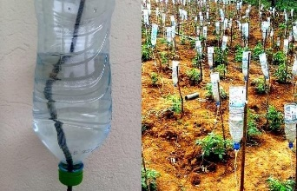
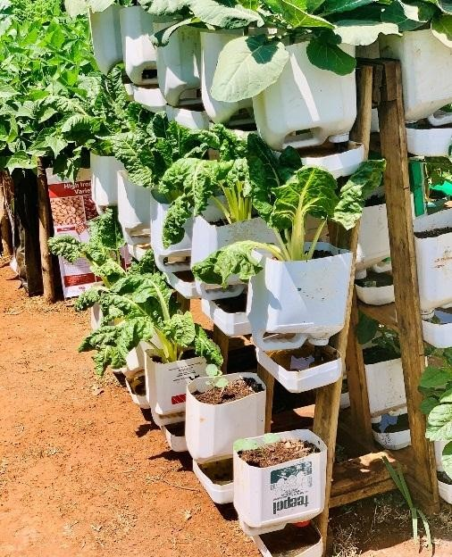

- Identify the primary threats to soil conservation.(2 mks)
- …………………………………………………………………………………………………..
- ………………………………………………………………………………………………….
- Why is soil conservation important? (2 mks)
- ………………………………………………………………………………………………..
- ……………………………………………………………………………………………….
- Name five benefits of Soil Conservation. (5 mks)
- ……………………………………………………………………………………………….
- ……………………………………………………………………………………………….
- ……………………………………………………………………………………………….
- ………………………………………………………………………………………………..
- ………………………………………………………………………………………………..
- State four techniques to apply in water harvesting for farming.
- ………………………………………………………
- ……………………………………………………….
- ……………………………………………………….
- ………………………………………………………
- Identify the following water harvesting techniques
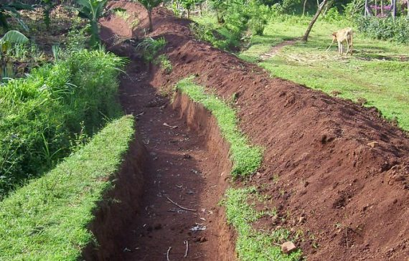

- Name the following pest

