CONFIDENTIAL
GRADE 8
AGRICULTURE AND NUTRITION
MARKING SCHEME

- Observe the following diseased plants carefully. Identify the following effects of vegetables crops attacked by pests and diseases.(6 mks)
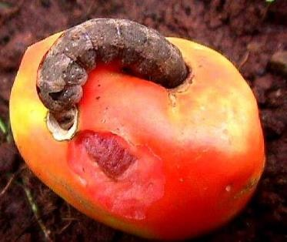
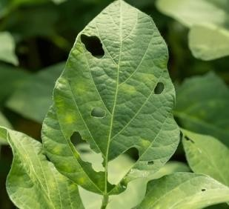
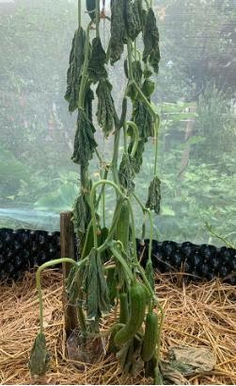

Holes on leaves/punctured leaf
f

Holes on fruit
f
Wilted plant
f

- State five ways used to Control of pests and diseases on vegetables crops. (5 mks)

- Handpicking-pests are removed by hands.
- Removing affected plants parts-affected plant parts should be removed to prevent spread of pests to other plant parts.
- Uprooting heavily affected crops-uprooting heavily affected plants stops spread of pests in the farm.
- Applying natural pesticides such as ashes-some natural pesticide such as ashes help to prevent attack of pests.
- Removing affected plant parts.
- Uproot heavily affected crops.

- Grace is a fish farmer from Lake Victoria. Identify three processes she carries out to prepare fresh fish for transportation, storage and consumption.(3 mks)
  - Scaling-removal of scales.
  - Gutting-removal of gut or the alimentary canal.
  - Cleaning-washing the fish with clean water.

- Abraham visited a fish processing site and took the following photographs. Identify the process or activity taking place in each picture.(4 mks)
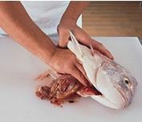
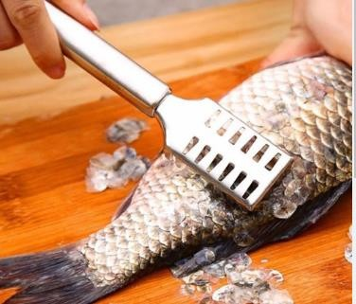
Gutting
Scaling

- Name four practices carried out to dress a poultry carcass.(4 mks)
- Beheading-restrain the poultry well and cut the neck muscles with a sharp knife.
- De-feathering-scald the bird into hot water of a temperature of 55⁰ C for about 2 minutes to loosen the feather. Remove and pluck off loose feathers completely.
- Singeing-hold the de-feathered bird over a flame for a few minutes to burn the hair like structures left on the skin.
- Washing-wash the whole bird in clean cold water to remove the surface dirt.

- State two Methods used in preserving milk. (2 mks)
- Boiling.
- Fermentation.
- Mention three Methods used to preserve meat. (3 mks)
- Sun drying.
- Smoking.
- Salting.

- What is the importance of preserving milk and meat? (2 mks)
- It increases the shelf-life of both milk and meat.
- It makes the two products available for a longer period of time hence enhancing food security.
- State five methods of soil conservation in agricultural environment. (5 mks)
- Strip cropping.
- Grassed water ways.
- Stone lines.
- Trash lines.
- Soil bunds.53
- State two components of agriculture and nutrition. (2 mks)
- Agriculture
- Home science/ nutrition
- Mention five causes of Soil Pollution in Farming.(5 mks)

- Excessive use of artificial fertilizers.
- Excessive use of agricultural chemicals (agrochemicals) such as herbicides and pesticides.
- Throwing plastic wastes in the garden.
- Throwing Chemical containers.
- Surface run off carrying contaminated water
- Industrial wastes

- Identify the following method of soil conservation in farming. (5 mks)
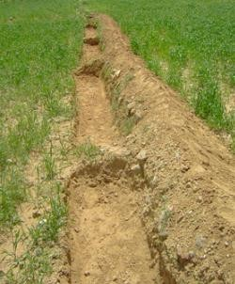
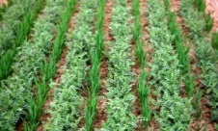
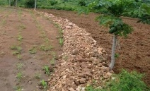

Strip cropping
Soil bunds
Stone lines

- State two importance of Farm layout. (2 mks)
- It helps in maximum utilization (use) of land.
- Farm enterprise are orderly arranged.
- Mention four Local available material that can be used to make a farm model in school. (4 mks)
- Cartons.
- Cardboards.
- Soil.
- Papier mache.
- State five methods of harvesting and storing water for farming purposes. (5 mks)
  - Use of rooftops.
  - Use of diversion channels. (directs water into water ponds and water tanks.)
  - Water ponds.
  - Shallow water pans.
  - Tanks.
- Outline five Factors to consider when setting up a water harvesting and storage unit at home or at school.(5 mks)
  - Location.
  - Accessibility.
  - Type of crop to be irrigated using water.
  - Size of the farm.
  - Dimension of the storage unit.
  - The slope of the land.
  - The cost of the work.
- State five Importance of harvesting and storing water.( 5mks)
- Harvesting and storing water helps to supplement other sources of water.
- It provides water during shortage and in dry seasons.
- Water is available through out.
- Reduces cost of farming.
- Excess water from the rain is utilized.
- Helps to prevent destruction of infrastructures such as buildings and roads by surface runoff.

- State four Maintenance practices of water harvesting and storage structures.(4 mks)
  - Plant grass around the water pans and water ponds to control soil erosion and sedimentation and to stabilize the embankments.
  - Remove foreign material in water found in water pans, ponds and tanks.
  - Structures such as water pans and water pons should be fenced.
  - Water tanks should be cleaned and foreign materials such as gravel, twigs, leaves sieved out during water entry.
  - Clean the gutters to remove accumulated materials.
- State three Uses of water harvested and stored on the farm.(3 mks)
- Watering /irrigating crops.
- Watering animals.
- Domestic uses such as washing, cleaning items etc.

- In Kenya we have various types of water tanks made from various materials. Mention three types of water storage tanks.(3mks)
  - Plastic.
  - Metallic.
  - Concrete.

- Davis, a grade 8 learner wants to start an innovative gardens at home, state five ways in which the innovative gardens would benefit him. (5 mks)

- Use locally available materials.
- Requires little amount of water.
- Easy to manage because less labour is required.
- Makes good use of little space.
- Some are portable-can be moved from one area to another.
- High productivity or yields.
- Aesthetic value around the compound.
- Ideal for urban areas and congested homesteads.

- In the space provided, draw a farm layout of your choice. (10 mks)

(2 Marks)

(2 Marks)

(3 Marks)
- a) Use of wrong artificial fertilisers/ chemicals

  - Use of wrong amount of artificial fertilisers/ chemicals

  - Inorganic farming

  - Dumping plastic wastes

  - Dumping used chemical containers

  - Excessive use of chemicals

(2 Marks)
- i) Feeding.

  - Watering.

  - Clearing tools and equipment.

  - Maintaining an appropriate number.

  - Parasite control.

  - Veterinary care.

(6 Marks)
- i. Mulching – helps to prevent water loss from the soil by not exposing it to direct sunlight.

  - Uprooting of weeds – helps in ensuring minimum disturbance to the soil.

  - Slashing weeds – weeds compete for water with crops from the soil.

  - Slashing the weeds will prevent water loss through transpiration.

25. | This is the practice of growing crops together with trees. | (1 Marks)
26. | a) Hanging reflective materials | (2 Marks)
 | b) Hanging torches
 | c) Using solar light
27. | Shallow pits | (1 Marks)
28. | It is the deliberate growing of crops, trees and animals on the same piece of land. | (2 Marks)

(2 Marks)
- a. Oxalis

b. Blackjack

(2 Marks)
- i. Sunken beds ii. Shallow pits

31. | a. Slashing weeds | (2 Marks)
 | b. Mulching
 | c. Uprooting weeds
 | d. Use of herbicides
 | e. Restricted cultivation
32. | Maintaining or protecting something so that it is not wasted or lost. | (1 Marks)
33. | i) Soil moisture | (5 Marks)
 | ii) Onset of rain
 | iii) Staggered planting
 | iv) Time of harvesting
34. | Rabbit | (1 Marks)
35. | i) Animal activities | (2 Marks)
 | ii) Human activities
 | iii) Types of soil
 | iv) Rainfall
 | v) Slopes
36. | i) Earth basin | (3 Marks)
 | ii) Water retention ditches
 | iii) Water retention pits
37. | Harvesting rice/ wheat. | (1 Marks)
38. | i) Harvesting | (4 Marks)
 | ii) Recycling
 | iii) Re using
 | iv)Storing water in dams

(2 Marks)
- X - Gulley Y - Rill

(1 Marks)
- Refers to maintaining water as a natural resource and ensuring it is not lost or wasted to be used for future use.

- i) Water melons.

  - Pumpkins.

  - Strawberries.

iv) Cucumber.

v) Calabash.
(2 Marks)

(2 Marks)

