JUNIOR SCHOOL ASSESSMENT
TERM TWO
OPENER
MARKING SCHEME

SOCIAL STUDIES.

1.
- Define the goal.

- Know your alternatives.

- Gather enough information about your goal.

- Consider the consequences

- Determine the plan of action or the steps needed to achieve your goal.

- Setting clear goals makes obtaining your career choices easier. The clearer you are

- about the steps (or objectives), the more likely you will achieve your goals.

2.

Law
Geology
Museology.
Cartography.
Urban planning
Meteorology and climatology.
Aviation.
Archaeology.
Medicine.
Teaching.
Survey.
Engineering

3.
Participate in physical activities.
Share out your problems to trusted people.
Seek guidance and counselling.
Avoid peer influence.
Always set achievable targets.

4.
Availability of slaves.
Long distance traders.
Accessibility of east African coasts.

Existence of the monsoon winds.
Peace and political stability at the coast.
Collaboration of the African chiefs.

5.

Gender is the state of being male or female in relation to social and cultural roles.

6.
Africa.
Europe.
South America.
North America.

Asia.

7.

Commitment, Courage, Intelligence, Kindness, Humour, Common sense

- i.

1.13 PM ii.
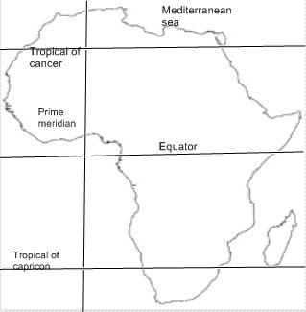

9.
a-cartography is the science or practice of drawing
maps
b- Geology –studying the earth

c- Archaeology-study of human past using material remains.

10.

The believe that certain careers or entrepreneurial opportunities belong to a given gender (male or female)

11.
a- Writing- the Egyptians hieroglyphics inventions
b- Shadoof irrigation.

12.
13.
Provide for the family needs.
Provide leadership.

Provide security.

14.

- Process of focusing attention on our self with the purpose of better understanding yourself.

16.
History.
Geography.

