COMPETENCE BASED CURRICULUM
Kenya Junior Secondary Education Assessment
FORMATIVE ASSESSMENT
TIME
2 HRS
ENDTERM 1
SOCIAL STUDIES
G7
2024
SCHOOL: ……….……………………………………………………..……
NAME: ……………….…………………..………………………...………..
SIGNATURE: ………………ASSESSMENT NO…………………………..
RUBRICS (for official use)
MARK SCORE RANGE | Below 40 | 40-59 | 60-79 | 80-100
PERFORMANCE LEVEL | Below expectation | Approaching expectations | Meeting expectations | Exceeding expectations

OUT OF | 100%
LEARNERS SCORE
PERCENTAGE SCORE
PERFORMANCE LEVEL

FOR FACILITATOR’S USE ONLY

Answer all Questions

- What is elf-exploration? (2 mks)
__________________________________________________________________________________________________________________
- State four ways of improving personal abilities and Interests for Self-Improvement. (5 mks)
- ____________________________________________________
- ____________________________________________________
- ____________________________________________________
- ____________________________________________________
- ____________________________________________________

- Mention five opportunities related to social studies. (5 mks)

_____________________

_____________________

_____________________

_____________________

_____________________

How do you set a goal in decision-making strategy? (6 mks)
  - ______________________________________________
  - ______________________________________________
  - ______________________________________________

- Goals set must be SMART. The initials SMART stands for?(5 mks)

S-_______________________________
M-______________________________
A-_______________________________
R-_______________________________
T-_______________________________

- Some of the entrepreneurial opportunities for social studies in our society include? (4 mks)
- ________________________________________________
- ________________________________________________
- ________________________________________________
- ________________________________________________

- Some people believe that certain careers or entrepreneurial opportunities belong to a given gender (male or female). These are called _________________________________________.(1 mk)

We can address gender stereotypes in career and entrepreneurial opportunities related to social studies through the following strategies.name four strategies (4 mks)
- _______________________________________________________
- _______________________________________________________
- _______________________________________________________
- _______________________________________________________
- Outline the origin of man according to the following community.(6 mks)

Maasai
- __________________________________________________________
- __________________________________________________________
- __________________________________________________________

- State four factors that led to growth of Ancient Egypt Civilization. (4 mks)
Presence of river Nile.
  - _________________________________________________
  - ________________________________________________
  - _________________________________________________
  - ________________________________________________

State four contributions of early civilization to modern world. (4 mks)
- ____________________________________________________
- ____________________________________________________
- ____________________________________________________
- ____________________________________________________

- Use the map of Kenya below to answer the questions that follow.
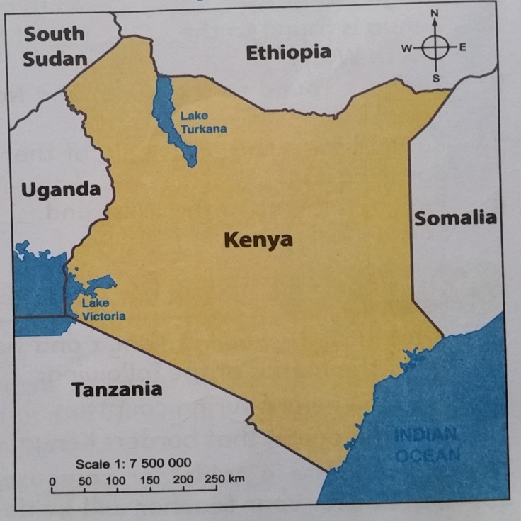
- Name the countries that boarder Kenya represented by the letters. (5 mks)
- _____________________

- _____________________

- _____________________

- _____________________
D
E
B
A
C

- On the map, draw the line of latitude(1 mk) ( check on the map)
- Locate the position of the following mountains.( use the symbol to show the mountains.)(3 mks) ( check on the map)
- Mount Kenya
- Mount Elgon
- Mount Kilimanjaro
- Give two examples of communities in each of the groups below. (5 mks)
Bantu | Nilotes | Cushites | Europeans | Asians
Kikuyu | Maasai | Somali | Americans | Indians
- Name the capital cities for the following African countries. (3 mks)
  - Kenya –_______________________________
  - Eritrea- _______________________________
  - Somalia –____________________________
- List four continents in the worlds. (4 mks)
- __________________________________________
- __________________________________________
- ___________________________________________
- ___________________________________________
- Name
- The major longitude passing through Africa. _________________
- The major latitude passing through Africa ____________________

