COMPETENCE BASED CURRICULUM
Kenya Junior Secondary Education Assessment
FORMATIVE ASSESSMENT
TIME
2 HRS
ENDTERM 1
SOCIAL STUDIES
G7
2024
SCHOOL: ……….……………………………………………………..……
NAME: ……………….…………………..………………………...………..
SIGNATURE: ………………ASSESSMENT NO…………………………..
RUBRICS (for official use)
MARK SCORE RANGE | Below 40 | 40-59 | 60-79 | 80-100
PERFORMANCE LEVEL | Below expectation | Approaching expectations | Meeting expectations | Exceeding expectations

OUT OF | 100%
LEARNERS SCORE
PERCENTAGE SCORE
PERFORMANCE LEVEL

FOR FACILITATOR’S USE ONLY

Answer all Questions

- What is elf-exploration? (2 mks) is the practice of examining your own thoughts, feelings, values, beliefs, identity, background, views, and emotions, with the purpose of better understanding yourself.
- State four ways of improving personal abilities and Interests for Self-Improvement. (5 mks)
- Setting Goals
- Learn New Skills
- Practice Self-Care
- Surround Yourself with Positive People
- Embrace Change

- Mention five opportunities related to social studies. (5 mks)

- Law -Advocate -Lawyer
- Geology –studying the earth
- Museology –study of museums.
- Cartography-the science or practice of drawing maps.
- Urban planning-the process of developing and designing urban areas to meet the needs of a community.
- Meteorology and climatology-study of atmosphere and weather pattern over time.
- Aviation-development and operation of aircrafts.
- Archaeology-study of human past using material remains.
- Medicine-a science practice of taking care of patients by managing and diagnosing them
- Teaching-passing of knowledge to other as a profession.
- Survey.
- Engineer

How do you set a goal in decision-making strategy? (6 mks)
  - Define the goal.
  - Know your alternatives.
  - Gather enough information about your goal.
  - Consider the consequences
  - Determine the plan of action or the steps needed to achieve your goal.
  - Setting clear goals makes obtaining your career choices easier. The clearer you are about the steps (or objectives), the more likely you will achieve your goals.
  - Use the “SMART” methodology in setting goals.

- Goals set must be SMART. The initials SMART stands for?(5 mks)

S-Specific
M-Measurable
A-Achievable
R-Realistic
T-Timely

- Some of the entrepreneurial opportunities for social studies in our society include? (4 mks)
- Pottery
- Basketry
- Ecotourism
- Horticulture
- Agro forestry
- Fishing
- Dairy farming

- Some people believe that certain careers or entrepreneurial opportunities belong to a given gender (male or female). These are called gender stereotypes.(1 mk)

We can address gender stereotypes in career and entrepreneurial opportunities related to social studies through the following strategies.name four strategies (4 mks)
- Committing and encouraging both males and females to take a full range of careers and business opportunities
- Ensuring representation of both genders in leadership
- Treating both males and females equally by using texts and circular that does not promote gender bias
- Develop policies, law- and decision-making process that represent both males and females.
- Outline the origin of man according to the following community.(6 mks)

Maasai
- Once upon a time Enkai (God) owned all the cattle in the world. One day he opened the sky and replaced all the cattle he owned from heaven to earth using a long rope.
- Enkai created 3 communities on earth.
- The Torrobo (also the Ogiek) , the gikuyu whom God bless with seed and grain and the Maasai whom God blessed with all the cattle of the world.

- State four factors that led to growth of Ancient Egypt Civilization. (4 mks)
Presence of river Nile.
It the annual flood of river Nile and the use of shadoof method of irrigation boosted agriculture
Early technology
It ushered in the bronze stage where copper and tin were used to make simple tools such as chisels and needles.
Artisans also made pots for storage and cookery purposes using potter’s wheel

Population
High population in Ancient Egypt provided ready manpower and market

Strong military and leadership
They ensured growth of the kingdom through conquests and assimilation of conquered neighbours into the empire

Use of hieroglyphic
The formal writing helped keep reliable and accurate records in religion, government and history

Use of the calendar
Tracking of days and monitoring events such as annual flooding of the nile, planting and harvesting period

Specialized workers
They worked in various institutions. They helped in keeping records in the Egyptian empire.They recorded harvest, finances and history

State four contributions of early civilization to modern world. (4 mks)
- Religion was practiced in different communities in the past. This has developed over time shaping our spiritual beliefs and worship. Different religions are practiced in different countries.
- Writing- the Egyptians hieroglyphics inventions resulted in the modern writing paper industries also developed and were used to keep records developed into the modern writing and education.
- Ancient Egypt was the beginning of building designs and construction of permanent buildings we have today.
- The knowledge of planning and prediction of seasons based on calendar started in the early civilization. Today it has been developed further to include weather forecasting in predicting accurate changes.
- The industrial development in the ancient kingdoms was based on simple skill. Copper and tin were used in ancient Egypt to make items. Today most of the industries use metals and alloys to make construction and infrastructural equipment.
- The modern irrigation technology borrows a lot from the ancient irrigation techniques such as shadoof. This has been applied in the agricultural sector
- Tools such as jembes/hoes used in farming today were developed in the ancient civilization
- The political structure of modern government resembles the early civilization government.

- Use the map of Kenya below to answer the questions that follow.
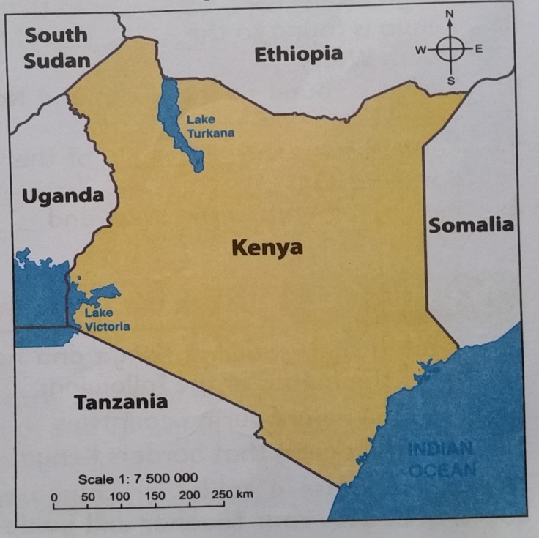
- Name the countries that boarder Kenya represented by the letters. (5 mks)
D
E
B
A
C
- South Sudan

- Uganda

- Tanzania

- Ethiopia

oº

- On the map, draw the line of latitude(1 mk) ( check on the map)
- Locate the position of the following mountains.( use the symbol to show the mountains.)(3 mks) ( check on the map)
- Mount Kenya
- Mount Elgon
- Mount Kilimanjaro
- Give two examples of communities in each of the groups below. (5 mks)
Bantu | Nilotes | Cushites | Europeans | Asians
Kikuyu | Maasai | Somali | Americans | Indians
Ameru | Kipsigis | Borana | British | Chinese
etc | Etc | Etc | Italians etc | Arabs etc
- Name the capital cities for the following African countries. (3 mks)
  - Kenya –Nairobi
  - Eritrea- Asmara
  - Somalia –Mogadishu
- List four continents in the worlds. (4 mks)
Antarctica
Africa
Asia
Europe
North America
South America
Australia
- Name
- The major longitude passing through Africa. Prime meridian/Greenwich meridian
- The major latitude passing through Africa Equator

