**JUNIOR SCHOOL EDUCATION ASSESSMENT**

 **2ND TERM 2024**

**GRADE 7**

INTEGRATED SCIENCE

END OF MAY ASSESSMENT

NAME: _______________________________________________________

SCHOOL: _____________________________________________________

ASSESSMENT NUMBER ____________________ DATE___________________

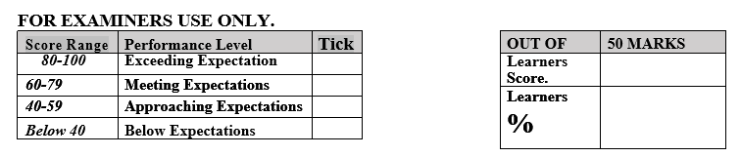

**LEARNER’S INSTRUCTIONS**

1. Write your name, School, Assessment Number and the exam date in the spaces provided above.
2. Answer all the questions in this paper.
3. All your answers must be written in the spaces provided in the question paper.
4. Writing and giving relevant examples is highly recommended.
5. Learners should check the question paper to ascertain that all the pages are printed as indicated and that no questions are missing.
6. Your answers must be clearly written (Legible) and well organized.
7. Use blue or black pens when writing answers.
8. Learners must answer the questions in English.
9. State three components of integrated science. (3 mks)
10. ……………………………………….
11. ………………………………………..
12. ………………………………………..
13. Mention three importance of learning integrated science. (3 mks)
14. …………………………………………………………………………
15. …………………………………………………………………………
16. ………………………………………………………………………….
17. Identify one accident caused by the following hazard. (4 mks)

|  |  |
| --- | --- |
| Hazard | Accident caused. |
| Acids and bases (chemicals) |  |
| Corrosives. |  |
| Electrical hazards (heating apparatus) |  |
| Glass apparatus |  |

1. . Name four scientific skill one attains through learning integrated science.(4 mks)
2. ………………………………………………………….
3. ………………………………………………………….
4. …………………………………………………………..
5. …………………………………………………………...
6. State four Information that are found on a packaging label. (4 mks)
7. ……………………………………………………..
8. ……………………………………………………..
9. ……………………………………………………..
10. ……………………………………………………..

###### Differentiate between Basic quantities and derived quantities. (4 mks)

*…………………………………………………………………………………………………………………………………………………………………………………………………………………………………………………………………………………………………………………………………………………………………………*

1. State the SI unit and symbol for the following quantities.(10 mks)

|  |  |  |
| --- | --- | --- |
| Basic quantity | SI unit | Symbol |
| Mass |  |  |
| Length |  |  |
| Time |  |  |
| Temperature |  |  |
| Electric current |  |  |

1. What is the meaning of the following hazard symbol? (6 mks)

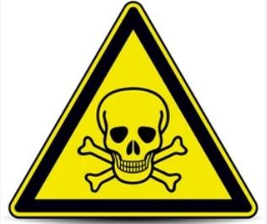

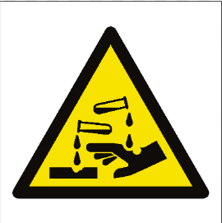

……………………………… …………………….…

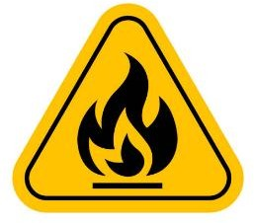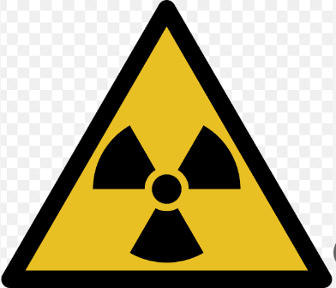

…………………………… ………………….……..

1. Mention four components of a first aid kit. (4 mks)
2. …………………………………………………
3. …………………………………………………
4. …………………………………………………
5. …………………………………………………
6. When working in the laboratory, you must observe the following safety rules: Namely? (4 mks)
   1. ………………………………………………………………………
   2. ……………………………………………………………………….
   3. ……………………………………………………………………….
   4. ………………………………………………………………………..
7. State the Functions of the different parts of the Microscope.(4 mks)

|  |  |  |
| --- | --- | --- |
|  | PART | USE/FUNCTION |
| 1 | Eyepiece lens |  |
| 2 | Body tube |  |
| 3 | Stage |  |
| 4 | Arm |  |

1. Name the following heating instruments. (5 mks)

|  |  |  |  |  |
| --- | --- | --- | --- | --- |
|  |  |  |  |  |
|  |  |  |  |  |

1. State the Functions of the parts of a Bunsen burner.( 7 mks)

|  |  |
| --- | --- |
| Part | Function |
| Collar |  |
| Air hole |  |
| Chimney  (barrel) |  |
| Base |  |
| Gas hose |  |
| Flame |  |
| Gas inlet |  |

1. Name the lab apparatus below. (3 mks)

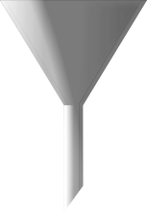

1. Name three careers that are related to the knowledge and skills gained in integrated science.( 3 mks)
2. ………………………………………………..
3. ……………………………………………….
4. ……………………………………………….
5. 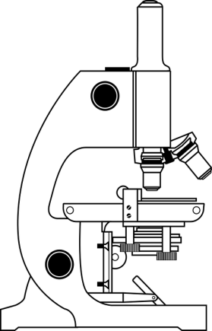Name the following parts of the light microscope.( 3 mks)

1. Name two common accidents in the laboratory.(2 mks)
2. …………………………………………
3. …………………………………………
4. Name the apparatus below. **(1mk)**
5. Name the parts R, T and P. **(3mks)**

R……………………………………

T……………………………………

P……………………………………

1. Give the parts of a light microscope used for. **(3mks)**

a.) Reflect light on the stage

b. Holds the slide that has specimen. ………………………………………………

c. Concentrates light on to the stage. ……………………………………………………

##### Outline two safe ways of handling of the Bunsen burner. (2 mks)

1. ………………………………………………………………………..
2. ………………………………………………………………………..

###### Outline two uses of bases. (2 mks)

1. …………………………………………………………………………
2. …………………………………………………………………………
3. Indicate their colour in the given solutions. (3 mks)

|  |  |  |  |
| --- | --- | --- | --- |
| Indicator | Acidic solution | Neutral solution | Basic solution |
| Methyl Orange |  |  |  |
| Phenolphthalein |  |  |  |

###### State two uses of acids. (2 mks)

1. ……………………………………………………………………..
2. ……………………………………………………………………….
3. Identify three basic science skills one gains in science practical.(3 mks)
4. ………………………………………….
5. ………………………………………….
6. ………………………………………….
7. Name two apparatus used for measuring length.(2 mks)
8. ………………………………
9. ………………………………
10. Give two differences between luminous and non-luminous flame.( 2 mks)

|  |  |
| --- | --- |
| Luminous flame | Non-luminous flame |
|  |  |
|  |  |

1. Grade 7 students had their practical lesson in the laboratory.name two common accidents their Integrated Science teacher taught them. (2 mks)
2. ………………………………………………….
3. ………………………………………………….
4. Name three protective wear for safety in the laboratory.( 3 mks)
5. ……………………………………..
6. …………………………………….
7. ……………………………………...