COMPETENCE BASED CURRICULUM
Kenya Junior Secondary Education Assessment
FORMATIVE ASSESSMENT
TIME
2 HRS
ENDTERM 1
INTEGRATED SCIENCE
G7
2024
SCHOOL: ……….……………………………………………………..……
NAME: ……………….…………………..………………………...………..
SIGNATURE: ………………ASSESSMENT NO…………………………..
RUBRICS (for official use)
MARK SCORE RANGE | Below 40 | 40-59 | 60-79 | 80-100
PERFORMANCE LEVEL | Below expectation | Approaching expectations | Meeting expectations | Exceeding expectations

OUT OF | 100%
LEARNERS SCORE
PERCENTAGE SCORE
PERFORMANCE LEVEL

FOR FACILITATOR’S USE ONLY

Answer all Questions

- State three components of integrated science. (3 mks)
  - ……………………………………….
  - ……………………………………….
  - ………………………………………

- Outline two laboratory safety measures. (2 mks)
- ………………………………………….……………………………………………………………………………
- …………………………………………………………………………………………………………………………

- Name the following laboratory apparatus.(8mks)
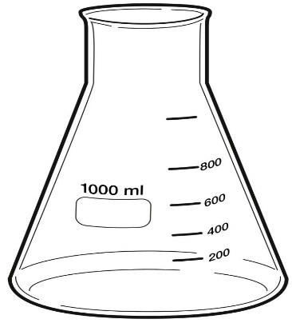
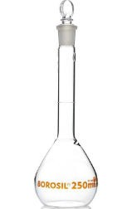
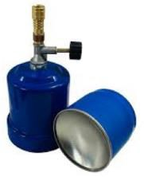

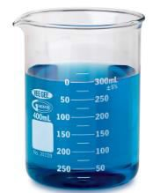
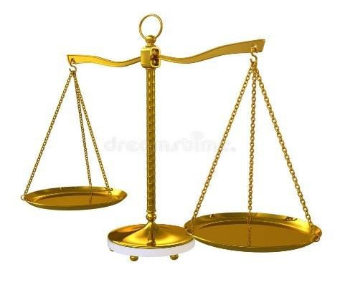

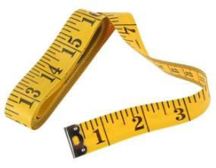

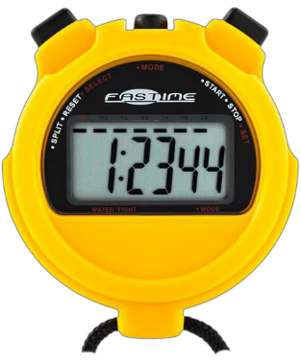

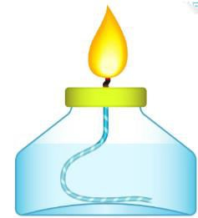

- State the functions of the parts of a Bunsen burner.(7 mks)
Part | Function
Collar
Air hole
Base

Gas hose

- State the meaning of the following laboratory hazard symbol. (3 mks)
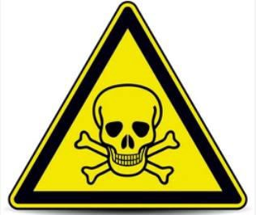
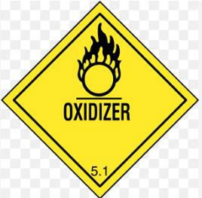
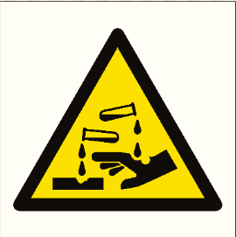

- The table below shows the basic quantity, write their SI unit and their symbols.(10 mks)
Basic quantity | SI unit | Symbol
Mass
Length
Time
Temperature
Electric current

- Calculate the volume of the box below. (3 mks)

5cm

10m

5m

- What is the density of a solid whose mass is 450grams having a volume of 90cm³?(3 mks)

- Calculate the area of a piece of land which measures 50m and 100 m.(3 mks)

- State three units that are used in measuring temperatures. (3 mks)
  - ………………………………………….
  - ………………………………………….
  - ……………………………………….

- Name four common accidents in the laboratory.(4 mks)
- …………………………….……………….……………….…
- …………….……………….……………….……………….…
- …………….……………….……………….…………………
- ……………….…………….…………….………………….
- Name four protective wear for safety in the laboratory.(4 mks)
- ……………………….…………….…………….…………….…………….…………….…………….
- …………….…………….…………….…………….…………….…………….…………….…………….
- …………….…………….…………….…………….…………….…………….…………….…………….
- …………….…………….…………….…………….…………….…………….…………….…………….
- Name three laboratory apparatus used for measuring mass of substances.(3 mks)
- . …………….…………….…………….…………….
- …………….…………….…………….…………….
- …………….…………….…………….…………….…
- Give four differences between luminous and non-luminous flame.(8 mks)
Luminous flame | Non-luminous flame

- Name the following parts of the light microscope.( 5 mks)
