COMPETENCE BASED CURRICULUM
Kenya Junior Secondary Education Assessment
FORMATIVE ASSESSMENT
TIME
2 HRS
ENDTERM 1
INTEGRATED SCIENCE
G7
2024
SCHOOL: ……….……………………………………………………..……
NAME: ……………….…………………..………………………...………..
SIGNATURE: ………………ASSESSMENT NO…………………………..
RUBRICS (for official use)
MARK SCORE RANGE | Below 40 | 40-59 | 60-79 | 80-100
PERFORMANCE LEVEL | Below expectation | Approaching expectations | Meeting expectations | Exceeding expectations

OUT OF | 100%
LEARNERS SCORE
PERCENTAGE SCORE
PERFORMANCE LEVEL

FOR FACILITATOR’S USE ONLY

Answer all Questions

- State three components of integrated science. (3 mks)
  - Biology
  - Chemistry
  - Physics
  - Health education

- Outline two laboratory safety measures. (2 mks)
- Do not run, eat, drink, smell or taste anything in the lab
- Do not do any experiment without teachers instructions
- Be careful when handling apparatus etc

- Name the following laboratory apparatus.(8mks)
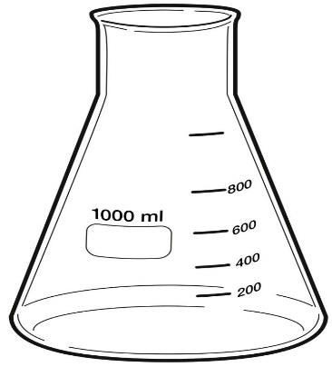
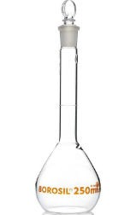
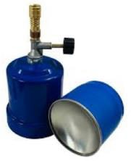

Flat bottomed flask

Portable burner
Conical flask

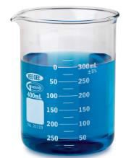
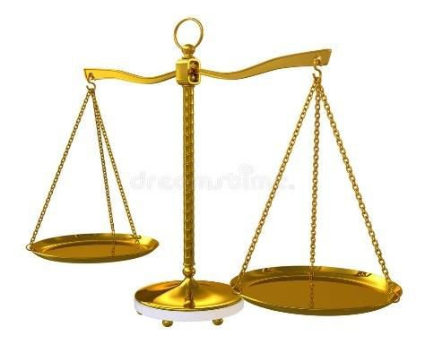

Beaker

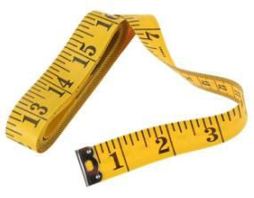
Beam balance

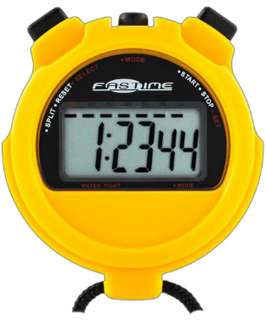

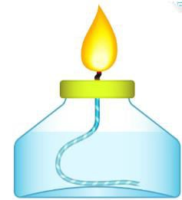

Tape measure

Stop watch
Spirit lamp

- State the functions of the parts of a Bunsen burner.(7 mks)
Part | Function
Collar | Regulates amount of air entering the Bunsen burner through the air hole.
Air hole | Allows air to enter the chimney. (air mixes with the gas making flame hotter and blue.
Base | Supports the Bunsen burner and prevent it from toppling.
Gas hose | The flexible hose pipe connects the Bunsen burner and the gas tap.

- State the meaning of the following laboratory hazard symbol. (3 mks)
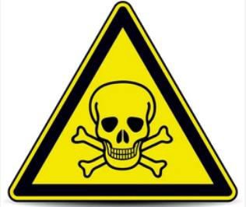
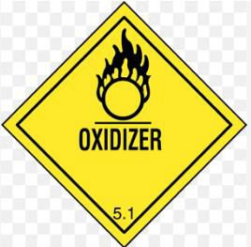
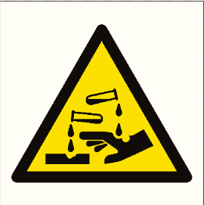

Oxidizer
Toxic
Corrosive

- The table below shows the basic quantity, write their SI unit and their symbols.(10 mks)
Basic quantity | SI unit | Symbol
Mass | Kilogram | kg
Length | Metre. | m
Time | Second | s
Temperature | Kelvin | K
Electric current | Ampere | A

- Calculate the volume of the box below. (3 mks)

5cm

10m

5m
Volume =length x width x height (m x m x m) or m3 (cubic metres)
=10m *5m*5m
=250cm³

- What is the density of a solid whose mass is 450grams having a volume of 90cm³?(3 mks)

Density = Mass (Kg/m3)
Volume
=450/90
=50g/cm³

- Calculate the area of a piece of land which measures 50m and 100 m.(3 mks)

Area (rectangle) = Length x width (m x m) or m2 (square metres)
=50m*100m=5000m²

- State three units that are used in measuring temperatures. (3 mks)
  - Degrees Celsius (0C.)
  - Degree Fahrenheit (0F.)
  - Kelvin (K)

- Name four common accidents in the laboratory.(4 mks)
- Falls
- Fractures
- Cuts
- Burns
- Electric shock
- Scalds
- Name four protective wear for safety in the laboratory.(4 mks)
- Goggles
- Masks
- Apron/coats
- Gloves
- Etc
- Name three laboratory apparatus used for measuring mass of substances.(3 mks)
- Electric beam baance
- Double beam balance
- Triple beam balance
- Give four differences between luminous and non-luminous flame.(8 mks)
- Luminous flame | Non-luminous flame
Yellow/orange in colour | Blue in colours
Used for lighting | Used for heating
Has 4 regions and burns quietly | Has 3 regions and noisy
Produced when air hole is closed | Produced when air hole is open
Produces soot | Does not produce soot
Its wavy and large | Its straight

- Name the following parts of the light microscope.( 5 mks)
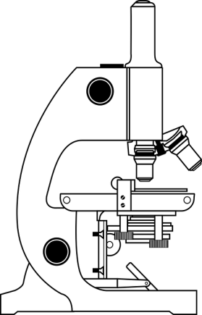
Eye piece lens

Body tube

Stage

Mirror
Base

