**KENYA JUNIOR SCHOOL ASSESSMENT**

**GRADE 7.**

**PRE-TECHNICAL STUDIES.**

**TERM 2**

**OPENER**

**Learner’s Name: ______________________________________________________________**

**Assessment No: _____________________________ Grade:___________________________**

**Date: ____________________________________________________________________**

**FOR EXAMINERS USE ONLY.**

|  |  |  |
| --- | --- | --- |
| **Score Range** | **Performance Level** | **Tick** |
| ***80-100*** | **Exceeding Expectation** |  |
|  |  |  |
| ***60-79*** | **Meeting Expectations** |  |
|  |  |  |
| ***40-59*** | **Approaching Expectations** |  |
|  |  |  |
| ***Below 40*** | **Below Expectations** |  |
|  |  |  |

|  |  |  |
| --- | --- | --- |
| **OUT OF** |  | **60 MARKS** |
| **Learners** |  |  |
| **Score.** |  |  |
|  |  |  |
| **Learners** |  |  |

**%**

**Instructions to Learners.**

***Answer all the Questions in the spaces provided after each question.***

**QUESTIONS.**

1. Name the computer parts labelled A-H. (8 mks)



Part A ______________________________ Part B ______________________________

|  |  |
| --- | --- |
| Part C ______________________________ | Part F ______________________________ |
| Part D _____________________________ | Part G ______________________________ |
| Part E ______________________________ |  |
| 2. Define the term hazard. | (2mks) |

_____________________________________________________________________________

_____________________________________________________________________________

3. a.) State four ways of observing safety in a work environment (4mks)

_____________________________________________________________________________

_____________________________________________________________________________

_____________________________________________________________________________

_____________________________________________________________________________

b.) What is a safety gear? (2mks)

_____________________________________________________________________________

_____________________________________________________________________________

_____________________________________________________________________________

_____________________________________________________________________________

4. State four safety wear you will advise motorbike boda-bodas to use in their daily work

|  |  |  |  |  |  |
| --- | --- | --- | --- | --- | --- |
|  | (4mks) | |  |  |  |
| ___________________________________ | | | ____________________________________ | | |
| ___________________________________ | | | ____________________________________ | | |
| 5. Identify the following safety items. | | |  | (4mks) | |
|  |  |  |  |  |  |
|  |  |  |  |  |  |
|  |  |  |  |  |  |

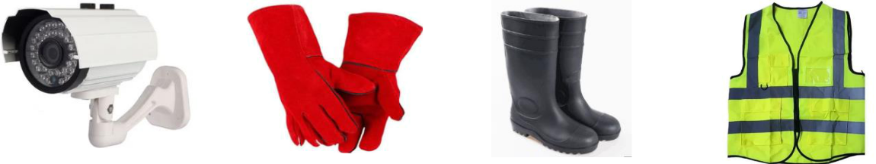

|  |  |  |  |  |
| --- | --- | --- | --- | --- |
| 6. | State four online threats at a work environment. | | (4mks) | |
|  | __________________________________________________________________________ | | | |
|  | __________________________________________________________________________ | | | |
|  | __________________________________________________________________________ | | | |
|  | __________________________________________________________________________ | | | |
| 7. | Identify the following artistic drawings described below | | (3mks) | |
|  | |  |  |  |
| a.) | | Drawn in public places such as walls using spray paints |  |  |
|  | |  |  |  |
| b.) | | A drawing or painting in which features have been |  |  |
|  |  | exaggerated to mock or satirize a subject |  |  |
|  | |  |  |  |
| c.) | | A drawn pictures in which the face is dominant |  |  |
|  |  |  |  | |

8. Identify the following types of lines. (3mks)

a.) 



b.)

____________________________

c.) 

_____________________________

9. a.) Identify three forms of communication in business. (3mks)

_________________________________ ____________________________________

_________________________________

Learners in Huduma Junior School were discussing about various examples of oral

|  |  |  |  |
| --- | --- | --- | --- |
|  | communication used today. Suggest any four examples they presented | | (4mks) |
| _______________________________________ | | ___________________________________ | |
| _______________________________________ | | ___________________________________ | |
| 10. | State three body parts affected due to prolonged use of computers | | (3mks) |
|  | __________________________________________________________________________ | | |
|  | __________________________________________________________________________ | | |
|  | __________________________________________________________________________ | | |
| 11. | Identify three characteristics of computers. |  | (4mks) |

__________________________________ ____________________________________ _________________________________ ____________________________________

12. State two careers one may pursue from studying Pre-technical studies (3mks)

__________________________________________________________________________

__________________________________________________________________________

__________________________________________________________________________