**CONFIDENTIAL**

**GRADE 7**

**PRETECHNICAL**

**MARKING SCHEME**

### Name two components of pre-technical studies. (2 mks)

### Business education

### Technical education

### Computer education

### Career studies

1. 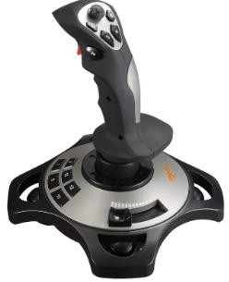Name the following input devices. (4 mks)

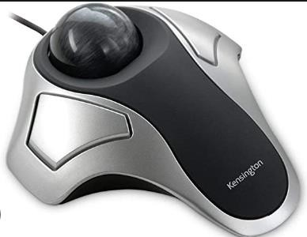

Trackball

Joystick

Touch pad

### State two Importance of safety in a work environment. (2 mks)

1. Reduces financial losses needed to repair damaged property.
2. Increases business rating because of customer and worker satisfaction.
3. Reduces job losses that comes from permanent injuries.
4. Reduces financial losses needed for medical expenses.
5. Reduces damage to property because of lower number of accidents at workplaces.
6. Reduces cases of injury because of lower number of accidents at workplaces.
7. It improves productivity.
8. Name the following storage devices. (2 mks)



Memory card Compact disc.

1. Complete the following Stages of computer processing cycle

**STORAGE**

**PROCESSING**

**OUTPUT/INFORMATION**

**INPUT/DATA**

1. Name the following parts of a Model of a computer. (3 mks)

Description: C:\Program Files (x86)\Microsoft Office\MEDIA\CAGCAT10\j0285750.wmf

**C.P.U**

**Monitor**

**Speaker**

1. State four Advantages of using a computer. (4 mks)
2. Computer process data faster than human beings
3. Computers keep data and information secure
4. Computers can store a lot of data in a small physical space
5. Computer can do the same repeatedly without getting tires or bored
6. Computer are able to perform different types of jobs at the same time
7. A computer is reliable because it consistently does what it is supposed to do.
8. Computers have a very big storage capacity and can store data and information for a very long time
9. Name four ICT Tools used in Communication.(4 mks)
10. Emails-used to exchange information over the internet to other individuals.
11. Mobile phones- allows calling and messaging in communication.
12. Computers -computer provide various communication channels such as emailing, video calling etc.
13. Videos and web conferencing- Video conferencing has a focus on face-to-face communication. Web conferencing has a focus on interaction and collaboration such as document sharing.
14. Social networking - use of dedicated websites and applications to interact with other users.
15. Online collaboration - using the internet and online tools to collaborate.
16. Softwares like word processor are used to design letters and memos that are used to pass information in business.
17. Social media is used to give immediate response to customer needs.
18. Name the types of artistic drawing illustrated below. (4 mks)



Illustrations

Caricature

Graffiti



1. Name three Examples of technical drawings:
   1. Architectural
   2. Mechanical systems drawings.
   3. Electrical drawings,
2. Name the Types of Lines used in drawing. (4 mks)

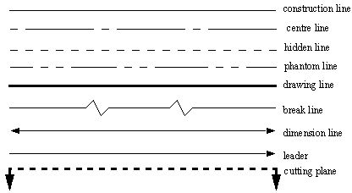

1. State the following basic abbreviations used in drawing in full.(5 mks)
   1. DRG -means drawing.
   2. A/F – means across flat.
   3. A/C – means across corners.
   4. I/D – means inner diameter.
   5. O/D – means outer diameter.
2. 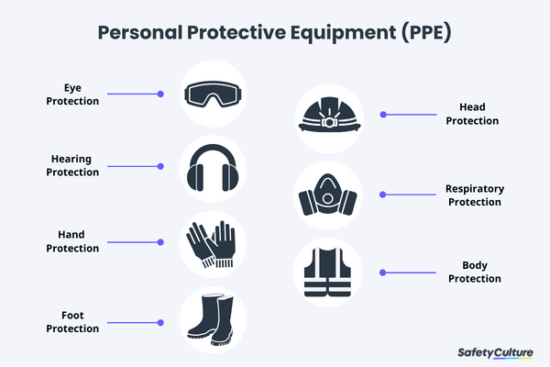Name the following safety wears. (7 mks)

Safety Goggles

Helmet

Head phones/ear muffs

Gas mask

Gloves

Safety jacket

Gumboots

### State two Causes of fire in a work environment. (2 mks)

1. Faulty equipment such as extension cables in places such as kitchens, offices, workshop or warehouses.
2. Fires when performing tasks such as welding, flame-cutting or grinding. This work generates heat, sparks or flames to cause fire.
3. Improper storage of flammable and combustible materials such as flammable liquids or charcoal in workplace.
4. Human errors such as using equipment such as electric cooker incorrectly, not reporting faulty machinery as well as leaving cooking food unattended may lead to fire accidents.

### Name four injuries caused by fire at work places. (4 mks)

1. Burns-where fire raises temperature of the skin and tissues causing the tissues and cells to die.
2. Smoke chocking- where the victim suffers obstructed breathing, seizures and comas.
3. Chemical poisoning from inhaling poisonous fumes such as carbon monoxide.
4. Shock where a victim develops abnormal heart rhythm and becomes unconscious.

### Outline four Prevention methods of fire outbreaks in a work environment. (4 mks)

* 1. Providing enough safety and security at work premises.
  2. Keeping a work environment clean and orderly.
  3. Being cautious when performing activities using open fire.
  4. Having all equipment well services and maintained.
  5. Allowing for easy access to electrical switches and fire alarm equipment.
  6. Storing and handling flammable materials and liquids with care.

1. CPU has 3 components, list them. (3mks)
2. Arithmetic and logic unit (ALU),
3. A control unit, and
4. Various registers.
5. Write in full. (3mks)

a.) ALU

The full form of ALU is arithmetic logic unit. It is a combinational digital circuit that performs arithmetic operations on binary numbers.

b.) USB

USB, in full universal serial bus, technology used to connect computers with peripheral devices

c.) HDMI

The full form of HDMI is the High Definition Multimedia Interface. It is an all-digital audio-video interface that transmits information to a computer monitor, video projector, digital television and so on, in uncompressed mode.

1. State two problems experienced when setting up computers. (2mks)
2. The Computer Won't Start.
3. A computer that suddenly shuts off or has difficulty starting up
4. Have a failing power supply.
5. The Screen is Blank.
6. Abnormally Functioning Operating System or Software.
7. Windows Won't Boot.
8. The Screen is frozen.
9. Computer is Slow.
10. Strange Noises.
11. Slow Internet.
12. Forgotten passwords

1. Give the names of the following cables used with computes. (3mks)





VGA AUX

1. State three physical threats to computers. (3mks)
2. Virus.
3. Trojans.
4. Worms.
5. Spyware.
6. Key loggers.
7. Adware.
8. Denial of Service Attacks.
9. Distributed Denial of Service Attacks
10. State three Function of a computer. (3 mks)
11. Stores data and information
12. Process data into information using given instructions
13. Accepts data from the user
14. A computer gives out information to the user