**COMPETENCE BASED CURRICULUM**

Kenya Junior Secondary Education Assessment

FORMATIVE ASSESSMENT

TIME

2 HRS

ENDTERM 1

**PRE-TECHNICAL EDUCATION**

G7

2024

**SCHOOL:** ……….……………………………………………………..……

**NAME:** ……………….…………………..………………………...………..

**SIGNATURE: ………………ASSESSMENT NO…………………………..**

***RUBRICS (for official use)***

|  |  |  |  |  |
| --- | --- | --- | --- | --- |
| **MARK SCORE RANGE** | ***Below 40*** | ***40-59*** | ***60-79*** | ***80-100*** |
| **PERFORMANCE LEVEL** | *Below expectation* | *Approaching expectations* | *Meeting expectations* | *Exceeding expectations* |
|  |  |  |  |  |

|  |  |
| --- | --- |
| **OUT OF** | **100%** |
| **LEARNERS SCORE** |  |
| **PERCENTAGE SCORE** |  |
| **PERFORMANCE LEVEL** |  |

**FOR FACILITATOR’S USE ONLY**

**Answer all Questions**

1. What is Pre-technical studies? (2 mks)

……………………………………………………………………………………………………………………………………………………………………….…………...

#### State three Components of Pre-technical studies. (3 mks)

1. ………………………………………………
2. ………………………………………………
3. ………………………………………………

#### Outline five roles of Pre-technical studies in day today life. (5 mks)

1. ………………………………………………………………………………….
2. …………………………………………………………………………………..
3. ………………………………………………………………………………….

#### Give three examples of Data. (3 mks)

* 1. ………………………………………………..
  2. ……………………………………………….
  3. ………………………………………………….

#### List five examples of computers used today.(5 mks)

1. ………………………………………………………………………………………………………………………..
2. …………………………………………………………………………………………………………………………
3. …………………………………………………………………………………………………………………………
4. …………………………………………………………………………………………………………………………
5. …………………………………………………………………………………………………………………………
6. State and explain three characteristics of computers. (6 mks)
7. ………………………………………………………………………………………………………………………………
8. ………………………………………………………………………………………………………………………………
9. ………………………………………………………………………………………………………………………………
10. We can classify computer by looking at the following: name three. (3 mks)
11. …………………………………………………
12. …………………………………………………
13. …………………………………………………
14. 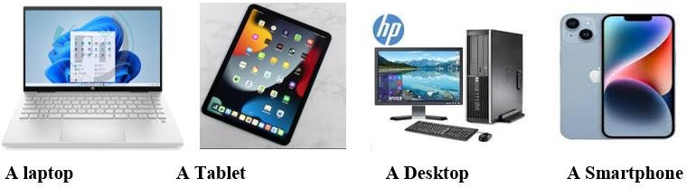Name the following digital computers. (4 mks)
15. List any two computer hardware components. (2mks)
16. …………………………………………
17. …………………………………………
18. State three examples of safety. (3 mks)
19. ……………………………………………………………………
20. ……………………………………………………………………
21. ……………………………………………………………………

#### Mention three physical threats at the workplaces. (3 mks)

1. ………………………………………………………………
2. ………………………………………………………………
3. ………………………………………………………………

##### Name four Examples of online threats at work place. (4 mks)

1. ………………………………………………
2. ………………………………………………..
3. ……………………………………………….
4. ……………………………………………….
5. Name any four tools found in the first aid kit. (8mks)
6. …………………………………..
7. …………………………………...
8. ……………………………………
9. …….………………………………
10.  Name the tools below (4mks)



1. List any two professions that require training on safety. (2mks)
2. …………………………………………………………………………….
3. ……………………………………………………………………………..

##### Name the parts of the computer shown below. (5 mks)

##### 

**OSCAR MWANGI O705443680**

1. Name the following safety wears. (7 mks)

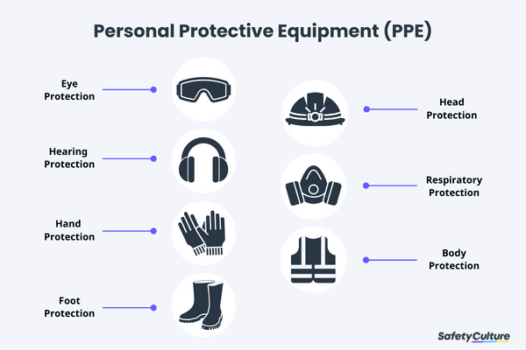

Safety Goggles

Head phones/ear muffs

Gloves

Gumboots

Safety jacket

Gas mask

Helmet

THE END