COMPETENCE BASED CURRICULUM
Kenya Junior Secondary Education Assessment
FORMATIVE ASSESSMENT
TIME
2 HRS
ENDTERM 1
MATHEMATICS
G7
2024
SCHOOL: ……….……………………………………………………..……
NAME: ……………….…………………..………………………...………..
SIGNATURE: ………………ASSESSMENT NO…………………………..
RUBRICS (for official use)
MARK SCORE RANGE | Below 40 | 40-59 | 60-79 | 80-100
PERFORMANCE LEVEL | Below expectation | Approaching expectations | Meeting expectations | Exceeding expectations

OUT OF | 100%
LEARNERS SCORE
PERCENTAGE SCORE
PERFORMANCE LEVEL

FOR FACILITATOR’S USE ONLY

Answer all Questions

Answer the following questions
- What is the place value of the underlined digits?(3mks)
  - 28105 ……………………………………
  - 13460……………..…………………….
  - 8935………………………………………
- Write the digits that are in the place value indicated in the brackets.(3mks)
  - 2569 (thousands)……………………………….………..
  - 13978 (tens of thousands)……………………………..
  - 834 ( hundreds)……………………………………………
- What is the total value of digit 7 in the following numbers? (4mks)
  - 378………………………………………..
  - 7613………………..……………………
  - 71438……………….…………………..
  - 107………………………………………
- Write in symbols(3mks).
  - Three thousand and eight.

  - Eight hundred and eighty eight.

  - Ten thousand.

- Write in words.(3mks)
  - 999………………………………………………………………………………………………
  - 909……………………………………………………………………………………………….
  - 1000……………………………………………………………………………………………

- Use the digits 7, 3 and 5 to form six 3-digit numbers.(2mks)
  - Write the numbers formed.

  - Arrange the numbers formed from the smallest to the largest. (2mks)

  - Arrange the numbers formed from the largest to the smallest. (2mks)

- Round off the following numbers to the nearest 10(4mks)
  - 987

  - 408

  - 190

  - 888

- List the next 4 multiples of 8 after 40. (2mks)

- How many odd numbers are there between 30 and 40? (1mk)

- Complete the patterns:(2mks)
  - 92, 90, 88, _ ,
  - 61, 59, 57, _ ,
- A certain petrol station sold 4378 litres of petrol on Monday. On Tuesday they sold 3912 litres of petrol. How many litres of petrol were sold on Monday and Tuesday altogether? (1mk)

- Take away.(2mks)
  - 6435 - 5984 =

  - 5278 - 162 = (2mks)

- Multiply.
  - 28
x 15

  - 38
x 20
(3mks)

- Work out:
  - 37 ÷ 7 =

  - 62 ÷ 5 =

  - 4 88

- Shade the fractions. (3mks)
  - ³/₈
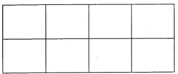

  - 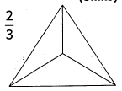

  - ⁷/₁₂
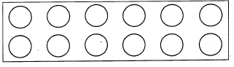

- Convert to improper fractions (2mks)
  - 3²/₃

  - 8½

- What is the place value of digit 8 in the number. (1mk)
8.03

- Measure the line below in cm. (1mk)

- Find the perimeter of the figure below.
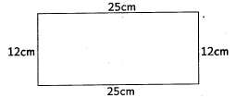

- A circle is made of lines. (1mk)
- Make a pattern using ovals and squares. (1mk)

Total = 50marks

