JUNIOR SCHOOL ASSESSMENT
TERM TWO
OPENER
MARKING SCHEME

MATHEMATICS

- 5000.

- Ninety-nine million, nine hundred and ninety-nine thousand and ninety-nine.

- 225, 289. (Any square of a number between 12 and 17 in ascending order)

4.
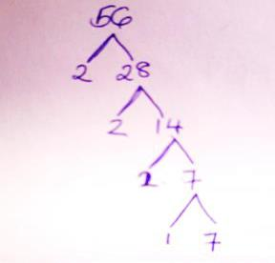

- 142.
- GCD=6
- 10.30 a.m.
- All the three numbers are divisible by 3.

a- 263486. b- 2.

c- 263,000.
- 450cm².
- 11+13+17+19 =60.
- 90⁰ - 42⁰ =48⁰.

- 0010hrs.

- y=4.
- Sh.19,041.
- 4¹/2 Kg.
17.
Faces-5

Edges-8
Vertices-5
- 15 x 52 =780 litres.

- 16 boys.
- 730,863.
- 1344.
- 110.

- 6160 cm³.

