CREATIVE ARTS AND SPORTS
G7 MIDTERM 2 MARKING SCHEME

- Visual arts,

Music and dance

Film and sports

- They help to increase the range of motion

They help to relieve the pain after exercise
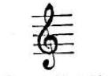

3.

- Sharp,

Flat,

Natural

- G major,

D major,

A major

- Color,

Form,

Line,

Shape

- Setting,

Character,

Theme

- Overarm serve

- Elbow stand,

Fence vault

Dive forward roll into squat stand

Partner balances

- Siiriri-luhya

Litungu- kuria

Adeudeu- Teso

- Semibreve - taa-aa-aa-aa

Crotchet - taa

Two quavers -ta- te

- Approach,

Take-off,

Sail or flight,

Landing

- back stroke

- a. Chivoti,

  - Nzumari

- Hitting,

Shaking,

Striking

- Positioning,

Number of forms

Perspective

- Repetition of note values

Variation of note values

- Glue,

Surface such as cardboard

Scissors

- Scissors technique

- For efficiency

For psychological benefits

It is sometimes used as a race strategy Reinforces proper technique
Helps in maintenance of endurance

- It is easily portable
- Helps in development of skill
- Used for historical significance
- It Is affordable
- Its versality is high

- Creates musical diversity
- Portrays expressiveness
- Gives dynamic contrast
- Enhances cultural exploration
- Promotes technical development

- Let the learner indicate the following; Sound hole
- Fingering holes Headstock Nut
- Strings Body

- Evoking our emotional connection
- Improves identity formation
- Helps in copping up mechanism
- Improves social connection
- Enhances self-expression (asses)

- Musical context
- Musical expression and creativity
- Type of accompaniment
- Level of skill development
- Posture

- It expresses cultural expression
- Enhances personal expression
- Contributes in bringing people together.
- It enriches education and enlightens
- Promotes inspiration and innovation
- Positively impacts economy
- Promotes global understanding
- Promotes visual continuity
- Provides temporal compression
- Creates visual depth and texture
- Promotes narrative complexity
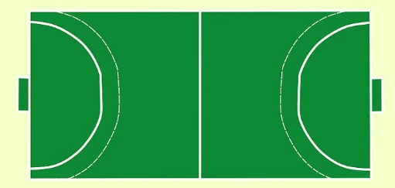

- A handball game is played in 2 30-minute halves with a 10 minute break in between. Youth or tournament games are shorter, played in 2 15-minute or 20-minute halves instead
- There are many ways to commit a rule violation. If one team commits a violation, then that means that the other team is awarded the ball, either as a throw-in, free-throw, or goalie-throw. Here are the different violations:
- Passive play. This means keeping the ball within one team's possession without trying to attack or to score. This basically means stalling with the ball.
- Endangering an opponent with the ball.
- Pulling, hitting, or punching the ball of the hands of an opponent.
- Making contact with the ball below the knee.
- Diving on the floor for a ball that is rolling or not moving.
- Outstretching your arms or legs to push, hold, obstruct, trip, or hit the opponent or to charge into a defensive player
- A-Warning B-disqualification

- A warning/yellow card. Each player can only receive one warning for a rule violation, and each team can only receive a total of three warnings.
- A 2-minute suspension. This is given for serious and repeated rule violations, illegal substitution, and unsportsmanlike conduct. You do not need a warning first to get a 2-minute violation. For this violation, the player sits out for 2 minutes and is not replaced, so his team has to play one player short.
- Disqualification/red card. A player is given this as an equivalent of three suspensions that last 2 minutes each. After the first 2-minute suspension, the player can be replaced.
- Exclusion. The exclusion is given for assault and the player is excluded for the rest of the game. This is a serious offense and this player's team is at a huge disadvantage because it has to play one player short for the rest of the game

- Character
Setting
Plot
Theme

- Visual arts
- Performing arts
- Literary arts
- Fine arts

- Brings unity and cohesion
- Creates emphasis on focal point
- It brings communication ideas
- Creates melodies
- Promotes harmony (asses)
- Convey movement

- Build blocks of visual arts Adds vibrancy to the art work (asses)

