COMPETENCE BASED CURRICULUM
Kenya Junior Secondary Education Assessment
FORMATIVE ASSESSMENT
TIME
2 HRS
ENDTERM 1
CREATIVE ARTS AND SPORTS
G7
2024
SCHOOL: ……….……………………………………………………..……
NAME: ……………….…………………..………………………...………..
SIGNATURE: ………………ASSESSMENT NO…………………………..
RUBRICS (for official use)
MARK SCORE RANGE | Below 40 | 40-59 | 60-79 | 80-100
PERFORMANCE LEVEL | Below expectation | Approaching expectations | Meeting expectations | Exceeding expectations

OUT OF | 100%
LEARNERS SCORE
PERCENTAGE SCORE
PERFORMANCE LEVEL

FOR FACILITATOR’S USE ONLY

What is creative arts? (2 mks)
__________________________________________________________________________________________________________________________________________________
- What is sports? (2 mks)
__________________________________________________________________________________________________________________________________________________
- Identify five roles of Creative arts and sports in the society.(5 mks)
- ______________________________________________________________________
- ______________________________________________________________________
- ______________________________________________________________________
- ______________________________________________________________________
- _____________________________________________________________________
- State four components of Creative Arts and Sports.(4 mks)
- ________________________________________
- _________________________________________
- _________________________________________
- _________________________________________
- State two Principles of Visual arts.(2 mks)
  - _____________________________________________________________
  - _____________________________________________________________
- What is the meaning of: (2mks)

  - An artiste-____________________________________________________________________________________________________________________________________________________________

  - An audience- ____________________________________________________________________________________________________________________________________________________________

- Outline four Basic Elements of a play. (4 mks)
- ___________________________________________________________________________-
- ___________________________________________________________________________
- ___________________________________________________________________________
- ___________________________________________________________________________
- State and explain three elements of Music in Creative Arts.(6 mks)
  - ___________________________________________________________________________
  - ___________________________________________________________________________
  - ___________________________________________________________________________
- State three Elements of Dance in Creative Arts.(3 mks)
- __________________________________________________________________
- __________________________________________________________________
- __________________________________________________________________
- The arts can be experienced through the following senses namely?(3 mks)
  - ________________________________________________________________
  - ________________________________________________________________
  - ________________________________________________________________
- Identify the three sections of a narrative (3mks)
- ______________________________________________________________________
- ______________________________________________________________________
- ______________________________________________________________________

- Fill in the chart below;
__________________________ _______________________

- Name the following parts of a note. (3 mks)

- Draw the following note. ( 5 mks)

- Draw the note of the French rhythm.(3 mks)

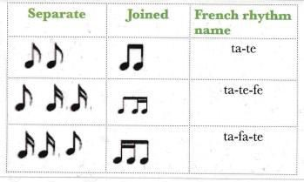

- State two categories of arts.(2 mks)
- ___________________________________________________________
- ___________________________________________________________
- Name three properties of colour.(3 mks)
- ________________________________________________________
- ________________________________________________________
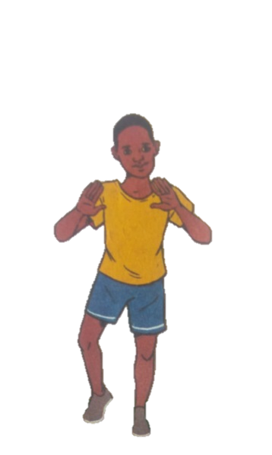
- _______________________________________________________
- Identify two landing techniques in footwork in netball.(2 mks)

