COMPETENCE BASED CURRICULUM
Kenya Junior Secondary Education Assessment
FORMATIVE ASSESSMENT
TIME
2 HRS
ENDTERM 1
CREATIVE ARTS AND SPORTS
G7
2024
SCHOOL: ……….……………………………………………………..……
NAME: ……………….…………………..………………………...………..
SIGNATURE: ………………ASSESSMENT NO…………………………..
RUBRICS (for official use)
MARK SCORE RANGE | Below 40 | 40-59 | 60-79 | 80-100
PERFORMANCE LEVEL | Below expectation | Approaching expectations | Meeting expectations | Exceeding expectations

OUT OF | 100%
LEARNERS SCORE
PERCENTAGE SCORE
PERFORMANCE LEVEL

FOR FACILITATOR’S USE ONLY

What is creative arts? (2 mks)
Creative Arts is a description of various artistic activities that allow performers to use their imaginations, creativity, and express ideas through a variety of mediums to passage a message to the audience.

- What is sports? (2 mks)
A sport is any activity involving physical or mental effort combined with skills in which an individual or a team or teams compete against another or others for entertainment.
- Identify five roles of Creative arts and sports in the society.(5 mks)

Social roles of Creative arts & Sports.
- Creates a sense of identity-bring people together, creating shared experiences that help to foster a sense of community and collective identity.

- Creative arts and sports promote cohesion through teamwork.

Through creative arts and sports culture is preserved-it ensures that our history and traditions are not forgotten, and that future generations can appreciate and learn from them.

- Creative arts and sports provide provides us with entertainment through components such as music, dance, drama, narratives, films and movies, various sports i.e., soccer, basketball, netball, volley ball.
Economic roles of Creative arts and Sports.
- Creative arts and sports provide employment opportunities such as artists, musicians, referees, sports coaches, sports doctors, choreographers. Trainers, teachers etc.
- One can earn income through activities related to creative arts and sports hence eradicating poetry.
- Through creative arts and sports, a country can earn or generate tax revenue. (boosts revenue collection)
- Creative arts and sports attract investments which in turn increases job opportunities.
- Creative arts and sports stimulate growth of economy through sectors such as tourism. (Encourages tourism)
- State four components of Creative Arts and Sports.(4 mks)

Creative arts is made of the following components:
- Visual arts -creative art forms appreciated through sense of sight such as;

- Play - a written work that tells a story through action and speech and is meant to be acted on a stage.

- Music - Music is a collection of coordinated sound or sounds. Making music is the process of putting sounds and tones in an order, often combining them to create a unified composition

- Dance – dance is the movement of the body in a rhythmic way, usually to music and within a given space, for the purpose of expressing an idea or emotion.

- State two Principles of Visual arts.(2 mks)
There are two principles of visual arts namely:

- Principle of dominance in Visual Arts.
Dominance is when a single element is so large and/or different compared to the rest of the design that it dominates.
It grabs your attention.
Famous examples include the London Eye that dominates the skyline of London or the Ashoka Lions that dominate the Indian Passport and other official documents.
- Principle of Proportion in Visual arts.
Proportion refers to the dimensions of a composition and relationships between height, width and depth. How proportion is used will affect how realistic or stylized. Proportion also describes how the sizes of different parts of a piece of art or design relate to each other.
Proportion in any art is the relative size of objects in relation to each other or corresponding to the other elements as a whole.

- What is the meaning of: (2mks)

  - An artiste-An artiste is a professional entertainer, especially a singer or dancer

  - An audience- Audience in the arts refers to an individual's. Or group's viewing, hearing, reading, and/or listening of an artistic product or products. From among the many definitions of audience in the arts, here is a selection: "an audience.
- Outline four Basic Elements of a play. (4 mks)

The theme: refers to the message (meaning) that is intended to be expressed in the story. In other words, it is the main idea or the lesson to be learned from the story.
- Character- this is a person or individual taking part in the play or drama that may have defined personal qualities and/or histories.
- Plot- A plot is a sequence of events within a play that tells a story. A plot is what makes a story. Five components make up a plot: exposition, rising action, climax, falling action, and resolution. Conflict and theme help drive the plot forward.
- Language- Language in drama is represented as spoken language or, in other words, as speech. In drama, language refers to the particular manner of verbal expression, the diction or style of writing, or the speech or phrasing that suggests a class or profession or type of character.
- Setting- The setting is the time and place in which the story takes place
- State and explain three elements of Music in Creative Arts.(6 mks)

Sound-any tone with characteristics such as controlled pitch and timbre

Rhythm- Rhythm is the pattern of sound, silence, and emphasis in a song

Melody- a melody is a combination of pitch and rhythm.

Harmony-harmony, in music, the sound of two or more notes heard simultaneously.
- State three Elements of Dance in Creative Arts.(3 mks)

Body - In dance, the body is the mobile figure or shape, felt by the dancer, seen by others. The body is sometimes relatively still and sometimes changing as the dancer moves in place or travels through the dance area. The body is the mobile instrument of the dancer and helps inform us of what is moving.
- Action – This is what a dancer does, for example travelling, turning, elevation, gesture, stillness, use of body parts, floor-work and the transference of weight

- Space – Space refers to the area through which the dancer's body moves.

- Time - It is an essential part of choreographing and performing dance. It helps us to stay together when we dance in unison, identify the beat and the rhythm of how we move and provide stimulus for choreography.
- The arts can be experienced through the following senses namely?(3 mks)

Sense of light
  - Hearing
  - Touch
  - Smell
  - Taste

- Identify the three sections of a narrative (3mks)

- exposition,
- rising action,
- climax,
- falling action
- resolution

- Fill in the chart below;
CROTCHET SEMIBREVE
- Name the following parts of a note. (3 mks)

- Name the following note. ( 5 mks)

- Name the French rhythm for the following notes.(3 mks)

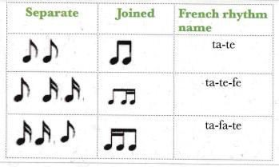

- State two categories of arts.(2 mks)
- Visual arts
- applied arts
- Performing arts
- Written/literacy arts
- Name three properties of colour.(3 mks)
- Hue
- Intensity
- Value
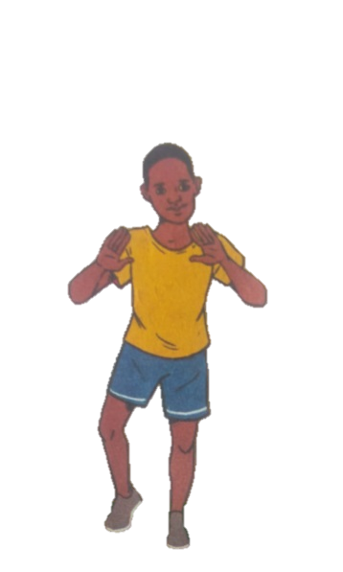
- Identify two landing techniques in footwork in netball.(2 mks)

Single Foot Landing
Double Foot Landing

