JUNIOR SCHOOL EDUCATION ASSESSMENT
2ND TERM 2024
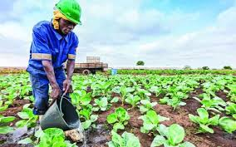
GRADE 7
AGRICULTURE AND NUTRITION
END OF MAY ASSESSMENT

NAME: _______________________________________________________
SCHOOL: _____________________________________________________

ASSESSMENT NUMBER ____________________ DATE___________________
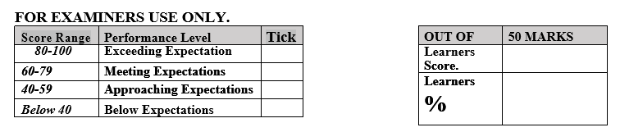

LEARNER’S INSTRUCTIONS

- Write your name, School, Assessment Number and the exam date in the spaces provided above.

- Answer all the questions in this paper.
- Any rough work must be done in this paper.

- All your answers must be written in the spaces provided in the question paper.
- Writing and giving relevant examples is highly recommended.
- It’s highly recommended to draw illustrations when explaining a concept.

- Learners should check the question paper to ascertain that all the pages are printed as indicated and that no questions are missing.
- Your answers must be clearly written (Legible) and well organized.
- Use blue or black pens when writing answers and a pencil when drawing.

- Learners must answer the questions in English.

(2 Marks)
- State two functions of the cut-off drains.

  - _______________________________________________________________

  - _______________________________________________________________

(4 Marks)
- State four types of soil erosion

i.______________________________________________________________

ii.______________________________________________________________

iii._______________________________________________________________

iv._______________________________________________________________

(2 Marks)
3. Name the types of seedbeds shown below

(2 Marks)
4. Identify two causes of soil pollution in the agricultural environment.
a. __________________________________________________________________________________________________
b. __________________________________________________________________________________________________
(3 Marks)
- State three ways of conserving surface runoff water.

  - ______________________________________________

  - ______________________________________________

  - ______________________________________________

(3 Marks)
- In one of the Agriculture lessons, the teacher asked learners to search for the meaning of Agroforestry and share their findings with their peers. If the teacher was happy that their definitions were correct.

  - State clearly what the learners might have said.

_________________________________________________________________________________________
_________________________________________________________________________________________

  - Give two reasons why agroforestry should be practiced in Kenya.

_________________________________________________________________________________________
_________________________________________________________________________________________
(3 Marks)
- A facilitator came to Heiman School during an Agriculture lesson and asked grade 7 learners on the importance of water retention. What answers did they give?

i.________________________________________________________________________

ii.________________________________________________________________________

iii._________________________________________________________________________
(3 Marks)
- State three farming practices that enhance conservation of water in the soil?

a._________________________________________________________________________________________

b._________________________________________________________________________________________

c._________________________________________________________________________________________

(1 Marks)
9. Identify one minimum tillage practice.
_________________________________________________________________________________
(2 Marks)
10. Which among the following animals can be sheared?
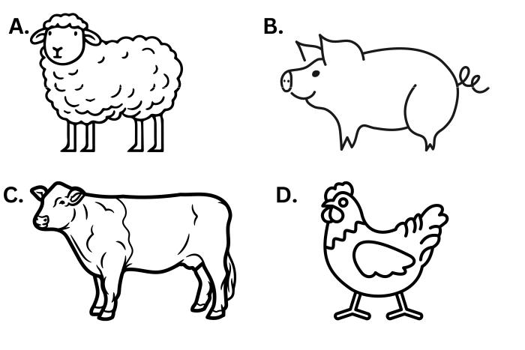

11. What do you understand by the term surface run – off. (2 Marks)

- Grade 7 pupils from Gedi Junior School visited a nearby farm. They noted the farm had a shallow depression filled with water. The water conservation method is known as___________________________________________________ (1 Mark)

(3 Marks)
- State three ways through which plants protect land against soil erosion?

a.

_________________________________________________________________________________________

b.

_________________________________________________________________________________________

c.

_________________________________________________________________________________________

(6 Marks)
- Grade 7 learners were instructed by their Agriculture teacher to carry out minimum tillage operations on the farm.

  - What is minimum tillage?

_________________________________________________________________________________________

  - Name two operations the learners likely carried out

_________________________________________________________________________________________

  - Why did the teacher ask them to carry out these operations?

_________________________________________________________________________________________

(2 Marks)
15. List two ways of practicing safe soil pollution control measures.
a. ______________________________________________________________________________________________
b. _______________________________________________________________________________________________
(3 Marks)
- Name three animals that can be prevented by the use of a safe trap?

  - ____________________________________________

  - _____________________________________________

  - _____________________________________________

17. State two factors to consider when sorting and preparing seeds as planting materials.
(2 Marks)
- _______________________________________________________________________________________
- _______________________________________________________________________________________
(3 Marks)
- Grade 7 learners visited a plantation and observed some structures used for conserving surface runoff. Name the three structures they observed.

  - ______________________________________________________________________________
  - ______________________________________________________________________________
  - ______________________________________________________________________________

(1 Marks)
19. The gardening practice from the diagram below is known as

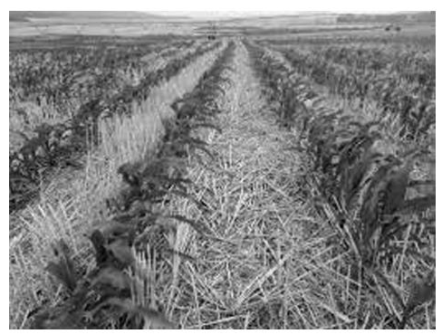

20. Explain the term agroforestry?(2 Marks)

________________________________________________________________________________________________________________________________________________________________________________________________________________________________________________________________________________________________________________________________________________________

