COMPETENCE BASED CURRICULUM
Kenya Junior Secondary Education Assessment
FORMATIVE ASSESSMENT
TIME
2 HRS
ENDTERM 1
AGRICULTURE AND NUTRITION
G7
2024
SCHOOL: ……….……………………………………………………..……
NAME: ……………….…………………..………………………...………..
SIGNATURE: ………………ASSESSMENT NO…………………………..
RUBRICS (for official use)
MARK SCORE RANGE | Below 40 | 40-59 | 60-79 | 80-100
PERFORMANCE LEVEL | Below expectation | Approaching expectations | Meeting expectations | Exceeding expectations

OUT OF | 100%
LEARNERS SCORE
PERCENTAGE SCORE
PERFORMANCE LEVEL

FOR FACILITATOR’S USE ONLY

Answer all Questions

MARKING SCHEME

- State two components of agriculture and nutrition. (2 mks)
- ______________________________________
- _______________________________________
- What is Soil pollution? (2 mks)
____________________________________________________________________________________________________________________________
- The harmful substances in the soil are known as ____________________________________.(1mk)

- Mention six causes of Soil Pollution in Farming.(6 mks)

  - _________________________________________________
  - _________________________________________________
  - _________________________________________________
  - _________________________________________________
  - _________________________________________________
  - _________________________________________________
- List four effects of soil pollution. (4mks)
- ______________________________________________________
- ______________________________________________________
- ______________________________________________________
- ______________________________________________________

Outline five Safe Soil pollution Control measures include the following methods:(5 mks)
  - __________________________________________________
  - __________________________________________________
  - __________________________________________________
  - __________________________________________________
  - __________________________________________________
- State three ways of creating The awareness message against soil pollution. (3 mks)
  - _______________________________________-
  - _________________________________________
  - _________________________________________
- Outline three damages caused by surface run off. (3 mks)
- _________________________________________________________
- _________________________________________________________
- _________________________________________________________
- Surface run off is conserved or collected in structures such as:(3 mks)

- __________________________
- ___________________________
- ____________________________

- Name four importance of conserving water in Farming.(4 mks)

- _______________________________________________________
- _______________________________________________________
- _______________________________________________________
- _______________________________________________________

What is the way or methods used to conserve Surface run-off? (3mks)

__________________________________________________________________

__________________________________________________________________

__________________________________________________________________

Mention three Crops that can be established in water retention structures:(3 mks)
- _____________________________________
- _____________________________________
- _____________________________________

Mention three importance of controlling soil pollution in farming? (3 mks)
- _____________________________________________________
- _____________________________________________________
- _____________________________________________________
- Give three importance of water conservation in farming.(3 mks)
- _______________________________________________________
- _______________________________________________________
- _______________________________________________________

- Match the following methods of planting ( 3mks)
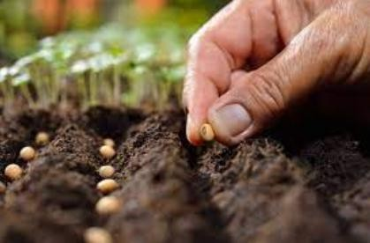
Broadcasting
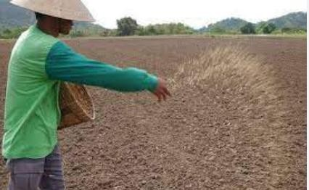
Dibbling
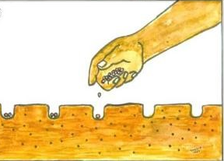
Drilling

What is the term used for describing the water that runs on the ground surface during and after raining?( 1mk)
__________________________________________________-

Name three minimum tillage practices for water conservation carried out in farming.( 3 mks)
  - ________________________________________________
  - ________________________________________________
  - ________________________________________________

