COMPETENCE BASED CURRICULUM
Kenya Junior Secondary Education Assessment
FORMATIVE ASSESSMENT
TIME
2 HRS
ENDTERM 1
AGRICULTURE AND NUTRITION
G7
2024
SCHOOL: ……….……………………………………………………..……
NAME: ……………….…………………..………………………...………..
SIGNATURE: ………………ASSESSMENT NO…………………………..
RUBRICS (for official use)
MARK SCORE RANGE | Below 40 | 40-59 | 60-79 | 80-100
PERFORMANCE LEVEL | Below expectation | Approaching expectations | Meeting expectations | Exceeding expectations

OUT OF | 100%
LEARNERS SCORE
PERCENTAGE SCORE
PERFORMANCE LEVEL

FOR FACILITATOR’S USE ONLY

Answer all Questions

MARKING SCHEME

- State two components of agriculture and nutrition. (2 mks)
- Agriculture
- Home science/ nutrition
- What is Soil pollution? (2 mks) is the contamination of soil with harmful substances.
- The harmful substances in the soil are known as pollutants or contaminants.(1mk)

- Mention six causes of Soil Pollution in Farming.(6 mks)

Excessive use of artificial fertilizers.
- These fertilizers introduce pollutants such as Nitrogen compounds and heavy metals into the soil which accumulate in the soil to toxic levels and become harmful to crops and soil living organisms.

Excessive use of agricultural chemicals (agrochemicals) such as herbicides and pesticides.
- These chemicals become pollutants when they get into the soil. They accumulate into the soil and become toxic to soil living organisms.

Throwing plastic wastes in the garden.
- Plastic wastes are not broken down by soil living organisms. They contaminate the soil and interfere with the growing crops or reduces agricultural space.

Throwing Chemical containers.
- Chemical leftovers from these containers get into the soil and become pollutants. The pollutants accumulate to toxic levels and become harmful to the soil living organisms.

Surface run off carrying contaminated water
- Surface run-off that contains any contaminants deposits them to the soil when passing over.

Industrial wastes
- Waste from industries have dangerous chemicals and heavy metals if not disposed off well ends up in the soil. The contaminants get into the soil and affect soil micro-organisms.
- List four effects of soil pollution. (4mks)
- It causes production of crops that are not safe for consumption or use by human beings. This poses health risks.
- Soil pollution also affects soil fertility and soil pH affecting agricultural production. This affects food security.

Outline five Safe Soil pollution Control measures include the following methods:(5 mks)
  - Reusing of plastic materials such as using bottles for drip irrigation.
  - Use of correct types and amount of artificial fertilizer and agrochemicals.
  - Safe disposal of used agricultural chemical containers.
  - Safe disposal of plastic wastes, containers and straws.
  - Recycling waste materials into other useful products.
  - Practicing organic farming which is the growing of crops and rearing livestock without using artificial fertilisers and agricultural chemical.
  - Planting trees and cover crops to reduce surface run-off than carry contaminants and distribute over the soil surface.
- State three ways of creating The awareness message against soil pollution. (3 mks)
  - Dramatization.
  - Presenting songs.
  - Poems.
  - Displaying posters etc
- Outline three damages caused by surface run off. (3 mks)

Soil erosion.
- Deposits contaminants such as fertilizer, oil, pesticides and dirt into water bodies causing water pollution.

Destruction to crops.
- Destruction to buildings and other infrastructure such as roads.
- Surface run off is conserved or collected in structures such as:(3 mks)

- Water retention ditches.
- Earth basins.
- Water retention pits.

- Name four importance of conserving water in Farming.(4 mks)

- Surplus or excess water can be conserved and used during the times of water scarcity in the farm.
- Conserving water reduces the cost of farming. This is because money that would be used to buy water in the farm is saved.
- Conserving water ensures availability of water for human life and livestock.
- A lot of water is wasted during rainy season.
- Rain water which forms surface run-off after heavy downpour is prevented from damaging property.

What is the way or methods used to conserve Surface run-off? (3mks)
- Construction of water retention ditches.
- Construction of an earth basin.
- Construction of a water retention pit.

Mention three Crops that can be established in water retention structures:(3 mks)
- Bananas.
- Arrow roots.
- Napier grass.
- Sugarcane.

Mention three importance of controlling soil pollution in farming? (3 mks)
- It ensures the soil remains productive.
- It promotes food security by making the soil more productive.
- Ensures safety of the farmers.
- Give three importance of water conservation in farming.(3 mks)
- Promotes food security where conserved water is used to grow crops along after the rains have stopped.
- It reduces cost of production by saving on money that would have been used to buy water and irrigation.
- Conserved water is used for human life and livestock.
- It prevents damage of property by surface run-off after a heavy rainfall.

- Match the following methods of planting ( 3mks)

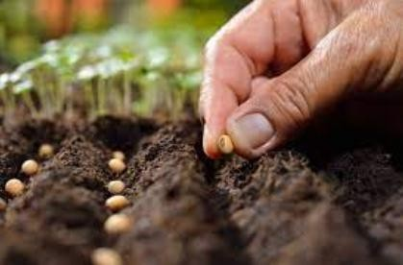
Broadcasting

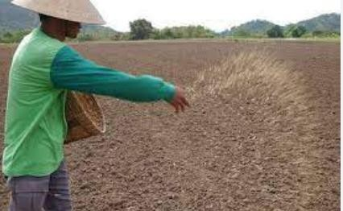
Dibbling
Drilling
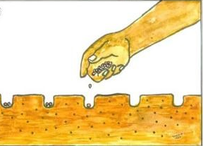

What is the term used for describing the water that runs on the ground surface during and after raining?( 1mk)
Surface run-off.

Name three minimum tillage practices for water conservation carried out in farming.( 3 mks)
  - Uprooting weeds.
  - Slashing weeds.
  - Mulching.
  - Restricted cultivation.

