NAME:………………..………………………… ……ADM. NO:………………..

CLASS:…………………………………………………DATE:.........................

FORM 3
232 / 2
PHYSICS
PAPER 2
2 HOURS

END TERM THREE EXAMINATIONS

INSTRUCTIONS TO CANDIDATES
- Write your name and index number in the spaces provided above.
- Sign and write the date of examination in the spaces provided above
- This paper consists of Two sections A and B
- Answer ALL the questions in sections A and B in the spaces provided.
- All working MUST be clearly shown
- Mathematical tables and Electronic calculators may be used.

For Examiners Use Only

Section | Question | Maximum Score | Candidates’ Score
A | 1 – 15 | 25
B | 16-21 | 55
 | TOTAL | 80

SECTION A (25MKS)

- State one disadvantage of using a pin hole camera to take photographs (1mk)
…………………………………………………………………………………………………….

- Name two advantages which a lead accumulator has over a dry cell (2mks)
………………………………………………………………………………………………………………………………………………………………………………………………………………
- A girl observes her face in a concave mirror of a focal length 90cm. If the mirror is 70cm away, state two characteristics of the image observed. (2mks)
…………………………………………………………………………………………………………………………………………………………………………………………………………….
4. What property of light is illustrated by formation of shadows? (1mk)
…………………………………………………………………………………………………………

5. Other than local action state another defect of a simple cell and explain how it reduces the current produced. (2mks)
……………………………………………………………………………………………………………………………………………………………………………………………………………

6. The figure below shows a simple experiment using a permanent magnet and two metal bars X and Y.
Y
X
After attraction
During attraction
Metal bar
X
Metal bar
Y

State, with reason, which bar is a soft magnetic material. (2mks)

…………………………………………………………………………………………………………………………………………………………………………………………………………………..
7.A plain sheet of paper and a plane mirror both reflect light yet only the plane mirror forms images. Explain why the paper cannot form images (2mks)
……………………………………………………………………………………………………………………………………………………………………………………………………………………
8.The Figure below shows an ammeter used to measure current through the conductor. The student used the lower scale.
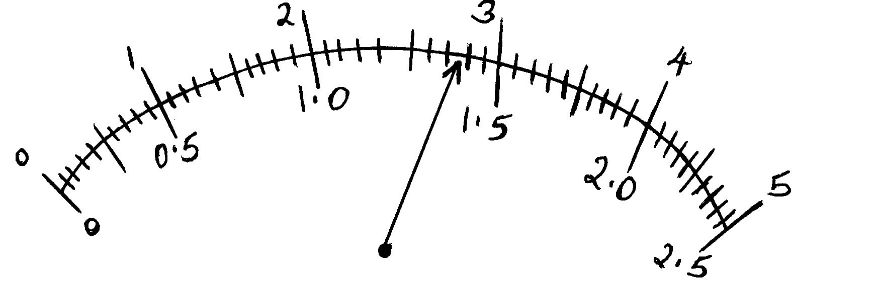

State the reading from the meter.
………………………………………………………………… (1mk)

10. Two similar razor blades are placed one on a wooden block and the other on a soft iron block as shown in the figure below
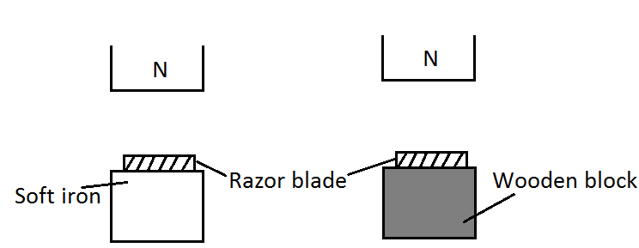

It was observed that the razor blade on the wooden block was attracted to the magnet
while the other on the soft iron block was not. Explain. (2 marks)
………………………………………………………………………………………………………………………………………………………………………………………………………………………………………………………………………………………………………
11. The figure below shows a displacement - time graph for a wave. Determine its frequency.
(3mks)
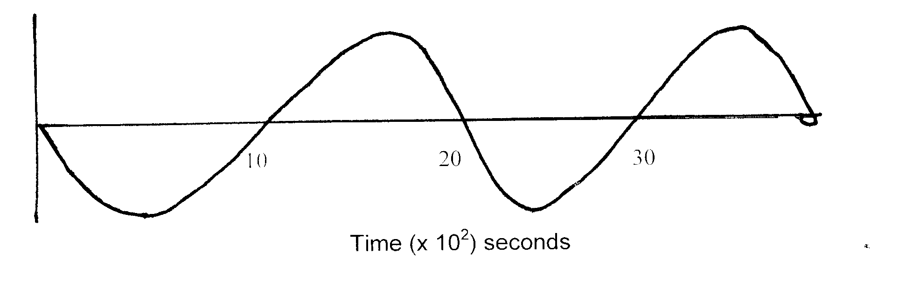

12 explain two reasons why in domestic electrical wiring bulbs are connected in parallel (2mks)

13 explain two defects of a simple cell (2mks)

14 differentiate between hammering in magnetization and demagnetization (2mks)

15 describe how an electric bell works

SECTION B (55 Marks)

Answer all questions in this section in the spaces provided

16.(a) (i) State Ohm’s law (1mk)

(b) A piece of red-hot charcoal is brought close to the cap of a negatively charged electroscope,
. Explain what is observed. (3mks)
…………………………………………………………………………………………………………………………………………………………………………………………………………………………………………………………………………………………………………………………………………………………………………………………………………..
(c) A cell of e.m.f E and internal resistance r is used to pass a current through various resistors R, Ohms and the values of current recorded in the table below.
R(Ohms) | 1.6 | 2.1 | 2.5 | 3.6 | 5 | 8
i(A) | 1 | 0.8 | 0.7 | 0.5 | 0.37 | 0.24
1/_{i}(A⁻¹)

(i) On the table record values of 1/i (1mk)

(ii) Plot a graph of 1/i versus R and use it to determine E (8mks)

17 (a) state and explain what happens when one removes a nylon cloth off the body (2mks)

(b) describe an experiment to investigate the law of charges ( 4mks)

(c) state basic law of charges (1mk)

(d) explain why repulsion is the surest test for electrostatic charging (2mks)

(e) a metal rubbed with a piece of cloth doesnot acquire charge (3mks)
(i) explain the phenomena

(ii) what precaution need to be taken so that the rod acquires charge

(f) explain 3 dangers of electrostatics ( 3mks)

18.(a) (i) State three properties of electric field lines. (3mks)
…………………………………………………………………………………………………
…………………………………………………………………………………………………
…………………………………………………………………………………………………

(ii) describe with explanations an experiment to show how the shape of a core affects the strength of an electromagnet (5mks)

19.a) Define the following terms as used in curved mirrors.
i) Principal focus (F). (1mk)
….………………………………………………………………………………………………
ii) Focal length (f) (1mk)
…………………………………………………………………………………………………

b) By use of a ray diagram, show how a concave mirror may be used by dentist when extracting teeth. (3mks)
…………………………………………………………………………………………………
…………………………………………………………………………………………………
…………………………………………………………………………………………………\
c) You are provided with the following apparatus a white screen, metre rule and concave mirror, using the apparatus, describe an approximate method of determining the focal length of the mirror. (3mks)

d) Show that the linear magnification M of a convex mirror is given by
Where V is the image distance and f the focal length of the mirror. (3mks)

e) The figure below represents an object, O, placed in front of a curved mirror.
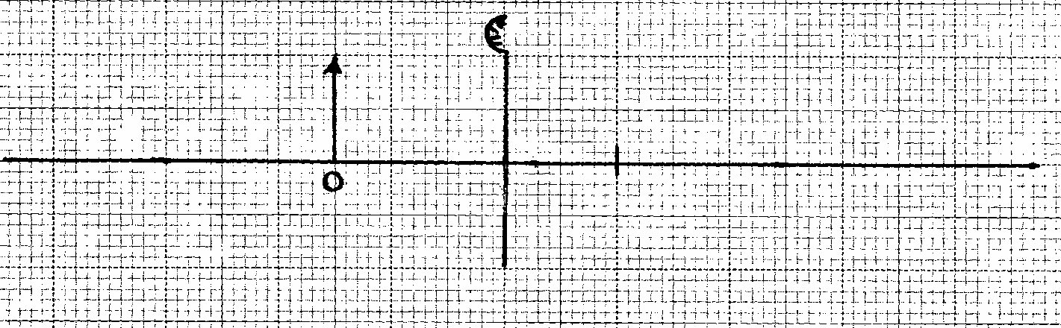
(i) By drawing suitable rays, complete the diagram to show the position of the image. (3marks)
F

  - State the characteristics of the image in (i) above (2mks)
………………………………………………………………………………………………………………………………………………………………………………………………………………………………………………………………………

20 (a)Differentiate between motor rule and Maxwell right hand grip rule (2mks)

(b)Define a solenoid (1mk)

(c)Describe how magnets should be stored (2mks)

