PHYSICS PP2 MARKING SCHEME FORM 3

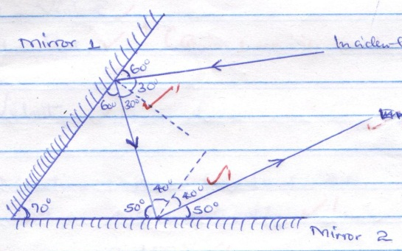
Incident light ray
All the angles must be indicated
- Eight dry cells in series have a very high internal resistance1 hence very little current can be drawn from them1
- The flame ionizes air producing both positive and negative ions1. The ions opposite to the charge of the electroscope are attracted to the cap of the electroscope causing discharge1.

- (a) X - Violet
Give 1mk if the two are correct
1
Y - Red
(b) Velocity 1
- Light waves have very short wavelength.1
- - Length of the conductor.1
- Cross section area of the conductors1
- a )Is a device used for storing charge
b ) C=E_{O}A/d
= 8.85*10⁻¹²*4*10⁻⁴/6*10⁻⁴
= 5.9*10⁻¹²
=5.90pF
Q = CV
=590*10⁻⁹*100
= 5.9*10⁻¹⁰C
- Q = It
= 0.8 x 6 x 60C ¹
∴Q = 288C ¹ (Units must be shown)
- .
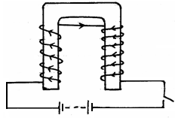
¹

10. ¹
¹
∴Speed = 320m/s ¹

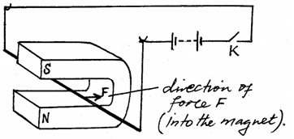
11. (a)

- - Reversing the direction of flow of electric current in the conductor.
- Reversing the direction of magnetic field;

- .i) Soft iron1 since it is easily magnetized and demagnetized.
ii) - Increasing the amount of current 1
- Increasing the number of turns on the coil1
13,. a) i) it requires a medium for transmission. 1
ii) It is propagated as a series of alternating compressions (High pressure zones) and rarefactions (Low pressure zones)1OR
The direction of the wave travel is parallel to the disturbance that produces it 1 (Any one)
b) i) To evacuate the bell jar 1 OR
To pump air in and out of the bell jar 1 (Any one)
ii) The electric bell starts ringing but its sound as heard from outside the bell jar reduces in intensity and diminishes. 1 This is because as the air is pumped out, the density of air in the bell jar reduces. 1 As this continues a vacuum is created in the bell jar which cannot transmit sound1hence the sound get diminished
iii) - It is not possible to create vacuum in the bell jar 1
- Some sound is transmitted through the connecting wires and the walls of the bell jar.1
c) i) - It penetrates deepest. 1
- It can be reflected easily by tiny grains.1
ii) S = $\frac{D}{T}$⇒ D = 84 x 2 = 164m
T = 0.12s
S = $\frac{168}{0.12}1$ = 1400 m/s 1
d) -Temperature of the solid√
-Density of the solid√
14 a) i) Double stroke method. 1
ii) A - South pole1
B - North pole1
iii) - Induction method.1
- Mechanical method - Hammering1
- Electrical method.1 (Any one)
b) i) Alternating current (a.c)
ii) It reverses many times per second, 1 disorienting the magnetic dipoles.1
c) So that they don’t retain any magnetism1 due to earth’s magnetic field.1

15. a( i) For a concave mirror ,is the point at which all rays parallel and close to the principal axis converge after reflection. For convex is the point at which all rays parallel and close to the principal axis appear to diverge from after reflection by the mirror

( ii) Is the centre of the sphere of which the mirror is part
(iii) Is a plane perpendicular to the principal axis and passes through the principal focus

b) u=+18 cm
f= +12 cm
using 1/v+1/u=1/f
1/v+1/+18=1/+12
1/v+1/18=1/12
1/v=1/12-1/18
1/v=-1/36
V=-36 cm

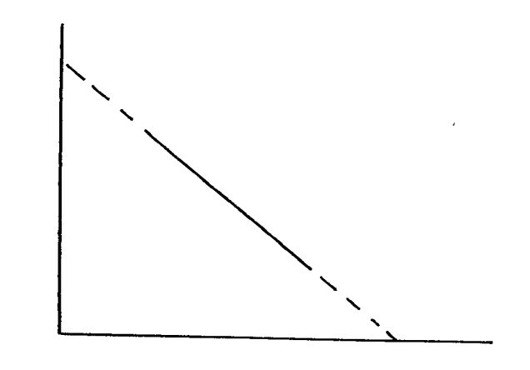
c)
I
u

I
v

(i) I – intercept = 0.07
u
I = 0.07
f
f = 0.07 = 1/ 0.07
= 14.29cm

(ii) I = I + u
f u v

I = I + I
14.29 20 v

I = 1 - 1
V 14.29 20
= 0.07 – 0.05
= 0.02

V = 1
0.02
= 50cm

- (a) (i) = V = IR ⇒ R = $\frac{V}{I}$
= $\frac{12}{2}$
= 6Ω
(ii) Y, Z are parallel
$\frac{1}{R_{P}}$ = $\frac{1}{6}$ + $\frac{1}{6}$
$P_{P}$ = 3Ω
X in series with $P_{P}$
⇒ $R_{T}$ = (6 + 3)
= 9Ω
(iii) I = $\frac{V}{R}$
= $\frac{12}{9}$
= 1.333A
X
Y
Z
(iv)

(b) (i) E.m.f = 1.5V
(ii) Terminal voltage = 1.3V
(iii) R = $\frac{V}{I}$
= $\frac{1.3}{0.5}$
= 2.6Ω

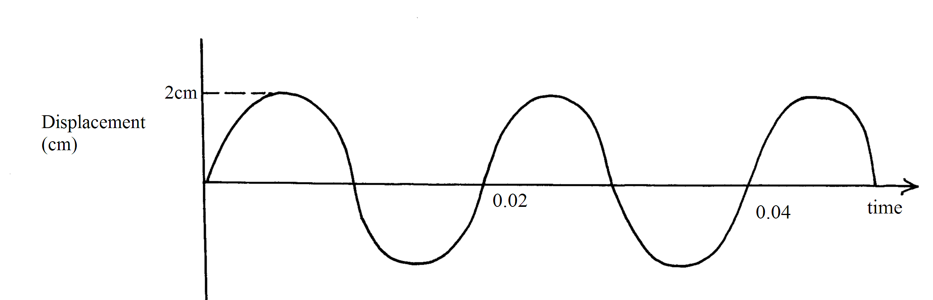
Axes correctly labelled;
2 complete circles:
T= 1/50 = 0.025; correct time indicated;

b) Direction of the wind ;
Temperature of the air
Humidity of the air

c) -Determining the speed of sound in air√ 1
-Determining distances using pulse echo-technique√ 1

