PHYSICS PAPER 1 FORM 3 MARKING SCHEME

Volume = 7.4cm³ – 4.6cm³ = 2.8 cm³
Density = mass = 11g = 3.9/cm³
Volume 2.8cm³

- In (a) the adhesive force between water and capillary tube is stronger than the cohesive force between water molecules while in (b) the cohesive force between mercury molecules is stronger than adhesive force between mercury and the tube.
- Force = Pressure x Area
P=hpg
=2x1000x10= 20 000
A = 2
10000
=0.0002m²
P = FxA
= 20000x 0.0002 = 4N
- Water and glass are poor conductors of heat.
- (i)Making the bore very fine
ii)Reducing the size of the bulb
iii)Making the wall of the bulb very thin
- (i)Friction is a force that resists one surface from sliding over the other.
ii) F = $μ$R
= $μ$mg
=0.6 x 30x10
= 180N
iii)- Use of rollers
- Use of ball bearings
- Lubrication
- (i)- Length of a conductor
- Cross-section area of a conductor
- Temperature difference between the ends of a conductor
- The nature of the material. [any two]
ii)On the wooden block. The wooden block is a poor conductor of heat and so all the heat goes in melting the wax.

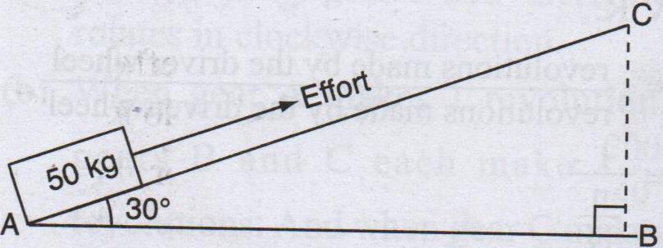
SECTION B
- (a)

V.R = 1
SIN 30
= 2
M.A= efficiency x V.R
= 72 X 2
100
= 1.44
Effort = load
M.A
= 50x10
1.44
= 347.2N
b)Work done against friction = work input – work output
work out put = mgh
= 50x10x4 = 2000J
Work input = effort x distance moved by effort
= 347.2 x AC
= 347.2 X 4
SIN 30
= 2777.65
Therefore work done against friction
= 2777.6 – 2000
= 777.6J
c) Efficiency = work output x 100
Work input
Work input = 2000x10 x 22 = 550 000J
0.8

- (a)i)The pressure above tube B is low than that above tube A. this is caused by high velocity of air above B compared to velocity above tube A.
ii) When the gas tap is opened, gas flows at high speed creating a low pressure region above the nozzle. The higher atmospheric pressure on the outside pushes air in and the gas burns
b) i) Centre of gravity is the point of application of resultant force due to earth’s attraction on the body.
ii) Sum of clockwise moment = sum of anticlockwise moments
0.1xw + (1x0.60) = 2x0.4
0.1w + 0.6 = 0.8
0.1w = 0.8 -0.6
0.1w = 0.2
W = 2N
- (a)Methylated spirit evaporates faster [is highly volatile] than water taking away the latant heat faster from the hand.
b)Specific latent heat of fusion of a substance is the quantity of heat required to melt completely one kilogram of a substance at constant temperature.
c)i)I. E = pt
= 60x5x60 = 18000J
II. E = L_{f}
18000 = 60 x L_{f}
1000
L_{f} = 300000J/kg
ii)The temperature of the room melted some ice since it was higher than the melting point of ice.
- (a)i)Smoke particles are used to show the behavior of air molecules since they are more visible than air molecules and light enough to move when bombardment by air molecules.
ii) The lens focuses the light from the lamp on the smoke particles causing them to be observable.
iii)The microscope enlarges [magnifies] the smoke particles so that they are visible.
b)The smoke particles are seen to be in constant random motion. The motion is caused by uneven bombarded by invisible particles of air.
c) The smoke particles would move faster.

- (a)i) OA : Body moves with constant acceleration or the body moves with uniformly increasing velocity.
ii)AB: Body moves with non-uniform decceleration.
iii)BC : Body moves with constant velocity or moves with zero acceleration.
b)i)I. V = U + at
= 10-(2.5x1.5)
= 6.25m/s
II. S= Ut + ½ at²
=(10x1.5)- ( ½ x2.5 x 1.5²)
= 12.1875m
III. V= u +at
O = 10 – 2.5t

T = 4 seconds
c)i) A body remains at rest or in a uniform motion in a straight line, unless acted upon by an external force.
ii)Total momentum before releasing the catapult.
= m₁u₁ + m₂u₂
=(0.25 x 0 )+ (0.01 x 0)
[Both catapult and stone at rest]
= 0kgm/s

Momentum of the catapult after release
=0.25 x v
=0.25vkgm/s

Momentum of the stone after release
= 0.01 x 175
=1.75kgm/s
Total final momentum is given by
= 1.75 + 0.25v

Initial momentum = final momentum
O = 1.75 + 0.25v
-1.75=0.25v

-1.75 = V
0.25
- 7 = V
$∴V=−7M/S$

