MARKING SCHEME
PHYSICS FORM 3

1.

Disp(m)

Time (s)

2

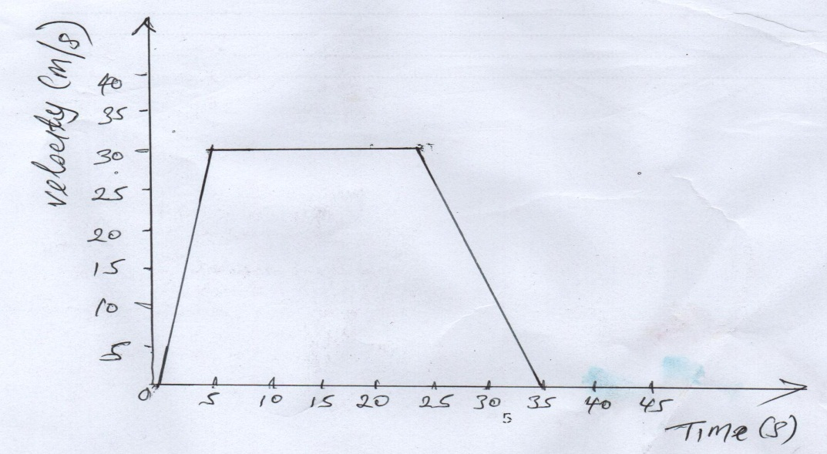
3. When a can is heated, air molecules are expelled from the can. When sealed the steam pressure balances the atmospheric pressure. On cooling the steam condenses creating partial vacuum on the inside . The outer atmospheric pressure on the outside makes the can Collapse.
4. The volume decreases so the collisions of the molecules with wall of the container increased hence the pressure increases
5. Assuming no heat loss , heat gained by the liquid =pt
MC𝝙Ө=Pt
2C x(30-20)=90x15x60
$C=\frac{Pt}{MΔӨ}$= $\frac{90x15x60}{2(10)}=4050J/Kg$ 2a

6. 2x0.25=0.2xW
W$=\frac{2x0.25}{0.2}$=2.5N

7. Hydrogen diffuses faster than helium since it is less dense
8. Initially the two balls accelerate through the liquid because of the weight, Mg greater than the sum of the upthrust and vicious drag. Viscous drag however increases with increase in velocity. The difference In the two graph is the fact that viscocity of L1 is greater than the viscocity of L2
9. The drop of coloured water initially rises up slightly then starts to drop
10. When the gas top is opened, gas flows at high speed creating a low pressure region above the nozzle . The higher the pressure on the outside pushes in air and the gas burns.
11. The gravitational force is different on different planets. Since the weight of the two bags is the same, then the masses must be different

SECTION 2
12. (a)Force=pressure x Area
P=ɦℓG=20x100x 10=20000 N/m²
F=20000$x\frac{2}{10000}=4N$
OR
MASS= density x volume
$$=1000=1000x\frac{2}{10000} x 2=0.4kg$$
Force= mass x gravity= 0.4kg x10= 4N

(b) P$=\frac{F}{A}=\frac{2500}{0.25x4}=25000pa$

(c) potential energy kinetic energy heat+ sound
13)
- Work done by forcer = F d=200x22.5= 4500J
- Work done by mass =M g h=30x10x7.7=2250J
- Work done to friction=work done by force -work done on mass =4500-2250J
(I) $efficiency=x=\frac{work output}{ work input} x 100=\frac{2250}{4500} x 100=50\%$
14. (a) Resistance=8N
(b) F=ma 14-8=30a a=6/30=o.2m/s²
16 F=MA =2x5=10N
(c)Frictional force =applied force-accelerating force = 12N-10N=2N

15(i) since U=0,S=1/2g² →45=1/2 x10 x t^{2→} t=3s
(ii) S = u t, 50=U x 3 →u=16.7 m/s
(iii)V=u + g t=0+10x3==30m/s

16.(a) V₁ =142mm, T₁=278+17=17=290 v₂=? T₂=298
$\frac{v_{1}}{v_{2}}= \frac{ v_{2}}{T_{2}}= \frac{142}{290}=$ $\frac{v_{2}}{298} →$ $V_{2}$=$\frac{298x142}{290}$ = 145.92MM

(b) The hot temperatures heat up he air inside the tyre and the molecules gain more kinetic energy and move faster since the volume is constant, the molecules collide more quickly with the walls of the tyre which leads to the greater change of momentum per unit time. This leads to greater change per momentum per unit. This leads to an increase in pressure

17. Heat = power x Time =2500x 4 x60 = 600,000 Joules

(ii) 600,000 MC𝝙Ө=2x 4200 x𝝙Ө $ΔӨ=\frac{600000}{2x 4200}$=71.43^{O}C

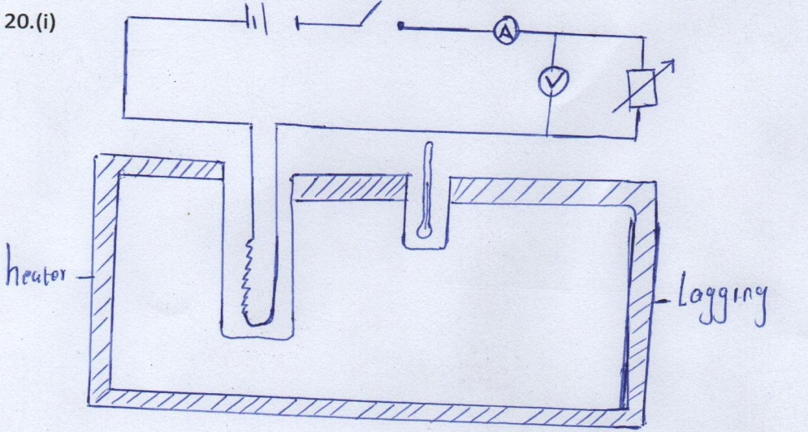

(ii) voltage from the voltammeter. Curre Nnt from ammeter .Time from stopwatch
(iii) VIt = MC (Ө₂-Ө₁) , c $=\frac{VIT}{ M(Ө_{2}-Ө_{1 })}$

(b)Reducing the size of the bore
Making the bulb thin
Reducing the size of the bulb

