NAME: …………………………………….………ADM NO: …………
CLASS: …………..
JOINT EXAMINATION
TERM THREE 2023
FORM 3
121/2 MATHEMATICS
PAPER 2
Time: 2 hours 30 MINUTES
Instructions to students
- Write your NAME, ADMISSION NUMBER and CLASS in the spaces provided above.
- This paper consists of TWO SECTIONS: SECTION I and SECTION II.
- Answer ALL the questions in SECTION I and ONLY FIVE questions from SECTION II.
- All answers and working must be written on the question paper in the spaces provided below each question.
- Show all the steps in your calculations, giving your answers at each stage in the spaces below each question.
- Marks may be given for correct working even if the answer is wrong.
- Non-programmable silent electronic calculators and KNEC Mathematical tables may be used except where stated otherwise.

For Examiner’s use only.

Section I
1 | 2 | 3 | 4 | 5 | 6 | 7 | 8 | 9 | 10 | 11 | 12 | 13 | 14 | 15 | 16 | Total

Section II Grand
17 | 18 | 19 | 20 | 21 | 22 | 23 | 24 | Total
Total

SECTION I: (50 MARKS)
Attempts all the questions in the spaces provided
- Evaluate $\frac{\frac{1}{2}of3\frac{1}{2}+1\frac{1}{2}\left(2\frac{1}{2}-\frac{2}{3}\right)}{\frac{3}{4}of2\frac{1}{2}÷\frac{1}{2}}$ (3mks)

- Use logarithm to 4 decimal places to evaluate (4mks)

- A bag contain 3 red and 5 green marble. Two marble are picked at random from the bag one at a time without replacement. Find the probability that two marble picked will be at of different colours (3mks)

- The figure below shows a triangular prism. The measurements are in cm
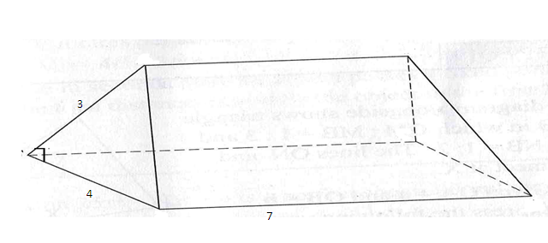
Draw the net of the prism and hence find the total surface area (4mks)

- Make x the subject of the formular (3mks)
$A=\sqrt{\frac{1-x}{1+x}}$

- Simplify by rationalizing the denominator (3mks)
$\frac{3}{2-\sqrt{2}}$

- The scientific calculator is marked at sh 1560. Under hire purchase it is available for down payment of sh. 200 and six installments of sh. 250 each. Calculate:
- The hire purchase price (2mks)

- The extra amount paid out over the cash price (1mk)

- Solve the equation (3mks)
$\log\left(x+2\right)-2 log3=log⁡(9-2x)$

- Expand ${\left(1+2x\right)}^{8}$ in ascending power of $x$ upto the term $x^{3}$. Hence evaluate ${\left(1.02\right)}^{8}$ to 4 S.F (4mks)

- The equation of a circle is $x^{2}+y^{2}+4x-10y-7=0$ determine the centre and the radius of the circle (3mks)

- Find the quadratic equation whose roots are 2 and -3 and write in the form ${ax}^{2}+bx+c=0$ where a,b,c are integers (3mks)

- The cost of maize flour and millet flour is kh 40 and ksh 52 respectively. Calculate the ratio in which they were mixed for the selling price to be ksh 46 per kilogram (3mks)

- Pipe A can fill an empty water tank in 3hrs while pipe B can fill the same tank in 6hrs. when the tank is full it can be emptied by pipe C in 8hrs. pipe A and B are opened at the same time, when the tank is empty. If one hour later pipe C is also opened, find the total time taken to fill the tank. (3mks)

- The ratio of the 10th to the 8th term of a geometric progression is 9. Find the two possible common ratios (3mks)

- Simplify $\frac{p^{2}-2pq+q^{2}}{p^{3}-{pq}^{2}}$ (2mks)

- Find the value of $x$in the matrix $\left(\begin{matrix}x & 1 \\ 4 & x-3\end{matrix}\right)$if it is a singular matrix (3mks)

SECTION B (50 MARKS)
Answer any five questions in this section
- The frequency table below shows the masses in kilograms of 30 people.
Class | Frequency
60-64  65-69  70-74  75-79  80-84  85-89 | 4  6  8  7  X  2

- Find the value of x (2mks)

- State the modal class (2mks)

- Estimate
- The mean (4mks)

- The median (3mks)

- In the figure below A and B are centers of circles intersecting at point P and Q angle PBQ=97.2^{O} while PAQ=52^{O} PB=4cm while AP= 10cm
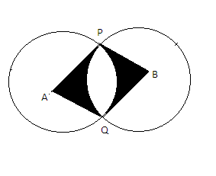
Determine:
- The length AB (2mks)

- The area of sector APQ (2mks)

- The area of the quadrilateral APBQ (3mks)

- The area of the shaded region (2mks)

- In the figure below O is the centre of the circle. Angle SPQ = 53^{O} and angle PQO= 30^{O}
Giving reasons find the size of angles

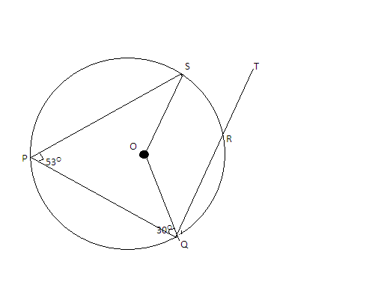
- Reflex SOQ (2mks)

- PSO (3mks)

- SRT (2mks)

- If the radius of the circle is 14cm find the area of the quadrilateral OQPS (3mks)

- The figure shows triangle OPQ in which QN:NP = 1:2, OT:TN = 3:2 and M is the mid- point of OQ

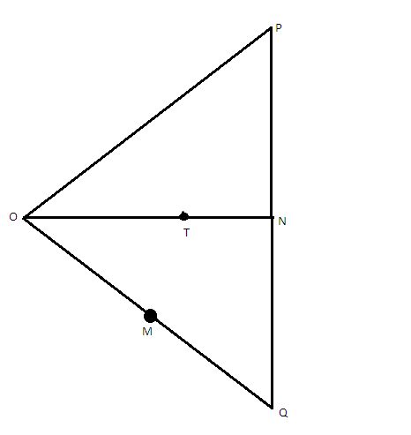
OP=p and OQ=q
- Express then following in terms of p and q
- PQ (2mks)

- ON (2mks)

- PT (2mks)

- PM (2mks)

- Hence show that P, T and M are collinear (3mks)

- A bus left Nairobi at 7.00am and travelled towards Eldoret at an average of 80km/hr. at 7.45am a car left Eldoret towards Nairobi at an average speed of 120km/hr. the distance between Nairobi and Eldoret is 300km. calculate:
- The time the bus arrives at Eldoret (2mks)

- The time of the day, the two vehicle met (2mk)

- The distance from Nairobi where the two vehicle met (2mks)

- The distance of the bus from Eldoret when the car arrived at Nairobi (2mks)

- P,Q and Rare three quantities such that P varies directly as the square of Q and inversely as the square root or R.
- Given that P=12 when Q=24 and R =36 find P when Q= 27 and R = 121 (3mks)

- If Q increases by 10% and R decreases by 25%, find the percentage increase in P (4mks)

- If q is inversely proportional to the square root of P and P= 4 when Q=3 calculate the value of P when Q =8 (3mks)

- Veterinary researcher were experimenting with a new drug in fowls in a research station. A sample of fowls which were known to have the disease was used. In this sample 30 fowls were treated with the drug and the remaining 18 fowls were not treated.
- Calculate the probability that fowls selected random from the sample is:
- Treated with drug (1mk)

- Not treated with the drug (1mk)

- The probability that a fowl treated with the drug will die is $\frac{1}{10}$ while the probability of the one which is not treated will die is $\frac{7}{10}$, calculate the probability that a foel picked at random from the sample is:
- Treated with the drug and will die (2mks)

- Not treated with the drug and will die (2mks)

- Treated with the drug and will not die (2mks)

- Not treated with the drug and will not die (2mks)

- (a). complete the table below for the equation $y=x^{2}+3x-6,$ given that $-6≤x≤4$ (2mks)
x | -6 | -5 | -4 | -3 | -2 | -1 | 0 | 1 | 2 | 3 | 4
y | 12 |  |  | -6 |  |  | -6 |  |  |  | 22
(b)Using a scale of 1cm to present 1 unit in the x-axis and 2 units in the y-axis, draw the graph of $y=x^{2}+3x-6$ (4mks)

(c). Use your graph to solve the quadratic equation
- $x^{2}+3x-6=0$ (2mks)

- $x^{2}+3x-2=0$ (2mks)

