**F3 MATHS PP1 TERM 3 2023 MARKING SCHEME**



1. Share of elder boy =

Share of younger boy=

=

Girls share =



% share of younger boy to girls share



1. 32(t+1)+32t=30

32t . 32+32t =30

32t(32+1)=30

32t×10=30

32t=31

2t=1

t= ½

1. 2x + 20 + x-50=180

3x – 30 = 180

3x = 210

3 3

x = 70

Each exterior angle = 70 – 50

= 200

No. of sides = 360

20

= 18

|  |  |
| --- | --- |
| Commission = 56,000 – 10 000  = Ksh. 46,000  Sales above 100 000 = 500 000 – 100 000  = Ksh. 400 000  Rate of commission = 46000 x 100%  400 000  = 11.5% | M1  M1  A1 |

1. 50,48,46,……………

$T_{8}$ = 50 + 7x (-2)

= 36

$S_{20}$ = $\frac{20}{2}$ (2 x 50 + (20 – 1) (x – 2)

= 620

1. (a) x(x + 4) = 96

+ 4x – 96 = 0

(x-8) (x + 12) = 0

x = 8

Length = 12

Width = 8

(b) Perimeter = 2 (8 + 12) = 40m

1. M1 = y

x

= 3 + 6

2 – 8

= 9 = -3

-6 2

M1 x M2 = -1

- x m2 = -1

M2 =

Taking (x,y) and P(2,3)

y-3 = 2

x- 2 5

3y – 9 = 2x -4

3y = 2x + 5

y = 2x + 5

3 3

1. PQ = q - p

~ ~

= (3ɩ -2j)- (2ɩ +3j)

= 3ɩ - 2j - 2ɩ - 3j

= I – 5j

/PQ/= $\sqrt{\left(1\right)2+\left(-5\right)2}$

= $\sqrt{26}$

= 5.099

1. 12 – 2x ˃ 18x – 8

= 20x ˃ - 20

x ˂ 1

18x – 8 ≥ -28 – 2x

20x ≥ - 20

X ≥ -1

-1 ≤ x ˂ 1

Integral solutions: 01, 0.

1. b 2 = a.c

2

-20 2 = 25k

2

100 = 25 k

K = 100

25

= 4

12

AB= $\left(\begin{matrix}K & 4 \\ 3 & 2\end{matrix}\right)$ $\left(\begin{matrix}1 & 2 \\ 3 & -4\end{matrix}\right)=\left(\begin{matrix}K+12 & 2K-16 \\ 9 & -2\end{matrix}\right)$

-2(K+12) -9 (2K-16)=10

-2K-24-18K+144=10

-20K = -110

∵K=5.5

13 I=

90,000 x 6.5 x 5

100 x 2

= sh.29,250

A =(90,000+29,250)

=SH. 119,250

14

$\log{\frac{b^{2}}{a }}$ = $\log{b^{2}-\log{a}}$

2(0.48) – 0.30

0.96 – 0.30

= 0.66

1. 3x – 180 = 30 or 330

3x – 180 = 30

3x = 210

x = 700

OR

3x – 180 = 330

3x = 510

x = 1700

1. Min Area = (19.95( (24.95)

= 497.7525

Max. Area = (20.05)(25.05)

= 502.2525

502.2525 – 497.7525

2

2.25 x 100

1. = 0.45%

|  |  |  |
| --- | --- | --- |
| **17**. Time of = 2 ½ hrs  Flow  Volume in 2 ½ hrs = 6.16 x 10 x 2 ½ x 3600  = 554400 cm3  Volume of tank = 3h = 554400  10000  H = 554400 m  30000  = 18.48m | B1  M1  M1  M1  A1 |  |
| Volume in per sec. = 6.16 x 10 – 11.6  = 61.6 – 11.6 = 50cm3  Volume of tank = 1.2 x 30000 x 100  Time = 3600000 sec  50  = 72000  3600  = 20 hrs | M1  A1  M1  M1  A1 (10) |  |

18

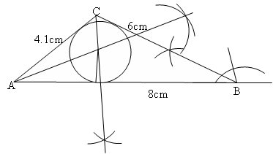

Triangle ABC

AC = 4.1cm

Bisecting <S

Circle

Radius = 1.2cm

Area = ½ x 8 x 6 sin 300 - x 1.22

= 4 x 6 x 0.5 – 4.5257

= 12 – 4.5257

= 7.4743

19

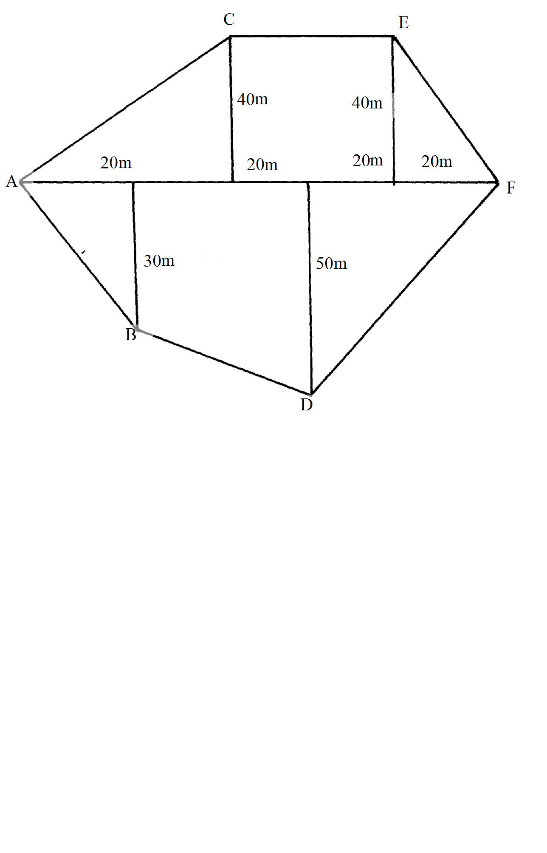



20. 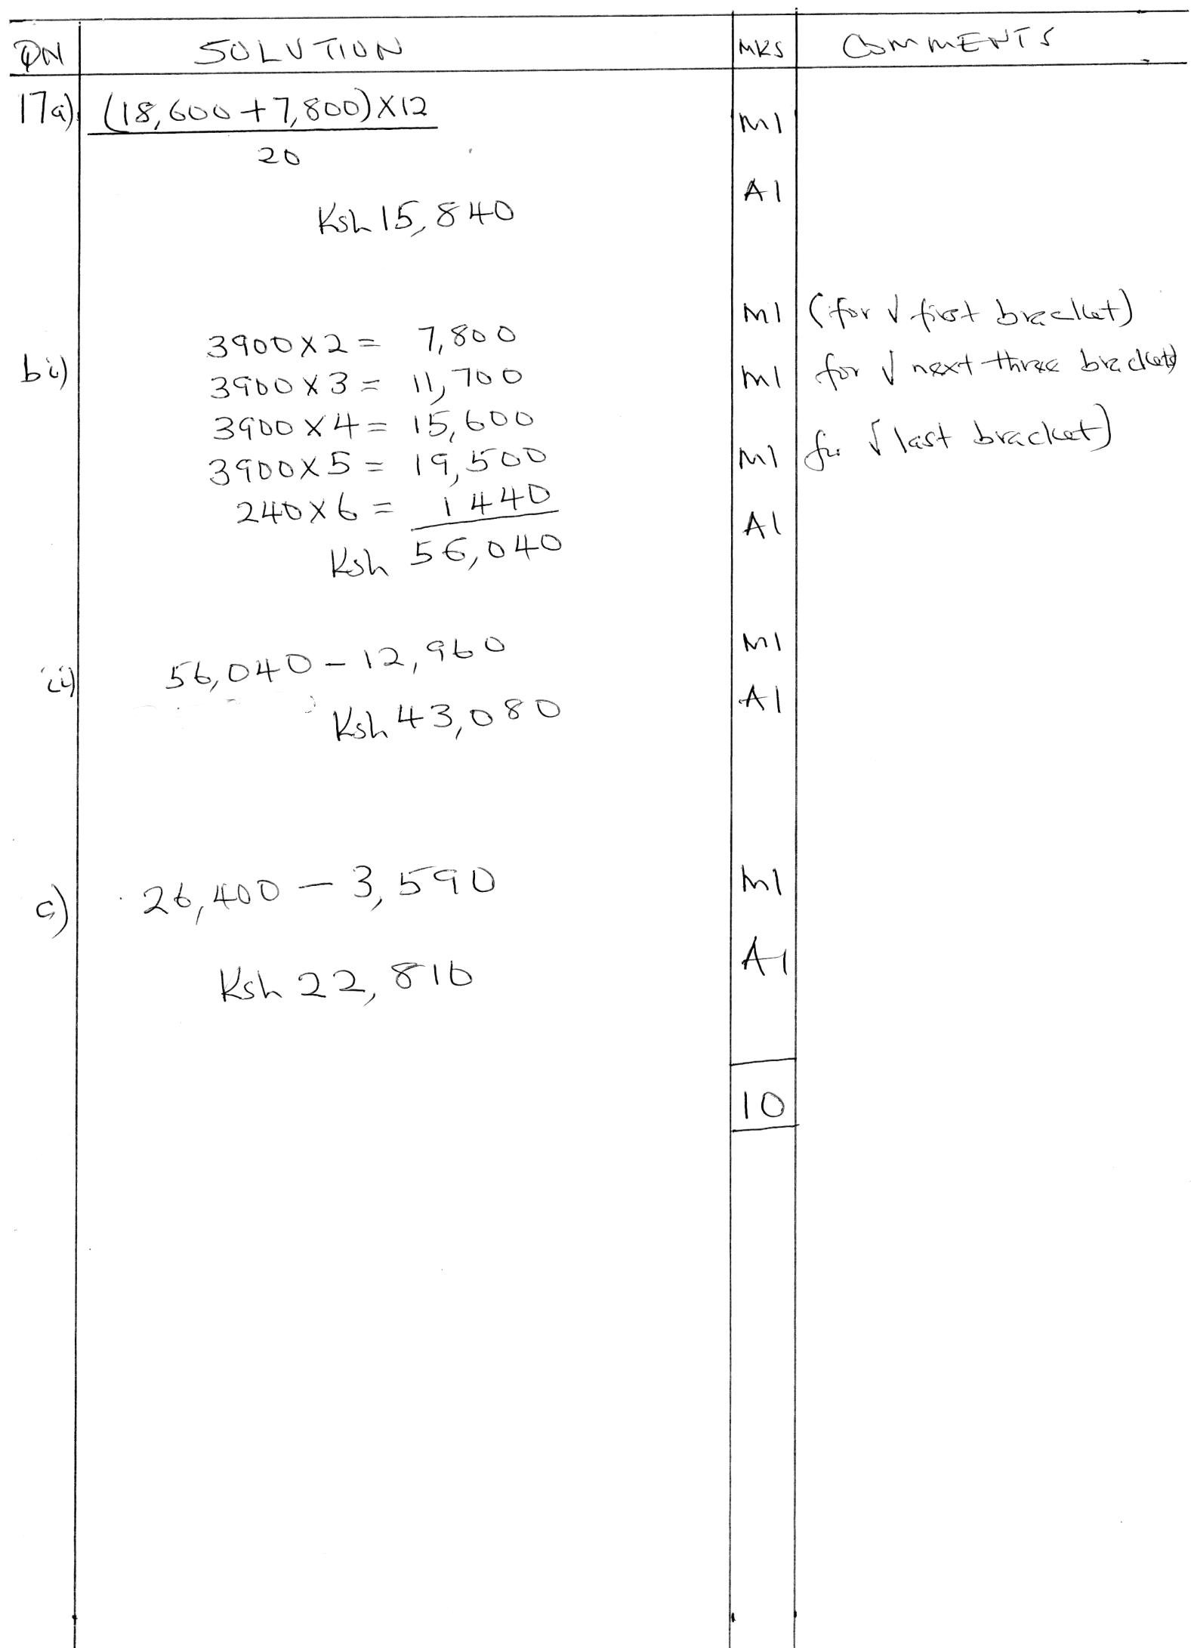

|  |  |  |  |
| --- | --- | --- | --- |
| **21** | (a)  Sum of arithmetic progression          Last five terms  term is a + 40d  term is a + 39d  term is a + 38d  term is a + 37d  term is a + 36d  total  Solving (i) and (ii) simultenously;          (b)  Last term is a + 40d    (c) | M1  M1  M1  A1  A1  M1  A1  M1  M1  A1 | Formation of each equation  Solving two equations simultaneously  For common difference  For the first term |

22.a)

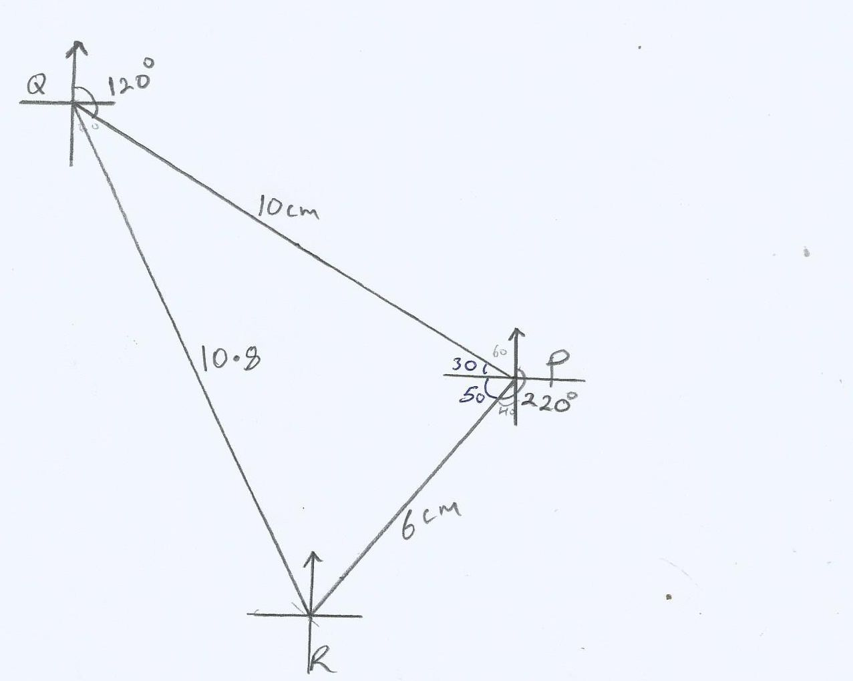

b) i)10.8 x2 = 21.6 km

ii)0400 + 1

iii) 1530 + 1

c) A = ½ a b sin

= ½ x 12 x 20 sin 800

= 118.18 km2

|  |  |  |  |
| --- | --- | --- | --- |
| **23** | (a)      cm  (b)  Let  be        (c)  Let  be    (d)  Area of ΔACD | M1  A1  M1  M1  A1  M1  M1  A1  M1  A1 | Accept 47.940,47.960 depending on the method  22.890 is possible. |

24

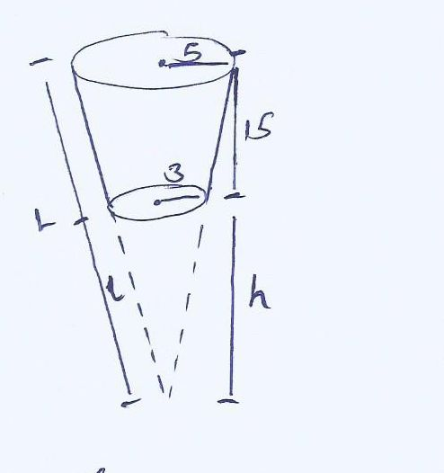

h = 6

15 + h 10

10h = 90 + 6h

4h = 90

H = 22.5

H = h + 15

= 37.5

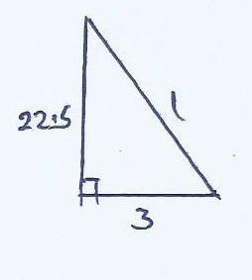

L = 2 + 9

= .25

= 22.70

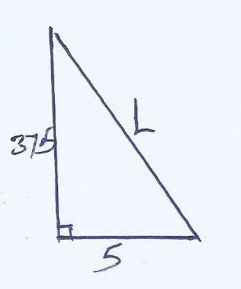

L = 2 + 25

=

= 37.83

S.A = (2

= (3.142 x 5 x 37.83 – 3.142 x3 x 22.70) + (3.142.9)

= 380.3391 + 28.278

= 408.6111 cm2

b) Volume = $\frac{1}{3}$ AH – $\frac{1}{3}$ Ah

= ( $\frac{1}{3 }$ x 3.142 x 25 x37.5)- $\frac{1}{3}$ (3.142 x 9 x 22.5)

= 981.875 – 212.085

= 769.79 cm3