NAME:………………..………………………… ……ADM.NO:……………

SCHOOL:…………………………………… ………. CLASS: ………………

CANDIDATE’S SIGNATURE:................................. DATE:.............................

312 / 1
GEOGRAPHY
PAPER 1

2 ¾ HOURS

END TERM EXAMINATION
FORM 3

312 / 1
GEOGRAPHY
PAPER 1

INSTRUCTIONS TO CANDIDATES

- This paper has two sections: A and B
- Answer all questions in section A.
- In Section B answer Question 6 and any other TWO questions.
- All answers must be written in the official answer sheet provided.
- This paper consists of 5 printed pages. Candidates should check the question paper to ensure that all pages are printed as indicated and no questions are missing.

SECTION A
- (a) How does a sea breeze occur? ( 2 mks)

(b) Use the map of Africa below to answer questions
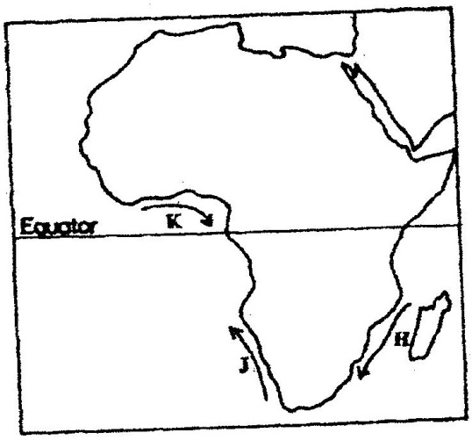

- Name the ocean currents marked H,J, and K ( 3 mks)
- State two effects of a warm ocean current on the adjacent coastlands ( 2 mks)

- Give two processes involved in each of the following types of weathering
(a) Physical weathering ( 2 mks)
(b) Chemical weathering ( 2mks)

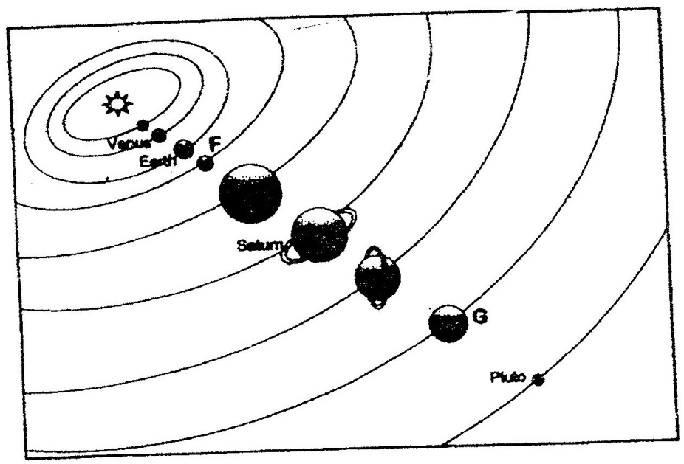
- The diagram below shows the composition of the solar system

(a) Name the planets marked F and G ( 2 mks)
(b) State three effects of the rotation of the earth on its axis ( 3 mks)

- (a) Name two scales used to measure the intensity of an earthquake ( 2 mks)
(b) Give three causes of earthquakes ( 3 mks)

- The table below represents rainfall and temperature figures for a town in Africa. Use it to answer the questions that follow

Month | J | F | M | A | M | J | J | A | S | O | N | D
Temp (⁰C) | 27 | 28 | 28 | 28 | 27 | 25 | 25 | 24 | 25 | 26 | 27 | 26
Rainfall (mm) | 25 | 38 | 99 | 140 | 277 | 439 | 277 | 69 | 142 | 201 | 71 | 25

(a) (i) calculate the annual range of temperature for the town ( 2 mks)
(ii) Calculate the mean annual rainfall for the town (2mks)

SECTION B
- Study the map of oyugis 1:50,000 (sheets 130/1) provided and answer the following questions
- i) what type of map is Oyugis extract ? (1mk)
ii) Give two scales that have been used in the map extract. (2mks)
iii) Measure the length of the township boundary shown on the map. Give your answer in kilometers. (2mks)
iv) Calculate the area covered by kodera forest. Give your answer in square kilometers. (2mks)
- i) Identify the methods that have been used to represent relief of the area covered by the map. (2mks)
ii) Name the physical features found in the grid square 6842. (2mks)
- Describe the drainage of the area covered by the map. (6mks)
- (i) Apart from agriculture, name two other economic activities in the area covered by the map. (2mks)
(ii) Citing evidence from the map, give three reasons why the area covered by the map is suitable for agricultural activities. (6mks)
- (a) (i) Name three types of faults ( 3 mks)
(ii) Apart from compressional forces, explain two other processes that may cause faulting ( 4 mks)

(b) With the aid of diagrams, describe how compressional forces may have led to the formation of the great rift valley ( 8 mks)
(c) Explain five ways in which faulting is of significance to human activities ( 10 mks)
- (a) (i) What is an ice sheet? (2mks)
(ii) Give two reasons why there are no ice sheets in Kenya (2mks)
(iii) Explain three factors that influence the movement of the ice from the place where it has accumulated (6mks)
(b) Describe how an arête is formed (4mks)
- The diagram below shows types of moraines in a valley glacier

    - Name the type of moraines marked S, T and V (3mks)
    - Explain four positive effects of glaciation in lowland areas. (8mks)

9. (a) Differentiate between river rejuvenation and river capture. (2 marks)

(b) Give three features resulting from;
(i) River rejuvenation; (3 marks)
(ii) River deposition. (3 marks)

(c) Explain the four ways through which a river transports its load. (8 marks)

(d) You are planning to carry out a field study on the lower course of a river.
- Give three reasons why you would require a route map. . (3 marks)
- State three characteristics of a river at the old stage that you are likely to observe during the field study. (3 marks)
- Give three follow-up activities you would be involved in after the field study. (3 marks)

10 The diagram below represents a well developed soil profile. Use it to answer question (a).
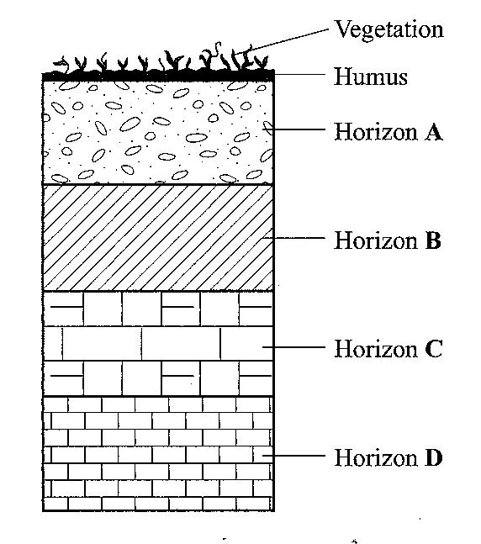
(a) (i) Describe the characteristics of horizon B. (3 marks)
(ii) Apart from humus, name three other components of soil. (3 marks)
(iii) State three ways in which humus contributes to the quality of soil. (3 marks)
(b) (i) Differentiate between soil structure and soil texture. (2 marks)
(ii) Explain how the following factors influence the formation of soil;
• Topography; (6 marks)
• Time. (2 marks)
(c) Explain how the following farming practices may lead to loss of soil fertility:
(i) Overgrazing; (2 marks)
(ii) Frequent ploughing; (2 marks)
(iii) Continuous irrigation. (2 marks)

