Name__________________________________________ Adm No __________
Date___________________________________________ Sign______________
JOINT EXAMINATION
312/1
GEOGRAPHY
2¾ HOURS
END TERM III EXAM
FORM THREE
INSTRUCTIONS TO CANDIDATES
- This paper consists of two sections A and B.
- Answer all the questions in section A.
- In section B answer question six and any other two questions
- All answers must be written in the answer booklet provided.
- Candidates should check the question paper to ascertain that all the pages are printed
and that no questions are missing.

Questions | Maximum score | Candidate score
1-5 | 25
6 | 25
 | 25
 | 25

SECTION A (25 MARKS)
Answer all questions in this section.
- a) What is the difference between a meteor and a meteorite (2mks)
- Meteor - is a streak of light seen in the sky in a clear night and occurs as a result of meteoroid burning as it enters earth’s atmosphere while
- Meteorite - is a meteoroid which has not completely burnt up and manages to reach the earth’s surface. 2x1
b) State three effects of earth’s revolution (3mks)
- -Revolution causes the four seasons-summers, autumn, winter and spring
- -Revolution causes changes in the position of the midday sun at different times of the year.
- -Revolution causes varying length of day and night at different times of the year
- -Revolution causes the lunar eclipse 3x1=3mks
- a) List two elements of weather (2mks)
- Temperature
- Air pressure
- Precipitation
- Humidity
- Wind
- Sunshine
- Cloud cover 2x1=2mks
b) Name three processes through which the atmosphere is heated (3mks)
- -Radiation
- -Conduction
- -Convection 3x1=3mks
- a) What is weathering (2mks)
- This is the breaking down/decomposition of rocks/at or near the earth surface in situ by chemical or physical processes 1x2=2mks
b) Give three processes of chemical weathering (3mks)
- -Hydrolysis
- -Solution
- -Oxidation
- -Carbonation
- -Hydration 3x1=3mks
- a) Name three types of coral reefs (3mks)
- -Barrier reefs
- -fringing reefs
- -Atoll 3x1=mks
b) What are the benefits of coral reefs in the areas they have developed (2mks)
- -Shallow corals are a tourist attraction earning the county foreign exchange
- -Sheltered water encourages growth of planktons/fish food 2x1mks
- a) Define the term waterfall (2mks)
A sudden and steep vertical fall of river water downstream due to a sharp break of the river valley gradient(2mks)
b) The diagram below shows a waterfall.
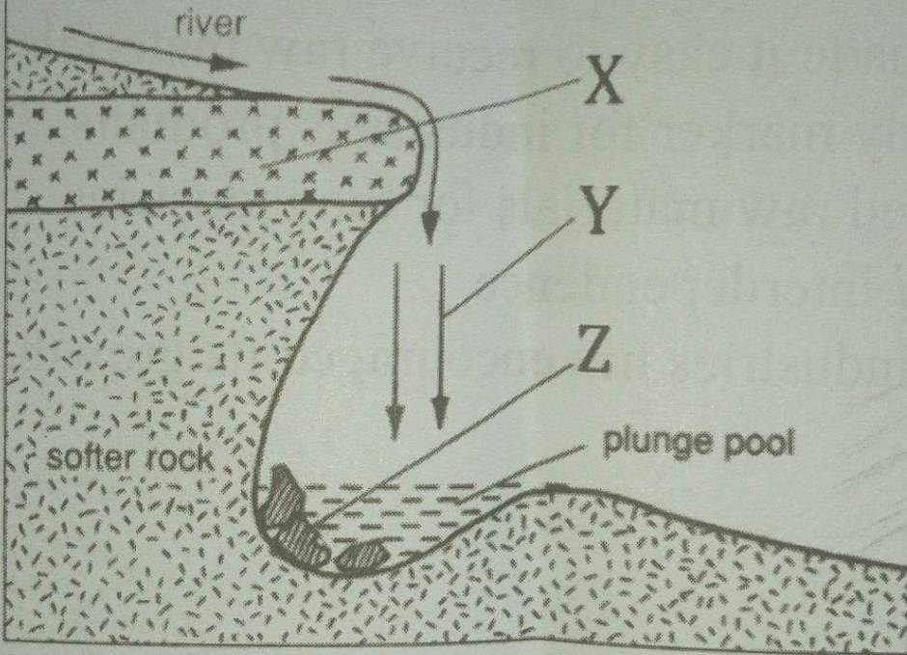
Name the features marked X, Y, and Z (3mks)
- X - Resistant rock or cap rock
- Y - Water fall
- Z - Rock boulder 3x1=3mks

SECTION B (75MARKS)
Answer question 6 and any other two questions from this section.
- Use the map of Nyeri to answer question 6
a) i) What is the map title? (1mk)
- East Africa 1:50,000
ii) Identify two districts found in Nyeri (2mks)
- Laikipia
- Nyeri
iii) Identify index to adjoining sheet found in the Northern and Southern (2mks)
- 120/2 – Ongobit
- 134/2 - Kangema
b) i) Name any three types of land transport in Nyeri (3mks)
- All weather road bound surface
- All weather road loose surface
- Other track (motorable)
- Dry weather roads
ii) Name two physical features found in grid square 6258 (2mks)
- River
- River valley
- Scrub
c) Describe relief of the area covered by the map (7mks)
- There are over valleys
- The highest point is 2800m/lowest point is 1600m a.s.l
- The forest point in 1600m
- They are gentle slope
- There are rugged slopes central parts
- There are ridges in the southern part
- There are slopes towards the east
d) Citing evidence, explain four physical factors which favour cattle keeping (8mks)
- Water evidence by may be perennial rivers which the livestock drink
- Pasture evidenced by forest/thicket which the livestock feed on
- Vast lands evidenced by few settlements which provide a large grazing field
- Gentle slopes which are evidenced by widely spaced contours easening mund of livestock

- a) i) Apart from surface run off, give two other processes in the hydrological cycle. (2mks)
- Precipitation
- Evaporation
- Transpiration
- Interception
- Infiltration
- Percolation
ii) State three factors that determine the amount of surface run off. (3mks)
- Amount of rainfall
- Rate of evaporation
- Gradient/slope of the land
- Nature of the rocks/pervious/impervious
- Amount of vegetation cover
b) Explain three factors that influence the transportation of materials by a river. (6mks)
- Volume of water-large water volume carry large amount of load
- Gradient of the channel-steep slopes generate greater kinetic energy enabling faster flow
- Nature of the load-light load is transported faster/over long distance
- Amount of load-small quantity transported for a long distance/large
- Load reduces the efficiency of a river to transport
c) i) What is river rejuvenation? (2mks)
- This is the renewal of the erosive activity of a river
ii) Explain three conditions that lead to rejuvenation of a river. (6mks)
- Increase in river discharge due to increased rainfall/river capture resulting in increased erosive power
- Change in rock resistance which make the river to start eroding vigorously
- Change in base level due to local uplift or drop in sea level causing a steep gradient
d) Explain three negative effects of rivers to the human environment. (6mks)
- Flooding of rivers may destroy property/crops/displace people
- Flooding of rivers can lead to loss of human lives
- Some rivers are habitat to dangerous animals which may attack human beings or destroy crops
- Wide or deep rivers are a barrier to transport especially where bridges have not been constructed
- River water may be a medium of spreading water borne diseases especially when flooding occurs

- a) Differentiate between folding and faulting (2mks)
- Folding is the bending of crustal rocks while faulting is the fracturing/cracking of crustal rocks by tectonic forces
b) The table below shows types of folds and faults. For each, identify the type it belongs to.
- Asymmetrical– Fault (1mk)
- Reverse – Fault (1mk)
- Isoclinals – Fold (1mk)
- Shear – Fault (1mk)
- Over thrust – Fold (1mk)
c) Using well labelled diagrams, describe how Fold Mountains are formed. (11mks)
- Extensive shallow depression called geosynclines develops on the earth’s surface
- Prolonged and extensive erosion occurs on the surrounding higher grounds
- Sediments are deposited in the geosynclines forming thick layers
- The weight of the sediments cause subsidence of the geosynclines leading to accumulation of more sediments
- Further subsidence of the geosynclines triggers off compressinal forces
- The sediments up fold down fold along the edges of geosynclines
- The up folds form Fold Mountains
- Text 7mks
- Diagram – sediments 1mk
- Geosynclines 1mk
- Compressinal forces 1mk
- Fold Mountains 1mk
d) Describe how a high fold mountain located at a coastal region influences the formation of rainfall
(7mks)
- During the day, the sea is heated by the sun’s rays
- Evaporation takes place from the sea
- Warm moist air moves towards the land and rises along the mountains to the higher atmosphere
- The rising air cools and condenses
- Clouds are formed
- Eventually the clouds releases rainfall on the windward side of the mountain
- Cold dry wind moves to the leeward side causing little or no rainfall (7mks)

- a) i) Differentiate between a soil profile and soil catena (2mks)
- Soil profile is the vertical arrangement of soil in layers from the top to the bedrock while
- Soil catena is the arrangement of soil in-layers along a slope 1x2=2mks
ii) Draw a well labeled diagram of a mature soil profile (4mks)
b) i) Other than topography name three factors that influence formation of soil (4mks)
- -Climate
- -parent rock
- -living organisms
- -time
- -vegetation cover 4x1=4mks
ii) Explain how topography influences formation of soil (3mks)
- -Valley bottoms/gentle slopes encourages the formation of deep and fertile soil due to deposition/accumulation of materials
- -Steep slopes encourages erosion of top layer of soil thus slowing down formation of soils/thin soils
- -Flat/flood plains are saturated with water therefore forming poor soils
- -Slope influences arrangements of soil catena 3x1=3mks
iii) List three characteristics of desert soils (3mks)
- -Have very little humus/organic matter content
- -They are thin/shallow
- -They are sandy and saline
- -They are loose ground
- -They are yellow brown
- -They are rich in calcium carbonate/high lime content 3x1=3mks
c) i) Give three types of soil erosion (3mks)
- Splash erosion
- Sheet
- Gulley
- Rill erosion 3x1=3mks
ii) Explain three effects of soil erosion on human activities (6mks)
- -The productive top soil is lost and only unproductive stony soil is left lowering the agricultural productivity of land.
- -Soil erosion leaves behind thin soils which cannot hold plants firms in the ground hence the plants are easily uprooted and blown away by the wind.
- -When gullies are deepened up to or below the water table, underground water is exposed leading to some of it flowing away or evaporating causing the water table to be lowered.
- -Loss of soil through wind and water erosion leads to destruction of vegetation cover which eventually turn the affected area into a semi –arid land area.
- -Soil erosion cause sedimentation in water reservoirs constructed along rivers hence lowering water levels hence shortage of electricity and expensive to dredge.
- -Soil erosion causes water pollution which may lead to death of aquatic animals/destroy mangrove vegetation
- -Where soils is deposited after erosion it forms rich agricultural lands
- -Sand eroded and when deposited on river valley is harvested for construction 3x2=6mks

- a) weather is the state of the atmosphere of a given place over a short period of time while climate is the average weather conditions of a place observed and recorded over a long period of time
b)-Site should be open space away from tall buildings and trees
-gently sloping ground
-away from paved or concrete surfaces
-should be secure
c) max thermometer
min thermometer
hygrometer
six thermometer
wet-bulb
dry-bulb
d. i) foretelling or predicting the weather conditions of a place for a period of time
ii)latitude
aspect
distance from the sea
cloud cover
humidity
e i) occurs in areas where onshore winds rise over a mountainous region lying parallel to the coast.
Moist are is forced to ascend the relief features or mountains far from water bodies.
The rising moist air expands, cool and condense to form clouds which eventually fall on the windward slope
ii)falls in light showers
rains for a long period of time
form on highland areas.

