GEOGRAPHY PAPER TWO MARKING SCHEME
SECTION A

1. (a) Two by-products from crude oil (2mks)
Bitumen
Grease lubricants
Tar
Wax
Asphalt
(b) three uses of soda ash (3mks)
Used in the manufacture of glass, caustic soda and detergents
It is used in other industries like paper making, oil refining, and textile
2 (a) two irrigation schemes in Kenya (2mks)
Ahero
Mwea tebere
Bura
Perkerra
Bunyara
Kibirigwi
(b) Three importance of irrigation farming in Kenya (3mks)
- Increased food production
-settlement of landless people
-control of floods
-source of income to farmers hence raising their living standards
-economic development in terms of infrastructure. 3. (a) State three differences between natural forests and man-made forests (3mks)
Natural forests have thick undergrowth while planted forests have little or no undergrowth
In natural forests trees are of mixed species while planted forests trees are of the same species
In natural forests trees grow close to each other while in planted forests trees are spaced
In natural forests trees do not mature uniformly while in planted forests trees mature uniformly
In natural forests trees grow without a pattern while in planted forests trees grow in a linear pattern
(b) Two industries associated with forestry (2mks)
Paper and pulp
Sawmilling
Furniture industries
Construction
Wood carving
4 (a) Define the term deadground (2mks)
It is the area hidden from the eye of the camera by an object
(b) State three aspects that should be considered when describing vegetation in a
photograph (3mks)
-type of vegetation
-the height and shape of vegetation
-density of vegetation
-vegetation species
5 (a) Two types of commercial dairy farming in Kenya (2mks)
-highland dairy farming
-lowland dairy farming
(b) Three types of beef cattle kept in Argentina (3mks)
-Short horn
-Hereford
-Galloway
-Aberdeen angus
-Brangus

6(a) (i) COMPOUND BAR GRAPH SHOWING MINERAL PRODUCTION IN COUNTRY Q
BETWEEN 1999 - 2002
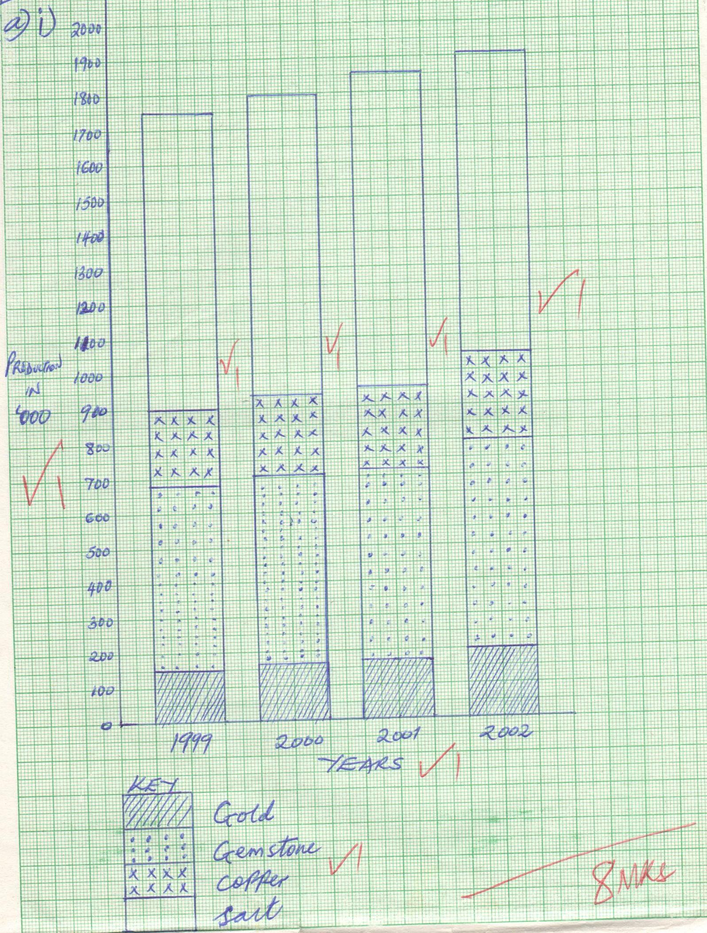
(ii) .
- Cumulative total for all variables in each year is shown clearly.
- One bar can accommodate wide range of variables.
- When properly drawn, they give a clear visual impression. (2mks)

- (i) Kariandusi – Diatomite
Kwale – Titanium
West Pokot – Gold (3mks)
c) Describe how deep shaft mining is carried out. (7mks)

- Vertical shafts are sunk underground.
- From the vertical shafts horizontal tunnels / galleries are dug to reach the mineral ore.
- The galleries are supported by timber pit – props / steel / concrete beams.
- Tunnels are adequately ventilated by supply of cool air and are well lit.
- Water is sprinkled on walls to control dust.
- Light railways are established on horizontal tunnels.
- Ore is conveyed to be base of the vertical shaft by tracks or trolleys or light railways.
- The ore is lifted to the surface using special lifting devices / cages / winding gear.

d)State five environmental problems associated with open cast mining. (5mks)
- Derelict / land is left ugly.
- Dust causes air pollution / industrial effluents cause water pollution / noise pollution / land pollution.
- Leads to soil erosion.
- Water collects in pits which becomes breeding sites for mosquitoes / pests.
- Loss of biodiversity.
7 a) - Forestry is the science / practice of planting cultivating developing
and management of forests/ tree farming while afforestation is the planting
of trees generally in an area which has not had trees in the past. (2mks)

b) i) Give three soft woods trees which grow in the forest reserves of Canada.(3mks)
- Cedar
- Douglas fir
- Pine
- Spruce
- Fir
- Cypress

ii) State four characteristics of planted forests in Kenya. (4mks)
- Trees appear in rows
- Trees are of the same species/
- Are mostly softwoods
- Little / no undergrowth
- Trees take short time to mature
- Trees appear in blocks of different stage / age
c) i) Growth (2mks)
- Severe winter in Canada slow down growth of trees hence take long to mature while in Kenya trees mature faster due to cool climates in the highlands.
ii)Harvesting (2mks)
- In Canada harvesting is done through clearing cutting while in Kenya selective cutting is used.
- In Canada harvesting is done in summer while in Kenya it takes place throughout
- In both cases machines are used for logging.
iii) Marketing
- Most of Canadas wood products are exported to USA/ Britain/ Europe while wood products in Kenya are sold locally with few being exported to USA and Europe.
2mks
d)-State four measures taken by the Kenyan government to conserve forest.(4mks)

- Agro forestry programmes
- Public awareness and education through mass media
- Establishment of forest research stations
- Afforestation and reafforestation program creation better zone
- Enactment of legislation governing forest conservation
4mks
e) Explain three problems facing forests in Kenya (6mks)
- High demand for timber products-high demand for timber and its product in the construction, paper and pulp industries is very high which has led to over-exploitation of forests.
-Illegal logging-this involves cutting down of trees by unlicensed people for charcoal and other products.
-Forest fires- there has been fire outbreaks caused by hunters which consume large hectares of forests if not checked properly.
-Pests and diseases- pests and diseases are affecting trees especially the exotic trees eg the aphids are mainly affecting the cypress trees.
-Prolonged droughts-failure of rains in many areas has led to shrinking of forests and retarded growth rate

8.
(a) i) Name two varieties of coffee grown in Western parts of Kenya. (2 marks)
- Arabic coffee
- Robusta coffee

ii) Apart from being used as a beverage, state two other uses of coffee (2 marks)
- Coffee husks are used as fuel
- Coffee husks are used as manure on the farm

(b) State three physical conditions that favour coffee growing in the Central Highlands of Kenya. (3mks)
- High rainfall of 1000 – 2000mm per year
- Cool to hot temperature/15⁰c – 30⁰c
- High altitude areas of 1000m to 2300m a.s.l.
- Deep well drained fertile soils

(c) Describe the stages involved in coffee production from picking to marketing. (8 marks)
- Ripe red berries are picked by hand
- The berries are transported to the factory
- In the factory, the outer covering of the berries is removed to extract beans
- Beans are fermented to remove green skin
- Curing is done by drying beans for 1 week
- Beans are roasted and ground into powder
- Coffee powder is then packed ready for marketing

(d) Explain three significance of coffee farming in Brazil (6 marks)
- Coffee is exported to earn Brazil foreign exchange used to develop other sectors of economy like transport
- Coffee is raw material to industries which process coffee
- It provides employment hence people earn income which raise their living standards
- May lead to improvement of infrastructure in the country
(e) Your class intends to conduct a field study on coffee farming
i) State two preparations your class will make before the field study. (2mks) -Make a reconnaissance study
- Prepare a working schedule
- Prepare the necessary material
- Group into various groups
- Seek permission from relevant authorities

ii) Give two problems facing coffee farming the class will find out (2 marks)
- Pests like leaf rust and diseases like coffee berry disease which lower production
- Fluctuation of market prices due to overproduction
- Shortage of labour during harvesting
- Delayed and or poor payments which lower farmers’ morale
- Occasional droughts which destroys the coffee trees
- Competition from other producers which limits market/competition from other beverages
- Corruption and mismanagement of coffee cooperative societies

9. Friesian
Jersey
Guernsey
Ayrshire (2mks)

b) availability of capital ton run the farms
there is specialisation and advanced technology
a well-developed cooperative movement
availability of market for dairy produce at home and abroad
plenty of pasture ie high nutritious fodder
a well-developed transport system
c) inadequate and poor pastures
stiff competition from other farming practises
poor transport network in some places
inadequate extension services
constant droughts leading to inadequate water
poor marketing systems
d) ideal climate of moderate rainfall about 1000 mm well distributed throughout the
year
presence of natural open grasslands i.e. pampass
well organised and managed ranches
ready market locally and abroad
availability of capital
good transport network

e) provision of veterinary services
construction of cattle dips
encouraging paddocking and zero grazing
construction of bore holes in dry areas to solve water problems
encouraging pastoralists to form cooperatives which can avail loans and required farming inputs to farmers

10 a)- it is an image of an object recorded by a camera on a film (2mks)
b) are easily taken since one does not need specific skills to take a photograph
taking a photograph is not time consuming
are more realisting in showing physical features
they record different stages of particular activities or changes that occur in a place over time (3mks)
c)ground close ups photographs- this are photographts taken when a camera focuses on one major object. This object may block out all the things behind it
ground general view- they capture the general appearance of an area. The objects become progressively smaller as distance from the camera increases.
Ground oblique- are taken when the photographer is standing on a higher ground and the camera is tilted downwards towards the object being photographed (6mks)
d) (9mks)
Left background | Centre background | Right background
Left middle ground | Centre middle ground | Right middle ground
Left foreground | Centre foreground | Right middle ground

e) to break the rocks into smaller particles (2mks)
to carry rock samples (2mks)
to show them direction (1mks)

while fisheries refer to water bodies where fishing is done.
b) Explain three human factors which have favored large scale fishing in the North
East Atlantic fishing ground. (6mks)
- The advanced ship building industry
- Establishment of settlements near the coast whose occupants practice commercial fishing
- The large capital investment by the Norwegian and other government in commercial fishing
- The advanced fish harvesting technology from the local people
- The advanced scientific research from the local people which has heightened the scale of fish
- The long – detailed historic traditions/ background in harvesting
c) Describe long –lining as a method of commercial fishing. (4mks)
- A sea / ocean part which is rich in large stocks of fish is located usually in
rugged beds
- A long line ranging between 19km and 24km with 300 to 400 hook is baited
- The hooks (baited) are cast into the fish rich water body from a deck by fish harvesters a steam vessel
- Once the fish bite the bait on the hooks they set attached to them
- Fish harvesters haul the hooked fish for unhooking manually

d) i) Differentiate marine fisheries from fresh water fisheries. (2mks)
- Fresh water bodies predominantly lakes, (fresh water ones only) and rivers
from which fish are harvested while marine water fisheries refer to the sea/
ocean as a water body from which fish are harvested.
ii) Explain four problems facing marine fishing in East Africa. (8mks
-The strong sea tides which cause fish harvesters and their vessels to capsize
The limited refrigeration facilities which makes the harvested fish to be spoiled easily
Competition from foreign companies / countries which discourage local fish harvesters
The low local demand for fish which discourage marine fishing
- The limited / low fish harvesting technology with regard to marine fishing

e) Give three reasons why the Kenya Government is keen on promoting the
conservation of fish as a resource. (3mks)
- To sustain the opportunities of those who are employed by the fishing industries
- To sustain industrial development
- For academic /educational research activities
- To protect / safeguard certain fish resources from extinction
- To sustain the generation of income to those who carry out fishing activities

