312/2
GEOGRAPHY
Paper 2
Time: 2¾ hours

Form Three Term Three 2023
Kenya Certificate of Secondary Education
312/2
Paper 2
GEOGRAPHY

INSTRUCTIONS TO STUDENTS

- This paper has two sections A and B
- Answer ALL the questions in section A. In section B answer questions 6 and any other TWO questions.

Answer all the questions in this section.
1. (a) Name two indigenous hardwood tree species in Kenya(2mks)
(b) State three factors that favor the growth of softwood forests in Kenya.(3mks)
2. Use the map of Kenya below to answer question (a).

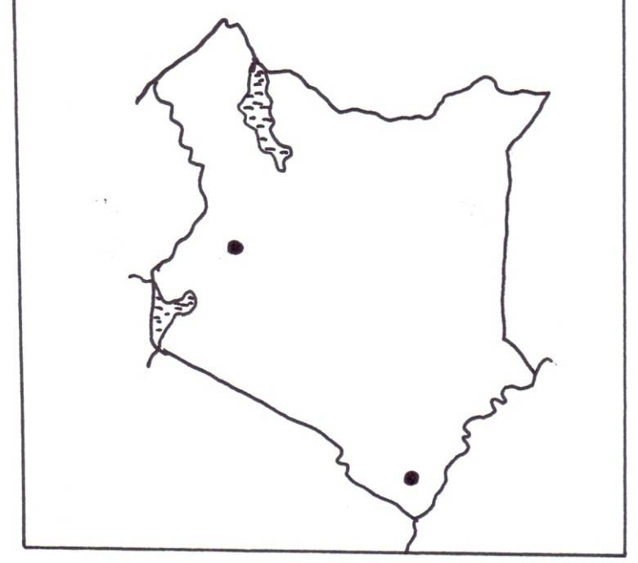
P
R
(a) Name the minerals mined in the areas marked P and R.(2 marks)
b) Statethree benefits of Gold mining to the economy of South Africa. (3 marks)
3. a) Apart from floods, name two other environmental hazards associated with
climatic conditions. (2mks)
b) Outline three problems caused by floods. (3mks)
4 a)Identify three environmental conditions which favor commercial beef farming in Kenya(3marks)
b)Give two exotic breeds of cattle reared in commercial ranches in the Kenyan highlands(2marks)
5a)Define the term photogragh(2mark)
b)state two types of aeriel photograph(2marks)

SECTION B

Answer question 6 and two other questions from this section.
6. The table below shows the production of maize in tonnes between 2015 and 2017 in four
divisions ofBaringo County
Division | 2015 | 2016 | 2017
Bartabwa | 3005 | 3500 | 4000
Barwesa | 6087 | 6198 | 7786
Kabartonjo | 6753 | 6547 | 6698
Kipsaraman | 4078 | 5465 | 5567
a. i)Calculate the percentage increase of the total maize production in the four divisions between
2016 -2017 (3mks)
ii) What is the difference in kilograms between the highest production and the lowest in three years? (2mks)
b.i) Using a radius of 5cm draw a pie-chart to represent production of 2017.(6mks)
ii) Give three advantages of using a pie-chart in representing information.(3mks)
c) State three climatic conditions favoring the growing of maize.3mks)
d) Explain four problems facing small-scale maize farmers in Kenya. (8mks)
7. a. i) What is forestry? (2mks)
ii) Explain three factors that favour the growth of natural forests on the slopes of Mt. Kenya. (6mks)
b) Name three exotic species of trees planted in Kenya.(3mks)
c) State four ways in which the clearing of the forests has affected the natural environment in Kenya.(4mks)
d) Discuss three challenges experienced in the exploitation of tropical hardwood forests in
Kenya. (6mks)
e) Give the differences in the exploitation of softwood forests in Kenya and Canada under the following sub-headings
i) Period of harvesting.(2mks)
ii) Distribution of softwood.(2mks)
8 (a) State three physical conditions that favor tea farming in Kenya. (3mks)
(b) Describe the cultivation of tea (6marks)
(c) Explain five problems facing tea farming in Kenya. (10mks)
(d) Your class visited a sugar factory for a field study on sugar processing.
(i) Outline four stages of tea processing that the class may have observed.(4mks)
(ii)Name two outlets through which KTDA markets tea.(2mks)
9.a. i)What is mining(2marks)
ii)State three effects of opencast mining on the environment(3marks)
b) Describe how deep shaft mining is carried out (4marks)
c) Explain four factors that affect the formation of soda ash(8marks)
d)Explain four problems facing the mining industry in Kenya(8marks)
10. a. i) Differentiate between subsistence farming and commercial farming. (2 mks)
(ii) State four characteristics of plantation farming in Kenya. (4mks)

(b) i) Name one cash crop grown in the Kenyan highlands. (1mks)

ii) State four ways through which Kenya has benefited from farming. (4mks)

iii) state three characteristics of shifting cultivation. (3mks)
iv) state three disadvantages of shifting cultivation (3mks)

c) Explain four factors that influence agriculture.(8mks)

