END OF TERM 3 EXAMS
CHEMISTRY THEORY
PAPER 1

TIME: 2 HOURS
NAME: …………………………………………………SIGNATURE………………..
FORM……………………..
233/1
CHEMISTRY
FORM III
Paper 1
(THEORY)
TIME 2 HOURS

INSTRUCTIONS TO CANDIDATES

- Write your name and index number in the spaces provided above
- Sign and write the date of examination in the spaces provided.
- Answer all the questions in the spaces provided.
- Mathematical table and silent electronic calculators may be used.
- All working must be clearly shown where necessary.

FOR EXAMINERS USE ONLY
QUESTION | MAXIMUM SCORE | CANDIDATE’S SCORE
1-26 | 80

This paper consists of 13 printed pages.
Candidates should check the question paper to ascertain all the pages are printed as indicated
And no questions are missing.

1. Three pure pigments were prepared and their spots placed on a filter paper as shown below. The
three pigments are A, B and C. A mixture F was also placed on the filter paper at the same time
with the pure pigments. The filter paper was then dipped in ethanol solvent and left for some half
an hour. The results were obtained as follows.

• •
•
• •

• • • •
A B C F

•

(i) Which of the three pure pigments is most sticky? Give a reason for your answer. (1mk)

(ii) Which pure pigment is not present in the mixture F? (1mk)

(iii) Show on the diagram the baseline. (1mk)

2. Describe how a pure sample of lead (II) carbonate can be prepared in the laboratory starting with lead II oxide.
(3mks)

3. Write ionic equations for the reactions between : (4mks)
- Aqueous solution of sodium chloride and lead nitrate

- Aqueous solution of barium chloride and magnesium sulphate

- Aqueous solution of potassium hydroxide and dilute nitric acid

- Zinc and an aqueous solution of copper (II) sulphate

4. If it takes 20 seconds for 200cm³ of oxygen gas to diffuse across a porous plug. How long will it take an equal volume of sulphur (IV) oxide to diffuse across the same plug? (3mks)

5. Explain reaction of lithium, sodium and potassium with water and write down the chemical equations in each case. (6mks)

6.A mixture contains ammonium chloride, aluminium oxide and sodium chloride. Describe how each solid substance can be obtained from the mixture. (3mks)

7. State the difference between the following salts;
Deliquescent and hygroscopic salts. (2mks)

8.. Below is a set-up of apparatus used to investigate the effect of electric current on molten lead (II) bromide.
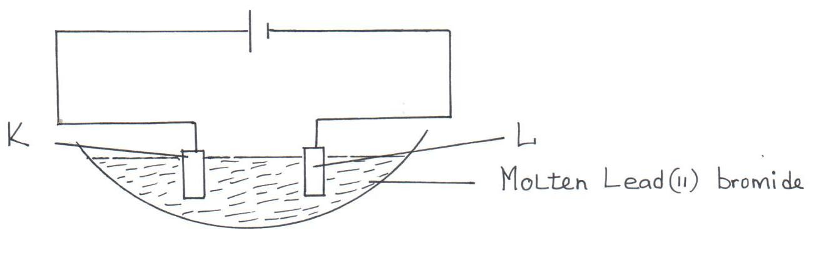

- Name electrode. (1mk)

K

L
(b) State the observation made at electrode K. (1mk)

(c) Write an equation for the reaction taking place at electrode L. (1mk)

9.A sample of a polyethene polymer has the following structure.

H H H H H H
| | | | | |
⎯ C ⎯ C ⎯ C ⎯ C ⎯ C ⎯ C ⎯
| | | | | |
H H H H H H

a) Draw the structural formula of the monomer that makes the above polymer

b)The polymer is found to have a molecular mass of 2268g. Determine the number of monomers
in the polymer. (H = 1, C = 12). (2mks)

10.The isotopes hydrogen are H and H. Determine the molecular masses of the molecules formed when each of these isotopes react with chlorine. (Cl = 37, H=1) (1mk)

11. The table below gives the atomic numbers of elements W,X,Y and Z. The letters do not represent the . actual symbol of the elements
Element | A | B | C | D
Atomic number | 9 | 10 | 11 | 12
a) Which one of the elements is unreactive? Explain (1mk)

b)i) Which two elements would react most vigorously with each other? (1mk)

ii) Give the formula of the compound formed when the elements in b (i) above react (1mk)

12a) Distinguish between a hydrogen bond and covalent bond (2mks)

b) Explain why the boiling point of water is higher than that of hydrogen Sulphide
(Relative molecular mass of water is 18 while that hydrogen sulphide is 34) (2mks)

.

13. The set-up below was used to investigate the products of burning methane gas. Study it and answer the questions that follow:
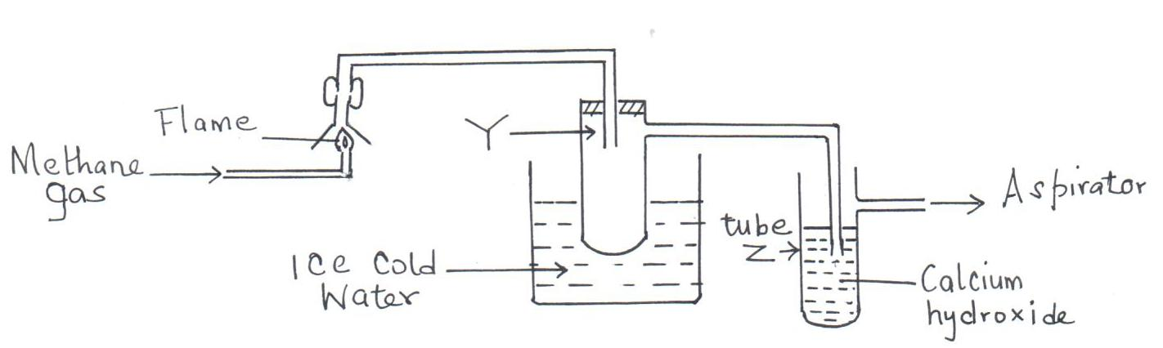

(a) What product will be formed in the test tube Y? (1mk)

(b) State and explain the observations made in tube Z. (2mks)

14. Below are P^{H} values of some solutions.
Solution | Z | Y | X | W
P^{H} | 6.5 | 13.5 | 2.2 | 7.2

- Which solution is likely to be

I Acidic rain. (½mk)

II Potassium hydroxide (½mk)

- A basic substance V reacted with both solutions Y and X. What is the nature of V. (1mk)

15. In cold countries, salt is sprayed on the road to melt ice but in the long run it costs the motorists.
(a) How does the salt help in melting ice? (1mk)

(b) How does the salt affect the motorists? (1mk)

16. Using dots (. ) and crosses (x) to represent electrons, show bonding in the compounds formed when the following elements react: (Si=14, Na=11, Cl=17).
- Sodium and chlorine. (2 Mks)

- Silicon and chlorine. (2 Mks)

17. (a) State Graham’s law of diffusion. (1mk)

- 20cm³ of an unknown gas Q takes 12.6 seconds to pass through a small orifice, 10cm³ of
oxygen gas takes 11.2 seconds to diffuse through the same orifice under the same conditions
of temperatures and pressure. Calculate the molecular mass of unknown gas Q (O = 16).
(3mks)

18. The peaks below show the mass spectrum of element X.
9.1
8.1
82.8
24
25
26
Isotopic mass
Intensity
(% abundance)

Calculate the relative atomic mass of X. (2mks)

19. Name the following compounds using the IUPAC rules.
(a) CH₃CH₂CHCH₂CH₂CH₃
|
CH₂CH₃ ______________________________________________ (1mk)

(b) CH₃CHCHCH₃ ___________________________________________ (1mk)

(c) Draw TWO structural formulae of isomers of compound with the molecular formula CH₃CH₂CH₂CH₃

(2mks)

20.(a) What is meant by allotropy? (1 mk)

b) The diagram below shows the structure of one allotropes of carbon.

i) Identify the allotrope ( 1 mk)

ii) State one property of the above allotrope and explain how it is related to its structure. (2mk) .

21. 24cm³ of a solution of 0.1 M potassium hydroxide were exactly neutralized by 30cm³ of a solution of sulphuric acid. Find the molarity of the acid.
(3 mks)

22. (a) Give one use of hygroscopic substances in the laboratory. (1 mk)

(b) What is meant by the terms: (2 mks)
- Isotopes

- Mass number

(c) The formulae for a chloride of phosphorus is PCl₃. What is the formula of its sulphide?
(1 mk)

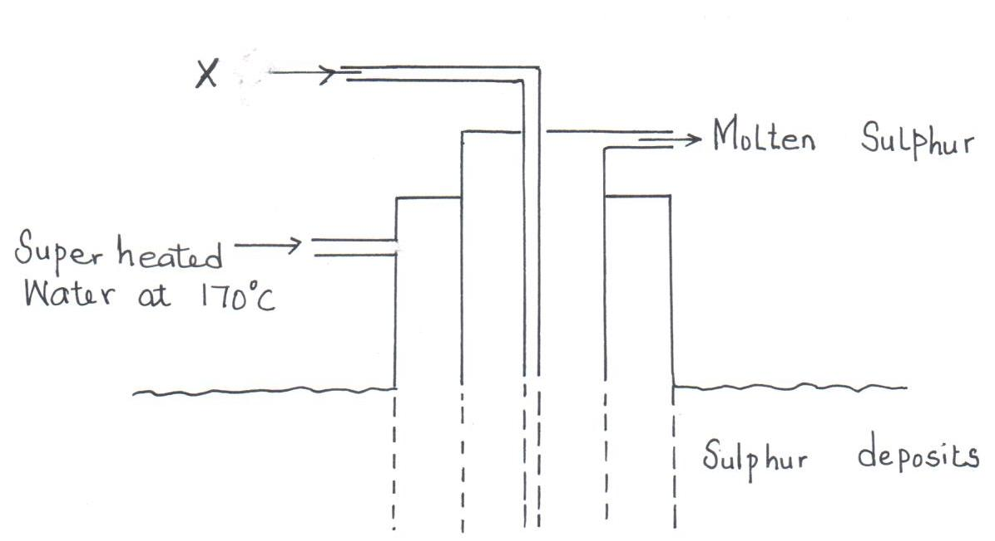
23. The diagram below shows the Frasch process used for extraction of sulphur. Use it to answer the questions that follow.

(i) Identify X. (1mk)

(ii) Why is it necessary to use super heated water in this process? (1mk)

(iii) State two physical properties of sulphur that makes it possible for it to be extracted by this method. (1mk)

24. A certain carbonate XCO_{3 ,} reacts with dilute hydrochloric acid according to the equation given below:
XCO_{3(s)} +2HCl _{(aq)} XCl_{2 (aq)} + CO_{2 (g)} + H₂O _{(l)}
If 4g of the carbonate reacts completely with 40cm³ of 2M hydrochloric acid, calculate the relative atomic mass of X. (C=12.0 ,O=16.0, Cl=35.5). (3 Mks)

25. The table below gives some properties of three substances I, J and K. Study it and answer the questions that follow.

Substance | Mpt (°C) | Solubility in water | Electrical conductivity  Solid Molten
I | 1063 | Insoluble | Conduct Conduct
J | 113 | Insoluble | Doesn’t Doesn’t
K | 402 | Sparingly soluble | Doesn’t Conduct and  is decomposed

- Suggest the type of structure in

(i) I (1mk)

(ii) K (1mk)

Explain why the molten K is decomposed by electric current but I is not decomposed.(2mks)

