MARKING SCHEME
CHEMISTRY PRACTICAL

 | I | II | III
Final burette reading (cm³)
Initial burette reading (cm³)
Volume of solution T used (cm³)

- Complete table ……………………………………………………………….(1mk)
Complete table with 3 titrations done – 1mk
In Complete table with 2 titrations done - 1mk
incomplete table with 1 titration done – 0mks

Penalize ½ mk once for
- Inverted table
- Wrong anthmetic
- Unrealistic titre values ( below 1 or above 50 unless explained)

- Use of decimals………………………………………………………………..1mk
- Accept 1 or 2 d.p uses consistently otherwise penalize fully
- If 2 d.p used the 2nd d.p should be either 0 or 5 otherwise penalize fully

c) Accuracy ……………………………………………………………………….1mk
Compare the candidates titre values with the S.V
- If any value is within +- 0.1 award 1mk
- If within + -0.2 award ½ mk
- If beyond +- 0.2 award zero mark

- Principles of averaging ……………………………………………………….1mk
1f 3 consistent titrations done and averaged 1mk
If 3 titrations done but only 2 are consistent and averaged (1mk)

If only two titrations done, are consistent and averaged (1mk)
If 3 titrations done and are consistent but only 2 are averaged ( 0mk)
If 3 inconsistent titres averaged ( 0mk)
1f 2 inconsistent titres averaged (0mk)

- Final answer accuracy……………………………………………………………..1mk
Compare the candidates correct average titre with S.V
- If within +- 0.1 of S.V (1mk)
- If within +- 0.2 of S.V ( ½ mk)
- If beyond +- 0.2 of S.V ( 0mk)

a) Calculate the:
- Average volume of solution T used (1 mark)
Captured in principal of averaging
- The number of moles of solution Z used in titration (1 mark)
$$\frac{25.0 x 0.4}{1000}=0.01 moles$$

- Concentration of solution T in moles per liter. (2 marks)
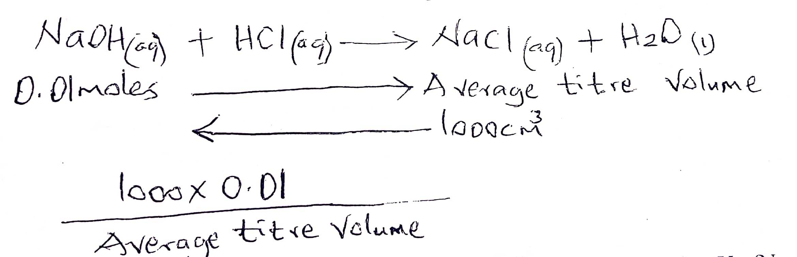
- Calculate the mass of sodium carbonate that reacted with solution Y. (Na= 23, C= 12, O= 16) (3marks)
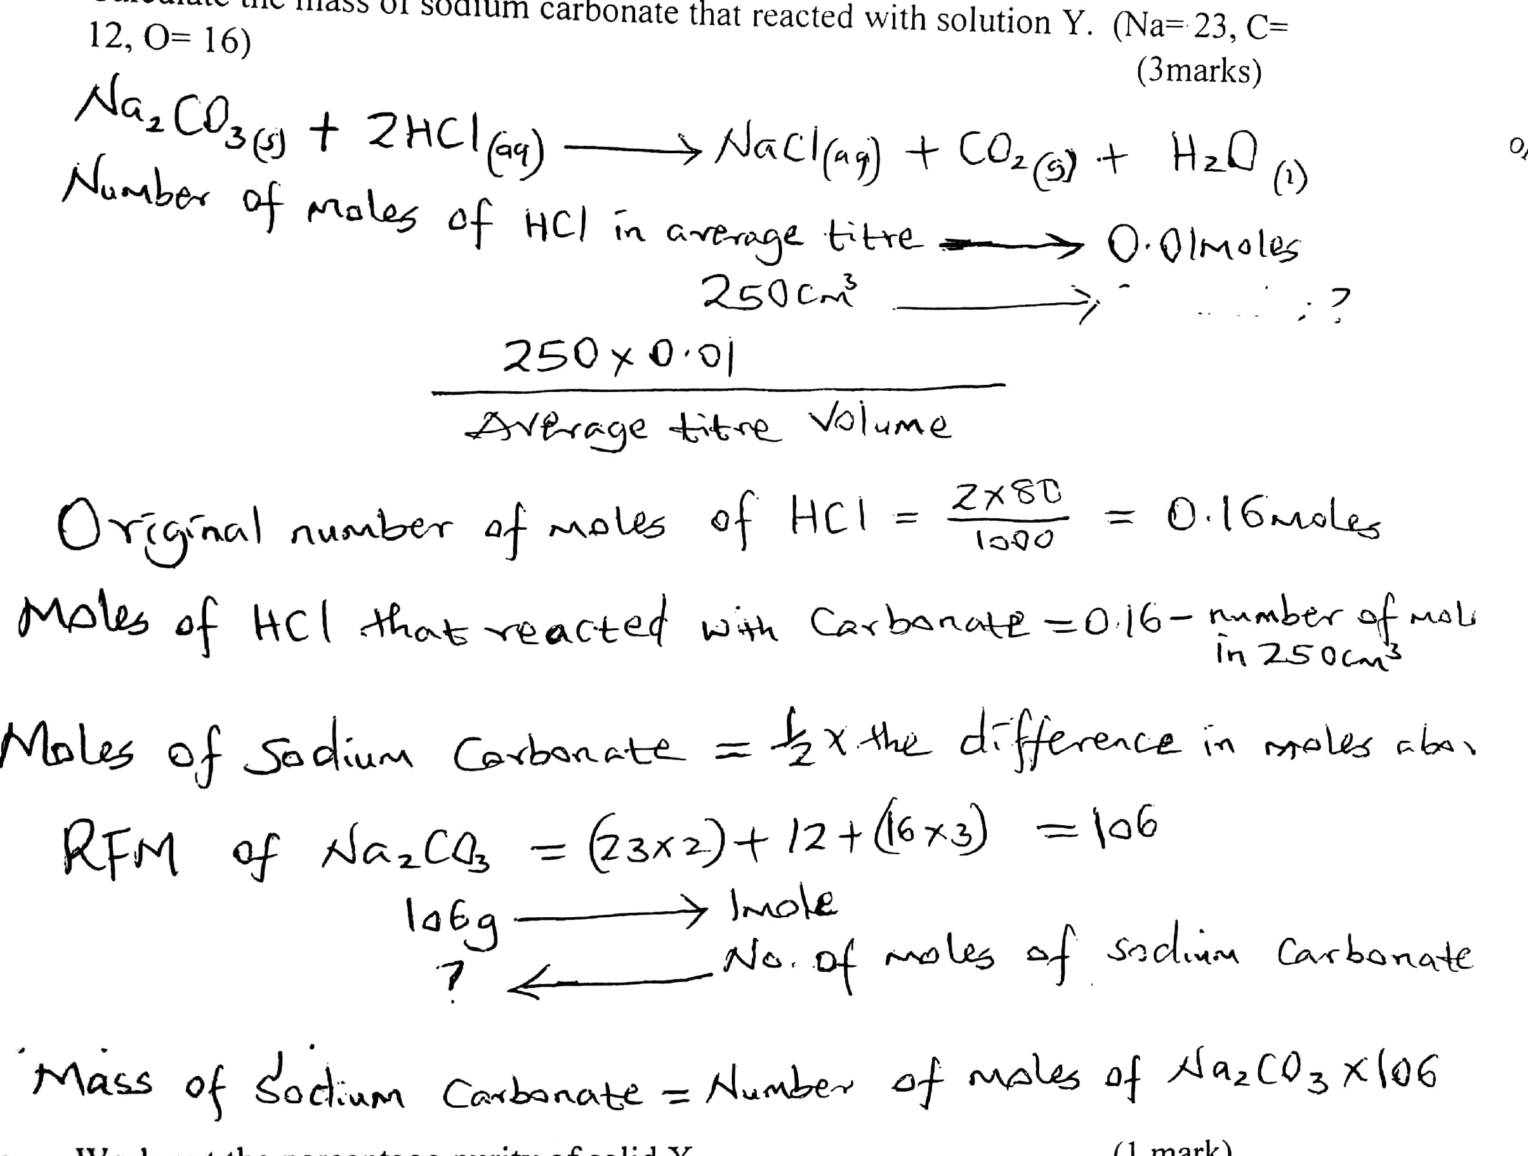

- Work out the percentage purity of solid X. (1 mark)
$\frac{mass of sodium carbonate that reacted with solution Y }{5}$ x 100
b) Write the ionic equation between solid X and solution Y. (1 mark
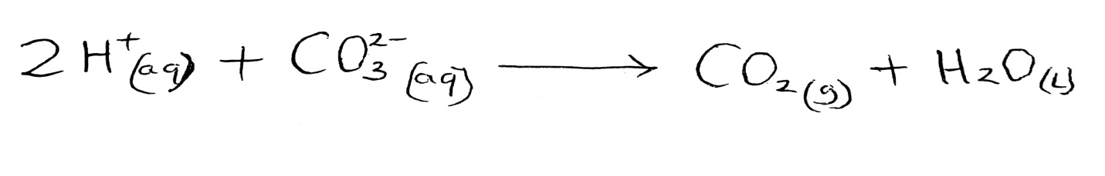
3. You are provided with solid L. Carry out the test below and record your observations and inferences in the spaces provided.
a) Describe solid. (2 marks)

b) Place half spatula of L in a non-luminous flame of a Bunsen burner.
Observations | Inference
Solid melts and burns with a yellow sooty flame  (¹/₂ mark) | 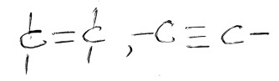  (¹/₂ mark)

c) Dissolve the remaining solid L in the distilled water and divide the solution into four portions.
- To the fourth portion, add few drops of acidified potassium chromate (vi) and warm.
Observations | Inference
Orange acidified potassium chromate VI does not change to green  Reject persist or remains or no color change, no observable change  (¹/₂ mark) | R-OH absent  (¹/₂ mark)

- To the second portion, add few drops of bromine water and warm.

Observations | Inference
Yellow bromine water changes to colorless / decolorized  (¹/₂ mark) | (¹/₂ mark)

- To the third portion add few drops of acidified potassium manganite (vii) and warm.
Observations | Inference
Purple acidified potassium manganate VII changes to colourless  (¹/₂ mark) | (¹/₂ mark)

- To the fourth portion add a quarter spatula end-full of sodium hydrogen carbonate.
Observations | Inference
Effervescence / bubbles produced  (¹/₂ mark) | R-COOH  (¹/₂ mark)

