CHEMISTRY
PAPER 1, 233/1
FORM THREE (3), END OF YEAR 2023
TIME:2HRS

Name: ……………………………………………
Adm No: .……………Class………….
Signature: ……………………………………Date: …………………...

Instructions to candidate
- Write your name, admission number, and stream in the spaces provided.
- Answer ALL questions in the spaces provided
- All workings MUST be clearly shown where applicable
- KNEC mathematical tables and silent non-programmable electronic calculators may be used
- This paper consists of 12 printed pages
- The candidate should check the question paper to ascertain that all the pages are printed as indicated and that no question is missing

FOR EXAMINERS’ USE ONLY
Question | Maximum Score | Candidate’s Score
1 – 29 | 80

- Given a mixture of sodium chloride, silver chloride, and ammonium chloride, describe how each component can be obtained. (3 Marks)
……………………………………………………………………………………………………..
……………………………………………………………………………………………………..
……………………………………………………………………………………………………...
………………………………………………………………………………………………………
………………………………………………………………………………………………………

- Air was passed through several reagents as shown below.

III
Heated excess magnesium powder.
II
Heated excess copper turnings
I
Concentrated potassium hydroxide solution

gas
collected

- What is the role of concentrated potassium hydroxide? (1mk)

- Write an equation that takes place in step III with Magnesium powder. (1mk)

(c) Name one gas that was collected from the process. (1mk)

- The diagram below represents the Frasch process. Study it and answer the questions that follow
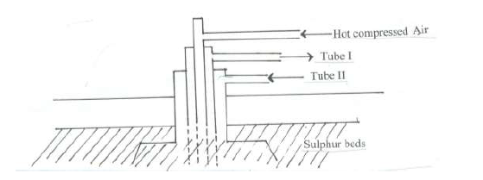
Sulphur deposit
A
C
B

- Name;
A ( ½mk)
B ( ½mk)
C ( ½mk)
- Why is C pumped to the sulphur deposit. ( ½ mk)

- Which property of sulphur enables it to be extracted by the method above. (1mk)

- Give the systematic name of the following compounds A and B (2 Marks)
A B
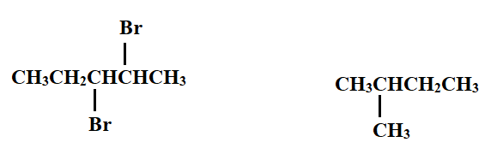
A …………………………………………….
B …………………………………………….

- (a) Define Gay-Lussac’s law (1 Mark)
…………………………………………………………………………………………………..
……………………………………………………………………………………………..........
…………………………………………………………………………………………………..
- In an experiment a mixture of 126.0cm³ of nitrogen gas and 120.0cm³ of hydrogen gas was heated in the presence of iron catalyst. Determine the composition of the final gaseous mixture. (2 Marks)
…………………………………………………………………………………………………..
…………………………………………………………………………………………………..
………………………………………………………………………………………………......
…………………………………………………………………………………………………..

- The table below shows certain properties of substances M, N, K, and L.
Substance | Melting point (ºC) | Solubility in water | Electrical conductivity
M | -119 | Soluble | Solution does not conduct
N | 1020 | Soluble | Solution conducts
K | 1740 | Insoluble | Does not conduct
L | 1600 | Insoluble | Conducts at room temperature

Which of the substances:
- Is a metal (½ Mark)
……………………………………………………………………………………………
- Has a simple molecular structure (½ Mark)
…………………………………………………………………………………………..
- Has a giant covalent structure (½ Mark)
……………………………………………………………………………………………

- Has a giant ionic structure (½ Mark)
……………………………………………………………………………………………
- A polymer has the following structure
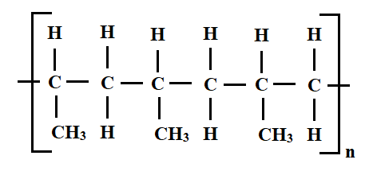
- Draw and name the monomer (2 Marks)

- Draw the repeating unit of the polymer (2 Marks)

- Draw dot (•) and cross (×) diagrams to show bonding in:
- Magnesium chloride (2 Marks)

- phosphonium ion (PH₄⁺) (2 Marks)

- (a). A piece of burning magnesium was introduced into a jar of nitrogen. State and explain the observation made (2 Marks)
………………………………………………………………………………………………..
…………………………………………………………………………………………………
…………………………………………………………………………………………………
…………………………………………………………………………………………………

- Water was added to the product of the reaction in a) and the resultant solution tested with red and blue litmus papers. State and explain the observation made (2 Marks)
……………………………………………………………………………………………….
……………………………………………………………………………………………….
……………………………………………………………………………………………….
- Briefly describe how sodium carbonate powder can be obtained in the laboratory starting with concentrated sodium hydroxide solution (2 Marks)
……………………………………………………………………………………………………..
……………………………………………………………………………………………………..
………………………………………………………………………………………………………

- The sketch graph below shows the relationship between pressure and temperature of a gas in a fixed volume container.
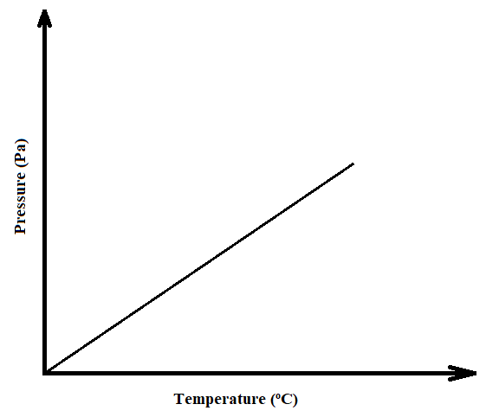
- State the relationship between pressure and temperature that can be deduced from the graph (1 Mark)
…………………………………………………………………………………………………
…………………………………………………………………………………………………
…………………………………………………………………………………………………
- Using the kinetic theory of matter, explain the relationship shown by the sketch graph (2 Marks)
…………………………………………………………………………………………………..
…………………………………………………………………………………………………..
…………………………………………………………………………………………………..

- (a) Group VIII elements are said to be inert. Explain. (1 Mark)
…………………………………………………………………………………………………..
…………………………………………………………………………………………………..
………………………………………………………………………………………………….
- In terms of structure and bonding, explain why group VIII elements exist as gases at room temperature (2 Marks)
………………………………………………………………………………………………………
…………………………………………………………………………………………………….
- Nitric (V) acid may be prepared in the laboratory by the action of concentrated sulphuric (VI) acid in a suitable nitrate and distilling off the nitric (V) acid
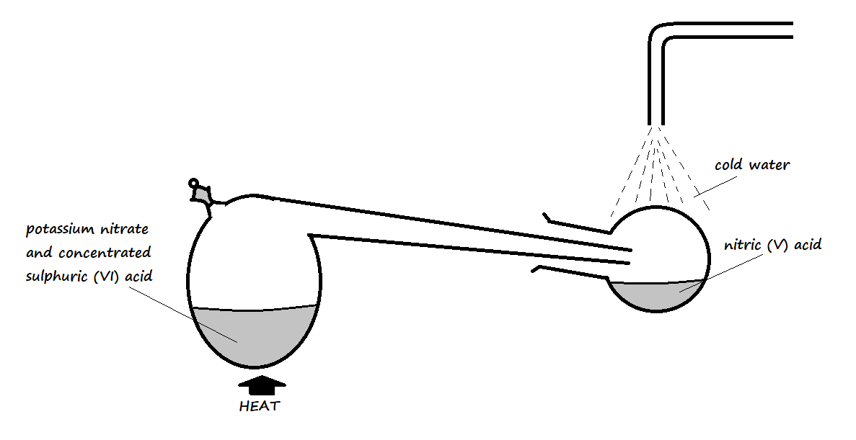
- Why does the setup only consist of apparatus made of glass? (1 Mark)
……………………………………………………………………………………………….
……………………………………………………………………………………………….
……………………………………………………………………………………………….
- Pure nitric (V) acid is colourless but the product in the collection vessel is yellow. Explain (1 Mark)
…………………………………………………………………………………………………
………………………………………………………………………………………………….
- Why is it possible to separate nitric (V) acid from sulphuric (VI) acid in the setup? (1 Mark)
…………………………………………………………………………………………………..
………………………………………………………………………………………………….

- Name the catalyst used in the following processes:
- Large scale manufacture of ammonia gas in the Haber process (1 Mark)
…………………………………………………………………………………………….
- Large scale manufacture of concentrated sulphuric (VI) acid in the Contact process (1 Mark)
…………………………………………………………………………………………………
- Laboratory preparation of oxygen using hydrogen peroxide (1 Mark)
……………………………………………………………………………………………….

- What mass of magnesium carbonate would remain if 15.0g of magnesium carbonate reacts with 25cm³ of 4M hydrochloric acid solution? (3 Marks)

- The setup below was used to investigate the reaction of a certain gas with lead (II) nitrate solution
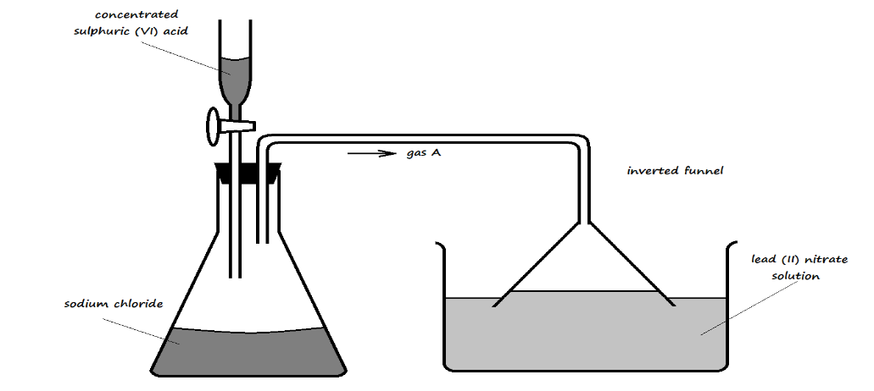
- Identify gas A (1 Mark)
……………………………………………………………………………………………..
- State the observation made in the trough containing lead (II) nitrate solution (1 Mark)
…………………………………………………………………………………………………..
- Write an ionic equation for the reaction occurring in the trough (1 Mark)
…………………………………………………………………………………………………
- Element Q reacts with dilute acids, but not with cold water. Element R does not react with dilute acids. Element S displaces element P from its oxide. P reacts with cold water. Arrange the four elements in order of reactivity, starting with the most reactive element. (2 Marks)
……………………………………………………………………………………………………..
……………………………………………………………………………………………………..
- A fixed mass of a gas occupies 200cm³ at 0ºC and 740mmHg pressure. Calculate its volume at -48ºC and 780mmHg. (3 Marks)

- In an experiment, a sample of an oxide of lead was heated over coke for some time. The following results were obtained:
Mass of the oxide before heating = 8.92g
Mass of residue after heating = 8.28g
- Determine the empirical formula of the oxide of lead (Pb = 207, O = 16) (2 Marks)

- Write an equation for the reaction in the experiment above (1 Mark)

- The information in the table below relates to the physical properties of the chlorides of certain elements.
Formula of compound | NaCl | MgCl₂ | AlCl₃ | SiCl₄ | PCl₃ | SCl₂
Boiling point (ºC) | 1470 | 1420 | Sublimes at 180ºC | 60 | 75 | 60
Melting point (ºC) | 800 | 710 |  | -70 | -90 | -80

- Select two chlorides that are liquid at room temperature (2 Marks)
…………………………………………………………………………………………………..
- Explain why AlCl₃ has a much lower melting point than MgCl₂, although both aluminium and magnesium are metals. (2 Marks)
…………………………………………………………………………………………………
…………………………………………………………………………………………………
…………………………………………………………………………………………………

- 400cm³ of a gas D diffuses through a porous plug in 50 seconds, while 600cm³ of oxygen gas diffuses from the same apparatus in 30 seconds. Calculate the relative molecular mass of gas D. (O = 16) (2 Marks)

- Calculate the volume of oxygen produced when 10g of silver nitrate was completely decomposed by heating at standard temperature and pressure (Ag = 108, N = 14, O = 16, Molar gas volume at s.t.p. = 22400cm³) (3 Marks)

- The electron arrangement of ions W³⁺ and Z²⁻ are 2.8 and 2.8.8 respectively.
- In which groups do elements W and Z belong? (1 Mark)
……………………………………………………………………………………………..
- Write the formula of the compound that would be formed between W and Z (1 Mark)
…………………………………………………………………………………………………
- 20cm³ of a solution containing 2.7g/dm³ of an alkali XOH completely reacted with 25cm³ of 0.045M sulphuric (VI) acid. Calculate the relative atomic mass of element X (O = 16, H = 1) (3 Marks)

- Calculate the number of sulphate ions in 150cm³ of 0.1M aluminium sulphate, Al₂(SO₄)₃ (3 Marks)
(L = 6.023 × 10²³)

- The following apparatus was set up to investigate the percentage of oxygen in air by slowly passing 100cm³ of air from syringe A to syringe B and then back until the volume of air remained constant. Study it and use it to answer the questions that follow.
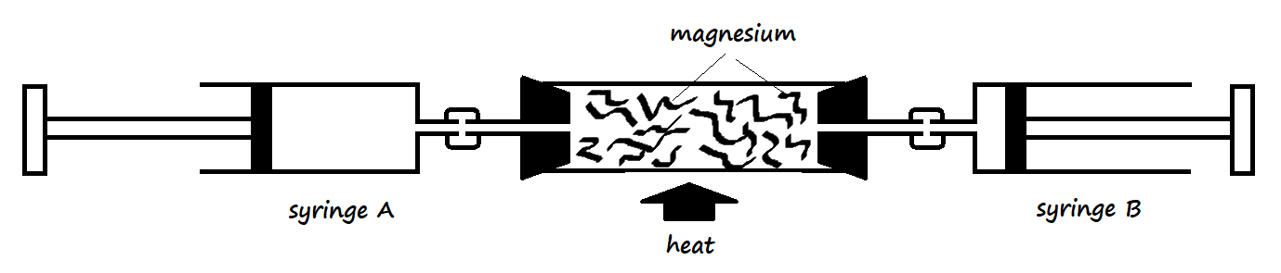
- Identify the mistake in the setup (1 Mark)
……………………………………………………………………………………………..
- Why was the air moved slowly from syringe A to syringe B and vice versa? (1 Mark)
………………………………………………………………………………………………
………………………………………………………………………………………………
- Write an equation for the reaction that took place in the combustion tube after the mistake was corrected (1 Mark)
…………………………………………………………………………………………………

- A luminous flame produces bright yellow light. Explain (1 Mark)
………………………………………………………………………………………………………
………………………………………………………………………………………………………
………………………………………………………………………………………………………

- Magnesium reacts by losing its 2 valence electrons. How does its 1st and 2nd ionization energy compare? Explain (2 Marks)
……………………………………………………………………………………………………..

29. The apparatus below was used for the preparation of iron (III) chloride in the laboratory. Study it and use it to answer the questions that follow.
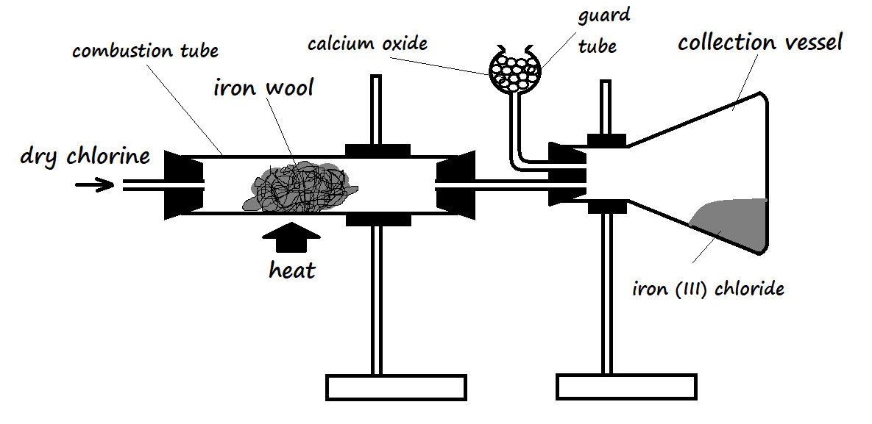

- Why is it preferred to use calcium oxide rather than calcium chloride in the guard tube? (2 Marks)
…………………………………………………………………………………………………
…………………………………………………………………………………………………
- What property of iron (III) chloride makes it possible to be collected as shown in the diagram? (1 Mark)
…………………………………………………………………………………………………..
………………………………………………………………………………………………….
…………………………………………………………………………………………………..

